CERT Traffic and Crowd Management

In this module you will learn about:
- CERT Basic Training Concepts That Apply to Traffic and Crowd Management. How Incident Command System (ICS), sizeup, safety, and team communication apply to traffic and crowd management.
- Communicating Effectively. Using hand signals and communication skills to direct traffic and crowds and communicating with team members and up the chain of command during traffic and crowd events.
- Crowd Management. Crowd psychology skills for responding to crowd behavior, when to back away from a crowd instead of responding, maintaining safety while managing crowds, and how to put together a basic crowd management plan.
- Traffic Management. Using traffic control devices to manage traffic in various situations, safety when managing traffic, and how to put together a basic traffic management plan.

[This page intentionally left blank]

Introduction and Overview

Module Purpose
The purpose of the CERT Traffic and Crowd Management module is to provide CERT members with the skills needed to manage traffic and crowds in planned and emergency situations.

What You Will Learn
This module will cover the following topics:
- Review of CERT Basic Training Concepts That Apply to Traffic and Crowd Management
- Communicating Effectively
- Crowd Management
- Traffic Management

Module Objectives
At the end of this module, you will be able to:
- Identify possible CERT roles in traffic and crowd management
- Explain CERT Basic Training concepts that apply to traffic and crowd management
- Demonstrate the standard hand signals for directing traffic and crowds
- Describe skills for effective verbal communication with the public
- Explain how to use radios and verbal communication skills to communicate with team members and the chain of command
- Recognize and respond to various types of crowd behavior
- Identify safety concerns for managing crowds
- Develop a basic crowd management plan for an emergency situation

Introduction and Overview (continued)

Module Objectives (continued)
- Demonstrate the correct use of traffic control devices
- Recognize safety concerns for managing traffic
- Read and write a basic traffic management plan

Introduction to Traffic and Crowd Management
A CERT may assist in a planned event such as:
- Parade
- Festival
- County fair
- Rush hour traffic
- Funeral procession
- Training exercise
- Traffic checkpoint
- Point of distribution (POD)
- Other special event

Introduction and Overview (continued)
A CERT may assist in an unplanned incident such as:
- Traffic accident
- Weather hazard
- Roadway defect
- Traffic signal failure
- Natural or manmade disaster
- Terrorist incident
The Role of CERT in Crowd Management
CERT members assisting with crowd management are responsible for:
- Directing the flow of people
- Providing directions and assistance to the public
- Communicating with team leaders and the chain of command
- Helping maintain an orderly scene by using hand signals and effective communication skills
Specifically, CERTs may assist with crowd management by:
- Calming crowds
- Providing security
- Distributing medication, food, or other items at a POD
- Managing shelter crowds
- Coordinating people at activities
- Setting up, adjusting, and manning barricades

Introduction and Overview (continued)
- Managing people who may assemble at site(s) where professionals or CERTs are responding
- Managing large numbers of unhurt victims while conducting triage during large-scale incidents
Caution: CERT members should never attempt to deal with aggressive or unruly crowds (leave that to professionals) and should never use force or violence against any members of a crowd.
The Role of CERT in Traffic Management
In terms of traffic management, the role of a CERT member is to:
- Direct the flow of traffic using hand signals and traffic control devices
- Provide directions and assistance to drivers and pedestrians
- Communicate with team members and the chain of command
- Help maintain an orderly traffic scene
CERT members should only assist in the direction or management of traffic if:
- They are activated to assist at a planned event and operate under direction of the appropriate government agency.
- Their assistance is requested by law enforcement or fire service responders at the scene of an emergency (unplanned incident).
- They encounter a specific traffic problem during CERT response to a large-scale event (unplanned incident).

Introduction and Overview (continued)
Local Evacuation Plan
One of the unplanned times when CERTs may be called to help with traffic and crowd management is during an evacuation due to some kind of disaster.
Reminder: Your most important duty is to make sure you do not jeopardize:
- Your own safety
- The safety of others
- The credibility of the CERT Program
Personal Safety
Dealing with traffic or crowds can be mentally and physically challenging as well as potentially dangerous. CERT members must make personal safety their number one priority. CERT members directing traffic and crowds can maintain personal safety by:
- Wearing correct attire (more on this later)
- Behaving appropriately (more on this later)
- Recognizing personal limits
- Asking for assistance or relief
- Backing away from dangerous situations
Management vs. Control
CERT members will be involved only in the management of traffic and crowds, not the control of traffic and crowds. The word control implies the use of force, and CERT members will not be trained to exert force over drivers or pedestrians.
Relevant local ordinances and state statutes pertaining to traffic and crowd management:

Review of CERT Basic Training Concepts
In this topic, you will review the CERT Basic Training topics that are relevant to the management of traffic and crowds:
- Incident Command System (ICS)
- CERT sizeup
- Maintaining scene safety
- Team communication
Incident Command System
As with any CERT emergency response, onscene management is important when dealing with traffic and crowds. Onscene management helps to:
- Maintain the safety of responders
- Provide clear leadership and organizational structure
- Improve the effectiveness of rescue efforts
ICS is the system used by emergency response agencies to manage emergency operations and establish onscene management.
- When CERTs activate for their neighborhood or workplace, they become part of that system.
- Basic ICS structure is established by person who arrives first on scene.
- All CERTs must report to the first fire or law enforcement official at their location and take directions from that person until told that the command system has changed or until they are relieved.
- If no professional responders are on the scene, a CERT Incident Commander/Team Leader (IC/TL) should guide the response effort.
- Initially, the IC/TL may handle all the command positions, but, as the incident evolves, he or she may assign personnel to fill these roles.

Review of CERT Basic Training Concepts (continued
See the organization chart, ICS Command Function Organization Chart, and the responsibilities of the four command positions beneath the IC/TL.
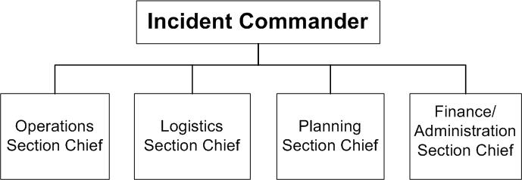
Operations  - Directs and coordinates all incident tactical operations  - Is typically one of the first functions to be assigned | Logistics  - Provides communications  - Provides food and medical support to Team members  - Manages supplies and facilities
Planning  - Tracks resource status (e.g., number of CERT members who have “reported for duty”)  - Tracks situation status  - Prepares the Team’s action plan  - Develops alternative strategies  - Provides documentation services | Finance and Administration  - Provides contract negotiation and monitoring  - Provides timekeeping  - Manages cost analysis  - Provides compensation for injury or damage to property

Review of CERT Basic Training Concepts (continued)
Team Organization
A CERT may operate as a single team that performs all tasks or may be divided into smaller teams to achieve specific goals established by the team leader under the Operations function.
In all situations, each unit assigned must have an identified leader to:
- Supervise tasks being performed
- Account for team members
- Report information to his or her designated leader

CERT Sizeup
The CERT sizeup process will be used any time a CERT deploys for a crowd or traffic incident without professional responders to direct their actions.
- Gather facts
  - How can we gather facts?
  - What kind of situation are we dealing with?
  - What can be described or measured? (e.g., is the crowd growing; how far back is traffic stopped; how many hours of daylight are left?)
- Assess and communicate the situation
  - Does the traffic seem to be moving?
  - Does the crowd seem to be calm?
  - Can our CERT handle this job until professionals arrive?

Review of CERT Basic Training Concepts (continued)
- Consider probabilities
  - For traffic, do we need to manage the situation, or can it work itself out?
  - For crowds, do people in the crowd need assistance?
  - Will this be a long-term or short-term effort?
- Assess your own situation
  - Is this situation safe?
  - What resources do we have?
  - What supplies are needed? (traffic control devices, food, water)
  - Are there professionals on the scene? Is there more help coming?
- Establish priorities. Remember, life safety is the first priority!
  - Can our CERT handle the situation safely?
  - Will team members be safe? Will the public be safe?
  - Does the traffic or crowd need to be moved to a safer location?
  - If property damage is likely to occur, can it be lessened or prevented?
- Make decisions
  - Where will deployment of resources do the most good?
  - Make decisions based on safety and priorities.
- Develop a plan of action
- Determine how personnel and resources should be deployed.
- Keep your plan of action simple.
- Write down the plan of action.

Review of CERT Basic Training Concepts (continued)
- Take action
  - Put the plan into action.
  - Document what you do.
- Evaluate progress
  - Continually size up the situation to identify changes in the scope, safety risks, and resource availability.
Sizing up a crowd or traffic incident is critical to maintaining scene safety and ensuring that operations are run according to CERT protocol.

Maintaining Scene Safety
In addition to performing a thorough sizeup of a scene, CERT Basic Training specified other protocols for maintaining scene safety.
- Work with a buddy.
- Communicate frequently with team members.
- Keep the CERT IC/TL (or the professional responder in charge of the event) informed of important information.
- Wear appropriate attire.
- Crowd management: reflective vest, reflective rain gear if needed
- Traffic management: reflective vest, hard hat, whistle, reflective rain gear if needed
- Make sure communication devices are working properly.
- Recognize the signs of a dangerous situation.
- Know when to back away and call for assistance.
- Have backup available to assist with unruly crowds or out-of-control traffic situations.

Review of CERT Basic Training Concepts (continued)
- Relieve team members regularly.
- Three hours is a good maximum shift time.
- Be respectful to the public to keep situations from escalating.
- Listen to your intuition and pay attention to personal limitations.

Team Communication
Communication between team members is vital to the safety of a traffic or crowd situation.
- Since many traffic and crowd events are too large for any one person to view the entire scene, team members generally use radios to communicate with each other and the team leader.
- This allows team members to keep each other informed of changes in the situation and allows the team leader to make decisions based on a view of the entire event.
Crowd and traffic scenes can quickly turn dangerous, and a CERT member facing an unsafe scene must rely on radio communication to relay that the situation is taking a turn for the worse or to ask for backup.

Communicating Effectively
This topic reviews:
- The standard hand signals used to direct the flow of cars and pedestrians
- Communication skills for interacting effectively with the public, the team members, and the chain of command

Hand Signals

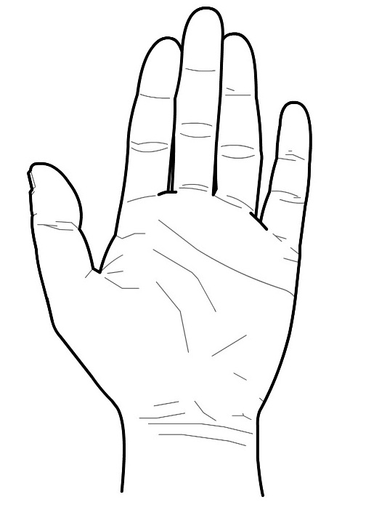 | Stop Hand Signal  - Point with your arm and index finger at the person you want to stop.  - Raise your hand 45 degrees above your shoulder, arm extended, and palm facing out toward the person to be stopped.  - Do not lower your arm until the person has completely stopped.  - If stopping two-way traffic, stop each direction individually.

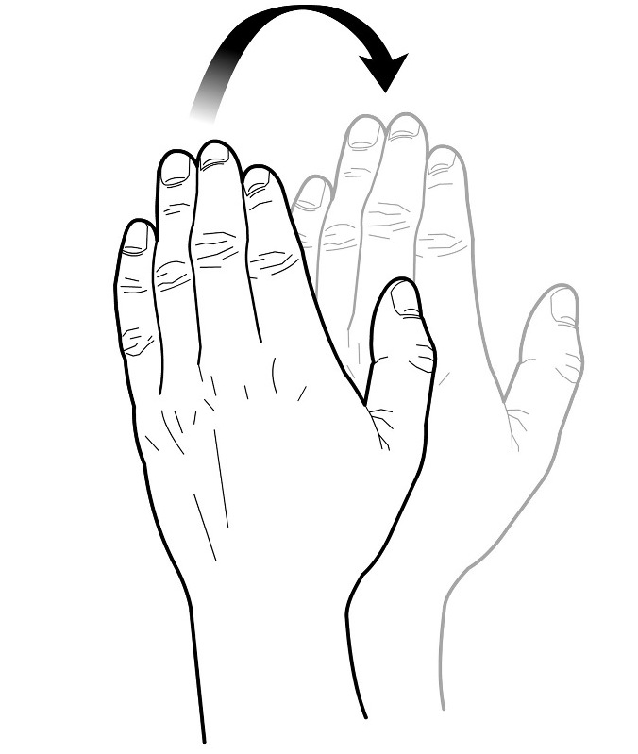 | Go Hand Signal  - Point with your arm and index finger at the person you want to go.  - Hold your arm out and sweep your forearm in an arc toward your body.  - Continue as long as you want people to proceed.
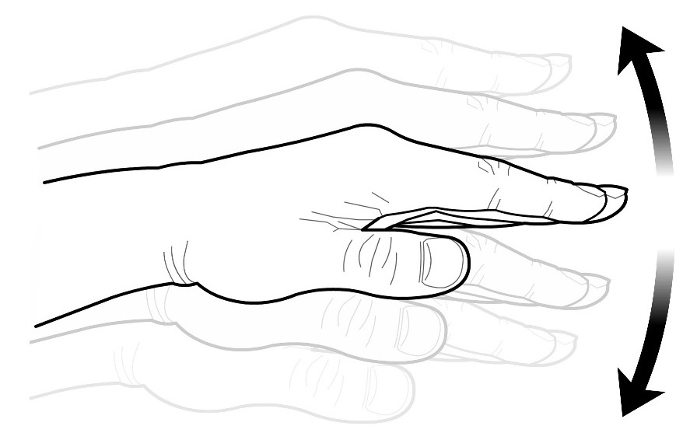 | Slow Hand Signal  - Hold your arm out in front of you, palm facing down to the ground, fingers together.  - Push downward in small movements.
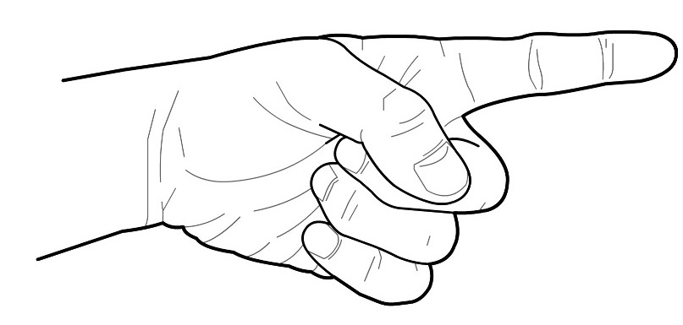 | Directional Hand Signal  - Raise your arm straight out to the side for which traffic should flow, pointing your index finger in that direction.  - Use your other hand to point with your arm and index finger at the person you want to proceed. Sweep that forearm in an arc toward your body, fingers together.  - Continue this motion pointing at those you want to proceed, until you want to stop the flow of people or cars.

Communicating Effectively (continued)

Exercise: Practicing Hand Signals
Purpose: Practice the hand signals.
Instructions: Follow the steps below.
- Form two lines, with lines facing each other.
- Demonstrate the correct signals for:
- Stop
- Proceed
- Go slow
- Move to the right
- Demonstrate them in any order. The person across from you should follow the directions you give.

Communication with the Public
Drivers and pedestrians will often ask questions of the person directing crowds or traffic. CERT members should be prepared to answer those questions.
- The agency in charge of the event should prepare CERT members by:
- Explaining how the crowd or traffic is expected to move, e.g., from where to where
- Providing general information that pedestrians or drivers may want to know
Along with precise hand signaling, clear and respectful communication with the public can prevent negative encounters and help maintain an orderly traffic or crowd scene.

Communicating Effectively (continued)
Be Assertive
You are in charge.
- CERT members must manage the operation so that the scene does not become confused and chaotic.
- Do not be intimidated. Directing crowds and traffic relies on common sense, good judgment, and good communication, which can all be developed. With basic instruction and some practice, traffic and crowd operations will come naturally.
Be Decisive
People at the scene need direction. Your directions must be clear and precise. If you are hesitant or indecisive about what you want people to do, people will be hesitant and indecisive in following your instructions.
Be Courteous
People standing in long lines or driving in heavy traffic may become irritated and take out their frustration on the person directing them. Remember that it is the situation, not you, that is the source of their frustration.
- Remain calm and polite at all times, even if people become angry. Responding rudely will escalate the other person’s anger and ruin your credibility as the person in charge.
- Be helpful and answer questions quickly so as not to halt the flow of the crowd or traffic.
- Keep people informed of expected changes in the situation to avoid increasing frustration.
- As you converse with people, always remain aware of your surroundings. Never let people divert your attention from your signaling duties, as it is your job to keep the scene under control.
- Remember that you are representing the agency in charge of the event or incident, and you are also representing the CERT Program. You must always behave appropriately and courteously.

Communicating Effectively (continued)

Exercise: Determining Your Comfort Level
Complete the Determining Your Comfort Level worksheet
Instructions: Read each item and then rank your own comfort level (1-7) in handling each situation. Remember, this is a self-assessment, so be honest!
No one else will see your worksheet.
1 2 3 4 5 6 7
Very Neutral Very
uncomfortable comfortable

You are directing people toward a line to get into an indoor event. A woman who has been waiting in line for a long time starts to mutter to others that you don’t know how to do your job. | 1 2 3 4 5 6 7
You are directing parking for a county fair. A car speeds right past you without stopping, knocking over traffic cones and entering an area that is clearly marked “Do Not Enter.” | 1 2 3 4 5 6 7
Your town is being evacuated due to an expected flood. Your CERT has been asked to assist in directing traffic out of the area. You have been directing traffic for 3 hours in cold rain and your boots are soaked through to your skin. | 1 2 3 4 5 6 7
You have been asked to assist in managing a large gathering at a local park. The speaker begins making controversial statements, and you can feel the mood of the crowd altering. Tension in the crowd builds and suddenly several fights break out at once. | 1 2 3 4 5 6 7
You are assisting in halting traffic that must wait for a lengthy funeral procession to pass. People keep getting out of their cars and coming up to you, asking, “When is this going to be over?” You have answered this same question more than 20 times in the last 10 minutes. | 1 2 3 4 5 6 7
You are directing a large crowd of people into six separate lines toward the entrance of an outdoor concert. Two teenage boys break out of the line and begin climbing the fence to get into the concert. Suddenly others begin following climbing the fence. Your backup assistance has not yet arrived. | 1 2 3 4 5 6 7
A local storm caused a power outage in your area. You have been asked to provide flagging at a four-way intersection where a traffic light is not working. Cars are backed up in all four directions. | 1 2 3 4 5 6 7
A large-scale disaster hit your area and your CERT is managing crowds at a point of delivery (POD) that is offering food and water supplies to families in need. The crowd outside the POD has been waiting for hours. You can feel the impatience of the crowd growing. | 1 2 3 4 5 6 7
You are assisting at a local hospital that has been overwhelmed by a flood of people after a suspected biological attack. The emergency waiting area is packed with people. Some are crying and begging you to help them. | 1 2 3 4 5 6 7

Communicating Effectively (continued)

Radio Communication
Team Organization
One way team members assist each other with difficult situations is by communicating with each other regularly. In most crowd situations, team members will be spread throughout a large area and will need radios to communicate with each other.
Some traffic operations require one-way traffic with a team member at each end of the traffic incident. Team members use radios to communicate with each other.
Radio communication allows team members to:
- Call for help when it is needed
- Know when traffic or pedestrians may proceed
- Notify each other of potential safety concerns
Communication is also essential for the IC/TL to keep track of team members and the situation.

Communicating Effectively (continued)
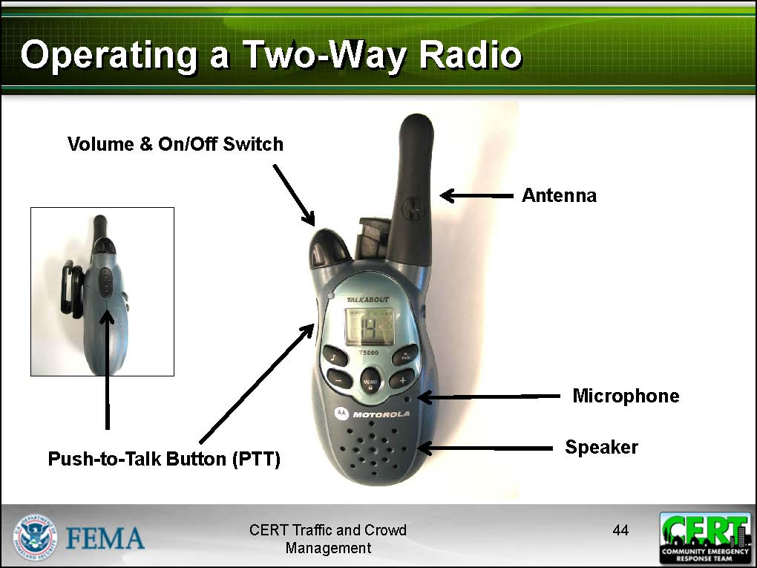
Operating a Two-Way Radio
Basic controls on the radio:
- On/off switch
- Volume control
- PTT button (Push-to-Talk): You must press down the PTT button while you are speaking. You must release the button to listen.
- Antenna: Hold it vertical for best reception.
- Speaker
- Microphone
- Battery location
- Channel selector

Communicating Effectively (continued)
A radio is essentially unusable while it is charging; therefore always carry extra batteries when working with the radio.
NEVER attempt to recharge alkaline batteries.
The agency that has jurisdiction for the event or incident is responsible for issuing radios to CERT members and telling them which radio channel should be used.
Radio Communication Tips
- Hold the PTT button down for at least 1 second before beginning your message.
- Know what you are going to say before you push the PTT button.
- Talk across the face of the microphone.
- Speak slowly, distinctly, and clearly.
- Say the unit identifier of the unit being called followed immediately by your identifier.
- Always acknowledge calls and instructions.
- Do NOT use 10 codes; speak in plain language
Communication is constant and ongoing while CERT members are on scene. Communication is the most important factor in any operation.
Communicating Up the Chain of Command
During traffic and crowd events, CERT members will assist uniformed officers, event security, and professional responders. CERT members need to be able to communicate professionally up the chain of command.
The agency that oversees the event or incident will provide a communication plan with protocols for communicating up the chain of command, so that each team member has someone to whom he or she directly reports.

Crowd Management
This topic reviews the basics of crowd behavior, how to respond to various crowd situations, and how to develop a basic crowd management plan for an unplanned incident.
Reminder: Your role in the management of crowds is to:
- Direct the flow of people
- Provide information and referral
- Communicate and coordinate with team members
- Monitor the scene
- Report to the chain of command
- Maintain personal safety

Crowd Psychology
CERT members directing or managing crowds should understand the basic dynamics of crowd psychology in order to recognize potentially dangerous crowd situations.
- A crowd can assume a personality of its own that is different than the personalities of individuals within the crowd.
- A “herd” mentality may cause members of a crowd to follow each others’ actions and behave differently than they would alone.

Crowd Management (continued)

Safety Concerns
Planned events are set up to maintain an organized flow of people and information. In general, most crowds that CERT members will deal with will be law-abiding and compliant.
Crowds are potentially dangerous.
- The actions of one individual can shape the dynamics of the entire crowd.
- Anonymity increases the odds that members will act outside the norms of acceptable behavior. This can occur when an individual’s sense of personal responsibility is diluted.
- Once in action, crowd behavior is difficult to stop or slow.
Behavior to Report
The following behavior should be reported, as it indicates that the crowd scene may become dangerous:
- Noncompliance (not following directions)
- Rumors
- Hostility
- Aggression
- Excitability
- Overcrowding
- Rushing
- Pushing
The most important thing you can do to protect your safety when dealing with crowds is to listen to your gut feeling. Even if the situation is not obviously out of control, if you feel threatened or uncomfortable or sense that things are not right, act on that feeling and call for help right away.

Crowd Management (continued)

Dangerous Situations
Unruly behavior in a crowd may result in the following situations:
- Vandalism/looting
- Throwing objects/lighting fireworks
- Fighting
- Trampling
- Panics (flight by a group trying to escape a real or perceived threat)
- Crazes (competitive rush by a group toward an attractive object)
Once crowd panic and trampling begins, it is uncontrollable and little can be done to prevent death and injury. For this reason, it is essential to notice the first signs of unruly behavior and report it immediately.
Unruly Crowds
CERT members should never deal with unruly or out-of-control crowds. CERT members involved in the direction or management of crowds need to:
- Have a planned escape route
- Recognize the signs of an unruly crowd
- Communicate the information up the chain of command
- Call for backup assistance (uniformed security guards or uniformed police officers)
- Back away from the situation
CERT members managing crowds during unplanned incidents such as disasters will also need to use the skills they learned in CERT Basic Training Unit 7 for dealing with the trauma of disaster. CERT members must maintain psychological self-preservation and pay attention to personal limitations, which is also discussed in CERT Basic Training Unit 7.

Crowd Management (continued)

Exercise: Responding to Crowd Behavior
Purpose: This exercise allows participants to look at some of the scenarios they considered in the Determining Your Comfort Level worksheet and to identify ways to respond to the crowd behavior in those situations.
Instructions:
- See the Responding to Crowd Behavior scenarios on the following pages.
- As a group, describe how you would manage each situation, using everything you have learned so far.
Scenario #1
- You are directing people toward a line to get into an indoor event. A woman who has been waiting in line for a long time starts to mutter to others that you don’t know how to do your job.
  - What should you do?
  - What if someone did push you out of the way to move past you? What would you do?
  - What if the person started pushing others in line? What would you do?
Scenario #2
- You are directing a large crowd of people into six separate lines toward the entrance of an outdoor concert.
  - What can you do to keep the situation running smoothly?
  - Two teenage boys break out of the line and begin climbing the fence to get into the concert. What should you do?
  - Suddenly others begin following climbing the fence. Your backup assistance has not yet arrived. What can you do to maintain the rest of the crowd from following?

Crowd Management (continued)
Scenario #3
- A large-scale disaster hit your area and your CERT is managing crowds at a point of delivery (POD) that is offering food and water supplies to families in need. The crowd outside the POD has been waiting for hours.
  - What can you do to help keep the crowd calm?
  - You can feel the impatience of the crowd growing. What should you do?
  - What if you suddenly hear the sound of many people screaming and the entire crowd surges forward? What should you do?
See Recognizing and Responding to Crowd Behavior on the next page. As the descriptions indicate, all crowd behavior needs to be observed. Even with manageable crowd behavior, CERT members need to look out. If crowd behavior begins to change and becomes less manageable, CERT members need to watch out.

Recognizing and Responding to Crowd Behavior Signs
Manageable Crowd Behavior
Observable Behavior Signs  - Friendly demeanor  - Makes eye contact  - Smiles some  - Follows directions | Response to Manageable Behavior  - Be friendly and respectful.  - Answer questions rationally.  - Try to keep people comfortable.  - Be honest about the situation.
Changing Crowd Behavior
Observable Behavior Signs  - Demeanor may become less friendly  - Complains or shows irritability  - May disregard some directions  - May avoid direct eye contact  - May pass rumors | Response to Changing Behavior  - Continue to be courteous and rational.  - Ask questions to see what people are upset about.  - Explain how you are trying to improve the situation.  - Call for assistance.
Unmanageable Crowd Behavior
Observable Behavior Signs  - Will not follow directions  - Angry or threatening demeanor  - Makes unreasonable demands  - Asks irrational questions  - Shows no respect for property  - Yelling  - Pushing | Response to Unmanageable Behavior  - Remain calm and courteous.  - Do not act authoritative. Do not threaten or demand anything from the crowd.  - Be polite and state facts.  - Make sure security or uniformed officers are on scene or on their way.  - If you feel threatened, back away from the situation.

Crowd Management (continued)
The two-sided mini Field Operating Guide (FOG) card can be used as a field operating guide during crowd and traffic situations.
One side of the card contains a Look Out/Watch Out for crowd behavior situations. The Look Out section describes crowd behavior that may potentially become dangerous and that CERTs should look out for. The Watch Out section describes crowd behavior that is more serious and can be considered imminently dangerous. CERTs should watch out for and avoid these situations.
The card also contains a Look Out/Watch Out guide for traffic situations, discussed later along with information from the other side of the card:
- Protocol for setting flares and traffic cones
- Safe procedures for lighting and extinguishing flares

Crowd Management Plan
CERT members assisting at a planned event should be briefed on the crowd management plan by the agency in charge of the event.
CERT members should never manage crowds without professional responders to provide direction, except in disaster situations. In this case, CERT members may need to develop a basic plan for managing the crowd until professional responders arrive.
CERT members can use the CERT sizeup process and an Incident Action Plan to develop a crowd management plan in the same way you would develop a plan for managing any incident.

Crowd Management (continued)

Exercise: Developing a Crowd Management Plan
Purpose: This exercise allows participants to practice sizing up a crowd situation and writing a crowd management plan.
Instructions: Follow the directions below.
- Break into small groups.
- See the Develop a Crowd Management Plan scenarios and the Incident Action Plan (IAP) on the following pages.
- The IAP form is one of a set of standards in the National Incident Management System (NIMS). The form includes space for a brief description of the objectives to be achieved (and alternatives if conditions change), and other important related information.
- Review the scenario assigned to your group and work together to write up a crowd management plan of action for the situation described using the IAP form.
- Report your crowd management plan to the class.
Scenarios
- An earthquake has hit your city, and hundreds of homes have been destroyed. Your CERT has been asked to set up a plan to manage a crowd of about 300 people that has gathered around a POD that is providing vouchers for food and lodging. Eight members of your CERT have gathered at the front entrance to the POD. The POD is located in a building with one entrance and two exits. The POD is about to open its doors to the first families in need. The crowd has been waiting for over an hour. People appear weary and sad, but you do not see signs of anger or aggressive behavior. However, several people have asked you for food and water, and you hear babies crying and children complaining.
- A severe winter storm has hit your community. Snow continues to fall intermittently and the wind is fierce. Power is out and may not be restored for at least a week. Your CERT has been asked to assist at a local school that has been set up as a temporary shelter. The shelter can hold about 100 people. Shortly after you arrive, you learn that the shelter has just reached capacity. There are still at least 50 more people waiting in the cold outside of the building.
- A fire has wiped out several buildings in your apartment complex including your own. Two other CERT members who live near you have come to your assistance. Firefighters have contained the fire, but are still working to put it out completely. Several people have been injured, but firefighters believe the building has been completely evacuated. Emergency medical personnel have set up a triage area, and ambulances are transporting the most severely injured people to the hospital. A huge crowd has gathered to watch the scene, and they are getting in the way of firefighter and medical personnel. You cannot tell which members of the crowd are residents, which need medical attention, and which are curious onlookers. Professional responders have asked your CERT to keep the crowd out of the way of professional responders.
- A river flooded your town, destroying many homes. The city was told to evacuate 3 days ago. The flood has receded so that only 1 to 2 feet of water are left in the worst areas. Your CERT has been asked to assess damage in your neighborhood. There are 12 members of your team spread throughout your neighborhood, and as you and your buddy exit a damaged house, you see that a small crowd has gathered at the CERT command post. People are asking the IC/TL questions about where they can go for help, talking over each other, and jostling each other to get her attention.
- An extreme heat wave has hit your area and a large-scale power outage has left hundreds of homes without air conditioning. A local motel has been set up by the City as a shelter, and your CERT has been asked to assist with crowd management outside the shelter. About 150 people are waiting in line outside of the motel for lodging. Your CERT has learned that there are only 20 rooms left.
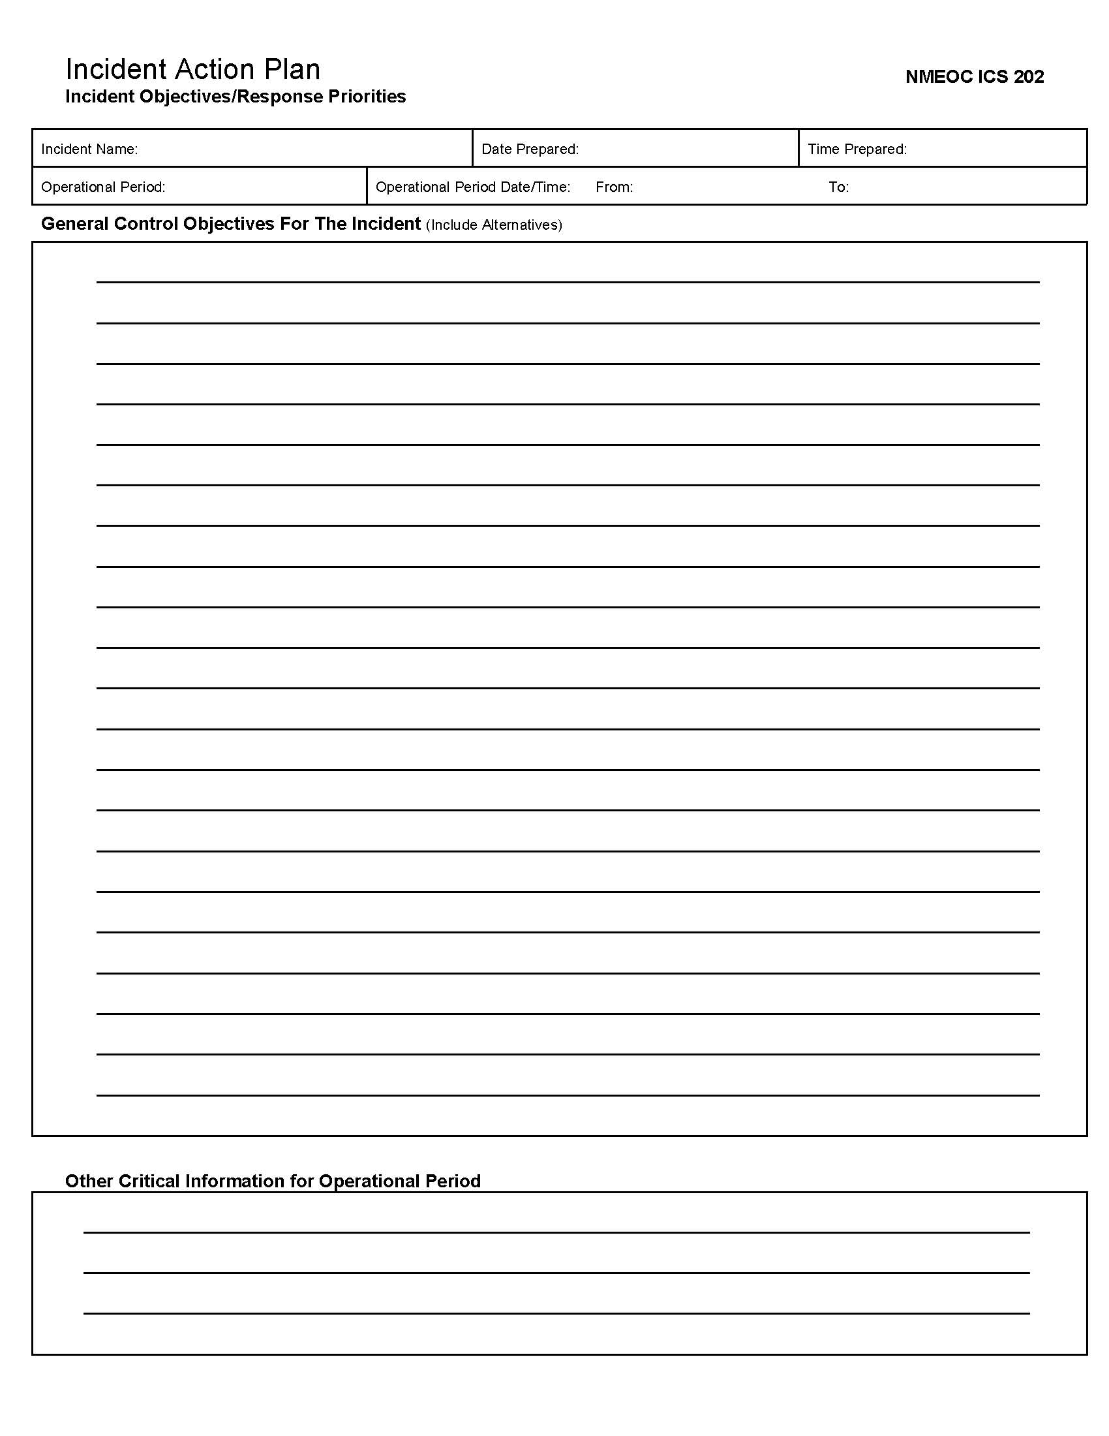

Traffic Management
This topic reviews using traffic control devices to manage various traffic situations, safety concerns for traffic management, and reading and developing a basic traffic management plan.
The CERT member’s role in traffic management is to:
- Direct the flow of traffic
- Provide safe passage for pedestrians
- Communicate and coordinate with team members
- Monitor the scene
- Report to the chain of command
- Maintain personal and scene safety
CERT members will be directing traffic at planned events – such as a county fair – or around an accident or some other type of incident.
Although traffic management may seem like an intimidating job and can indeed be dangerous, directing traffic is really nothing more than letting pedestrians and drivers know what you want them to do.

Using Flag Persons
In all traffic management operations there must be one person in charge of the traffic flow. A number of traffic situations require more than one person. In these situations, flag persons guide traffic. Flag persons are used when:
- Travel lanes are partially blocked
- The shoulder must be used to pass by the incident
- Only one direction of traffic is available

Traffic Management (Continued)

Equipment for Directing Traffic
The most important duty of CERT members is to protect their own safety and the safety of the scene.
Proper equipment is essential to maintaining personal safety while directing traffic, as it makes a flag person more visible and will help drivers recognize you as the person providing directions.
CERT members directing traffic will need:
- Reflective vest
- For daytime: High-Visibility Vest meeting ANSI 107-1999 standard performance for Class 2 risk exposure
- For nighttime: High-Visibility Vest meeting ANSI 107-1999 standard performance for Class 3 risk exposure
- Stop paddle (there are two types available)
- A hand-held stop paddle is small and easily carried in a vehicle.
- A stop paddle mounted on a 6-foot staff is more difficult to transport but easier to control in windy conditions and reduces arm fatigue.
- Flags
- For providing directions to drivers
- Radio
- Used for communication with team members and chain of command
(continued)

Traffic Management (Continued)
- Flashlight
- Increases visibility of flag person
- Important for nighttime, dawn, or dusk conditions
- Used to give directions to oncoming traffic. Swing a beam of light across the road to catch a driver’s attention
- Allows safe movement around emergency scene
- Road flares or traffic cones
- Essential for funneling traffic and separating vehicles from an incident scene
- Warning signs and emergency vehicle lights
- Warning signs are placed in advance of an incident to provide notice to drivers.
- Warning signs and emergency vehicles will have been put in place by professional responders if these are needed at the traffic incident site.

Demonstration: Paddle Method
To direct traffic, flag persons use the same hand signals that participants learned earlier in the module, with the addition of a stop paddle or a traffic flag.
See the Paddle Method Signals illustrations on the next page.

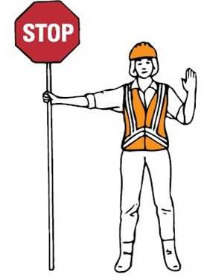 | Paddle Method: Stop  - Stand on the shoulder of the road.  - Hold the STOP sign paddle in a stationary position, arm extended horizontally from your body.  - Raise the palm of your free hand, facing it out toward approaching traffic.  - After traffic is stopped, move towards the middle of road, keeping your palm extended out.
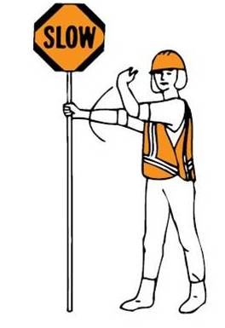 | Paddle Method: Proceed  - Return to a standing position at the shoulder of the road, facing traffic.  - Display the SLOW sign on the paddle.  - Point at and catch the eye of the driver who you want to proceed.  - Swing your free hand in an arc toward the direction that traffic should proceed.

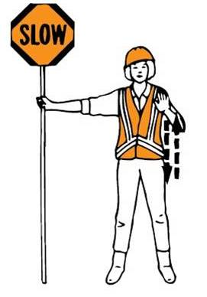 | Paddle Method: Slow  - Stand on the shoulder of the road, facing traffic.  - Display the SLOW sign on the paddle.  - Raise and lower your free hand with palm facing down to the ground.

Demonstration: Flag Method
This demonstration shows participants how to use a traffic flag to indicate to drivers to stop, proceed, or slow down.
See the Flag Method Signals illustrations on the next page.

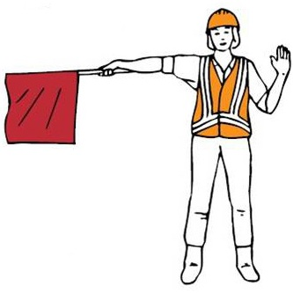 | Flag Method: Stop  - Face traffic from the shoulder of the road.  - Extend flag horizontally across traffic lane.  - Make sure the full flag is visible.  - Hold out free arm with palm facing approaching traffic in a Stop signal.
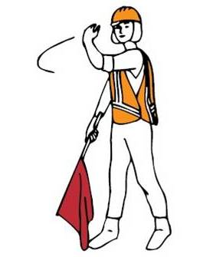 | Flag Method: Proceed  - Stand parallel to traffic movement.  - Keep flag and arm lowered from view.  - Motion traffic ahead with free arm.  - DO NOT wave the red flag!

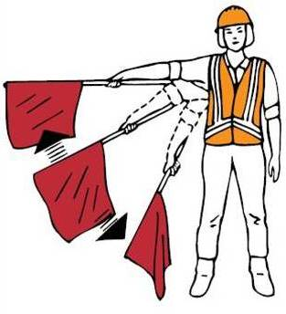 | Flag Method: Slow  - Face traffic from the shoulder of the road.  - Slowly wave flag in sweeping motion up and down from shoulder level, with your arm held out straight to your side.
Illustrations from Federal Highway Administration

Traffic Management (Continued)

Flares and Cones
Traffic flares and cones are used to funnel traffic, direct it along alternate routes, and separate vehicles from a vehicle accident or road work.
To set traffic patterns with flares and cones.
- Set approximately 20-25 feet apart in a straight line.
- Set at a gradual angle when directing traffic to change lanes.
- Set to direct traffic to only one side of an obstruction if possible.
A flag person should be positioned at each end of the obstruction if necessary to direct traffic.
Remember that traffic flares and cones are not barriers, and those directing traffic should be alert for vehicles driving through the cone and flare patterns.
Benefits and Limitations of Flares
The benefits of flares.
- They are effective in gaining the driver’s attention.
- They automatically indicate an emergency situation ahead.
- They work effectively in daylight and at night.
The limitations of flares:
- They cannot be used during fire season, in very dry weather, near any possibility of a gas leak, or at the scene of a HazMat incident.
- They are very dangerous to the user and can burn holes in garments or ignite garments, causing serious burns.
- They only burn for 15 to 30 minutes, depending on the version used.

Traffic Management (Continued)
Igniting Flares
The information on igniting and extinguishing flares and the safety tips for using flares can also be found on the mini FOG.
Follow these safe procedures for igniting flares, as lit flares can cause burns to eyes, face, hands, and clothes.
- Point the flare away from your body and down.
- Turn your face away from the flare and strike down away from your body.
- After lighting the flare, do not push cap onto end of flare with the palm of your hand, as the striking surface may hold hot residue after the flare is lit.
Extinguishing Flares
Follow these safe procedures for extinguishing flares.
- Pick up the flare and tap the lit end on the ground until the flare goes out.
- Do not throw or step on flares to put them out.
Safety Tips for Handling Flares
- Always wear protective equipment such as gloves and goggles when igniting or handling flares.
- Do not light flares near fire hazards such as leaking gas, butane, hazardous materials, or in windy conditions.
- Never hold a flare above your head and shoulders. Molten material drips from the end of flares and can cause severe burns.

Traffic Management (Continued)
Benefits and Limitations of Cones
The benefits of cones.
- They are more practical than flares if the incident will last a long time.
- They don’t burn out.
- They require little attention.
The limitations of cones.
- They cannot be seen from as far a distance as flares.
- They are bigger than flares and harder to transport in large amounts.

Personal Safety
The greatest danger to a flag person is oncoming traffic.
Follow these protocols for remaining safe while directing traffic.
- Be highly visible.
- Stand out from the background.
- Stand alone.
- Wear bright, fluorescent colors with reflective markings. Reflective markings make you more visible even in the daylight.
- Remain alert at all times.
- Always suspect that the oncoming driver does not see you or that the driver will not stop.
- Keep an eye out for impaired drivers or out-of-control vehicles.
(continued)

Traffic Management (Continued)
- Take a safe position.
- Stand alone and face oncoming traffic until you are SURE it has stopped. Never turn your back to oncoming traffic.
- Use a spot with a safety escape path.
- Stand to the side of the driving lane near the shoulder until the vehicle has come to a complete stop.
- Stand at a distance sufficient to allow the driver to slow down and stop before the traffic control point. A traffic control point is the area of an incident that is barricaded from the flow of traffic. This may be the scene of an accident or other type of incident.
- Never stand in the driving lane while traffic is moving.
- Do not stand in the shade, over the crest of a hill, or around a sharp curve.
- Do not have unnecessary conversation with workers, pedestrians, or drivers.
- Once oncoming traffic stops, stay aware of the traffic at your back.
- Take breaks away from moving traffic.
- Don’t wave the flag other than to signal, as this can confuse drivers.
- Don’t give flagging directions against a traffic signal

Team Safety
- Remain alert for any situation that may endanger your co-responders and be prepared to announce the danger.
- Provide for good communications. Keep fellow responders aware of what is going on around them.
- Warn others of changing situations and impending hazards. Never assume that other responders have noticed the same thing that you noticed, no matter how obvious it appears.

Traffic Management (Continued)
- Make sure everyone knows who is in charge of the situation.
- Keep your chain of command aware of changes in the situation.
- Consult your chain of command if you have questions.
See the Safe Protocols for Traffic Management list.

Traffic Management Do’s | Traffic Management Don’ts
- ALWAYS BE SEEN! Wear reflective vests.  - Make sure you know who is in charge of the situation.  - Be alert and oriented to your surroundings.  - Stand alone on the shoulder of the road, facing traffic.  - Have an escape route planned.  - Be alert for impaired drivers and out-of-control vehicles.  - Use clear and deliberate hand signals.  - Have a good understanding of the situation in order to answer drivers’ questions.  - Treat motorists courteously.  - Use proper equipment.  - Use traffic control devices when possible.  - Be prepared for changing weather. | - DON'T become distracted – stay focused.  - DON'T stand in a travel lane.  - DON'T start traffic until you communicate with the other end of the traffic control point.  - DON'T wave the flag other than to signal, as it confuses drivers.  - DON'T assume traffic will stop.  - DON'T turn your back to traffic unless it is absolutely necessary and only after approaching vehicles have stopped.  - DON’T get complacent.  - DON’T assume motorists see you.  - DON’T have unnecessary conversation with workers, pedestrians, or drivers.  - DON’T give flagging directions against a traffic signal.  - DON’T stand in the shade, over the crest of a hill, or around a sharp curve.  - DON’T leave your station until properly relieved.
- Keep your chain of command aware of changes in the situation.  - Consult your chain of command if you have questions.  - Take breaks away from moving traffic. | - DON’T stand with a group of people.

Traffic Management (Continued)

Scene Safety
- Always make sure there is one person in charge of the situation, and be sure you know who is in charge.
- Don’t allow traffic to proceed until you have communicated with the other end of the traffic control point.
- Don’t leave your station until properly relieved.
- Be mindful of the speed of traffic past the incident. Keep traffic slow.
- Be aware that “rubbernecking” makes drivers inattentive to their driving.
- Give clear, concise hand signals (gesture with full arm and make sure signals are high enough for people to see them).
- Address drivers politely and courteously. Do not antagonize drivers by shouting orders at them.
- Use verbal orders as little as possible, as they are not easy for drivers to hear or understand.

Traffic Management (Continued)

Traffic Situations
There are three main types of roadways for which CERT members may help manage traffic:
- Straight roads
- Curved roads
- Intersections
CERT members should NEVER be used to direct traffic on freeways.
Straight Roads
A straight road is the easiest location for directing traffic, as the incident is visible to approaching drivers from both directions.
This does not mean that the operation should be taken lightly. All of the safety hazards discussed in this topic still exist on straight roads.
If personnel are limited, it is possible for only one person to manage traffic on a straight road.
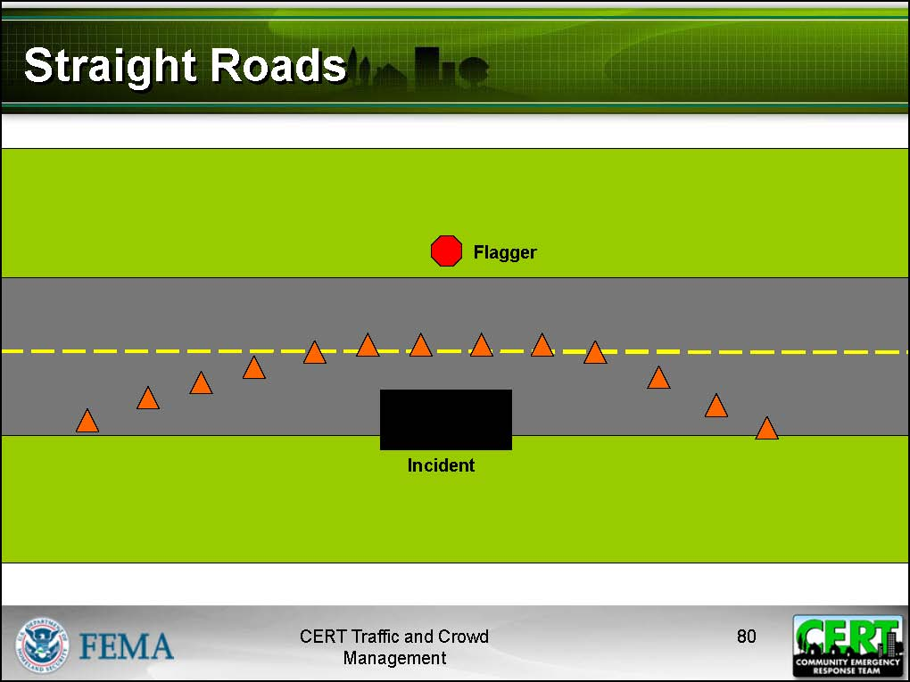

Traffic Management (Continued)
Traffic incidents on straight roads:
- One or both driving lanes may be blocked.
- The safest situation is to use a flag person at each end of the incident.
- If both driving lanes are blocked, traffic will have to be stopped until one lane can be opened.
- If only one driving lane is blocked, one-way traffic can be allowed to pass on the open lane by alternating traffic flow from each end of the incident scene. In this situation, good communication is critical.
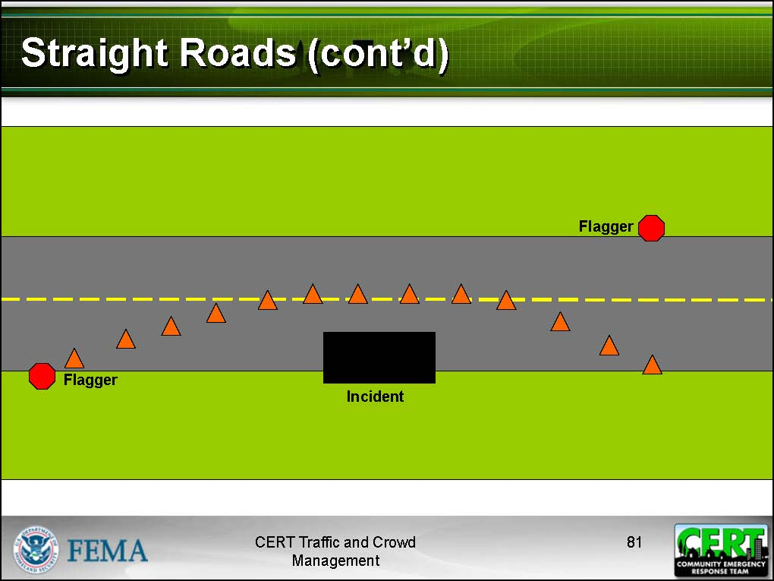

Traffic Management (Continued)
Curved Roads
Incidents occurring on curves or over the crest of a hill require similar traffic management layouts.
When an incident occurs in one of these locations, it may be obscured to drivers in one or both directions. Proper traffic management operations must be established as soon as possible.
Traffic incidents on curved roads:
- There must be a flag person at both ends of the incident.
- Communications between the two flag persons will most likely require radios.
- If radio equipment is not available, a three-flag person layout can be established:
- One flag person is placed at each end of the traffic control point and one in the middle that can see the other two. Communications may be accomplished by voice or hand signals.
- The flag person in the middle is the leader, and the flag persons at each end follow instructions from the leader and signal traffic at their control point.
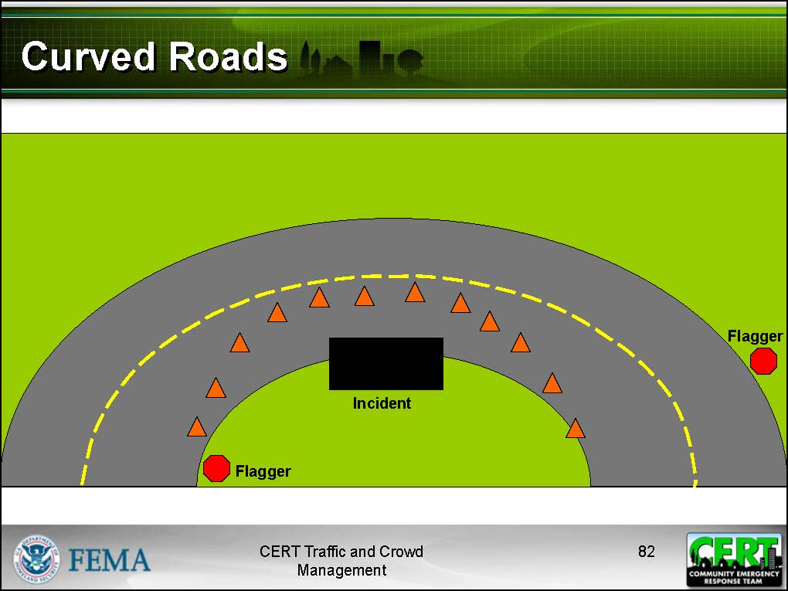

Traffic Management (Continued)
Intersections
Traffic management at intersections is the most hazardous traffic operation that CERT members may be asked to perform. The most common reason for this situation is a power outage. CERT members may also assist at intersections during a local evacuation.
General guidance for managing traffic incidents at intersections:
- Stand where you can see all traffic and where drivers can see you.
- Never turn your back to oncoming traffic.
- Signal to drivers in time for them to stop before they get to a crosswalk.
- Make sure all traffic and pedestrians have cleared the intersection before allowing opposite traffic to proceed.
- Don’t let too many cars build up in any direction.
For one person directing traffic at an intersection: In most cases, the flag person will stand in the center of the intersection. Remember that, as you direct traffic in one direction, there are three directions that do not have your full attention.
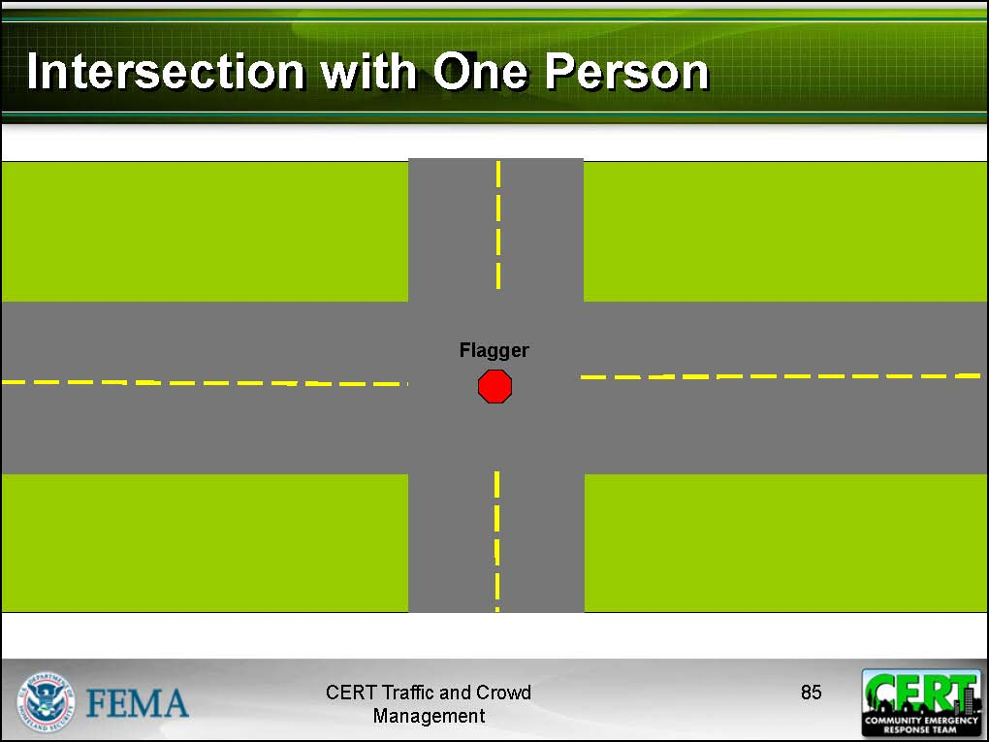

Traffic Management (Continued)
For more than one person directing traffic at an intersection:
- Establish four flag persons for the safest scene.
- Have each flag person control the traffic in one driving lane.
- Good communication between the four flag persons is critical.

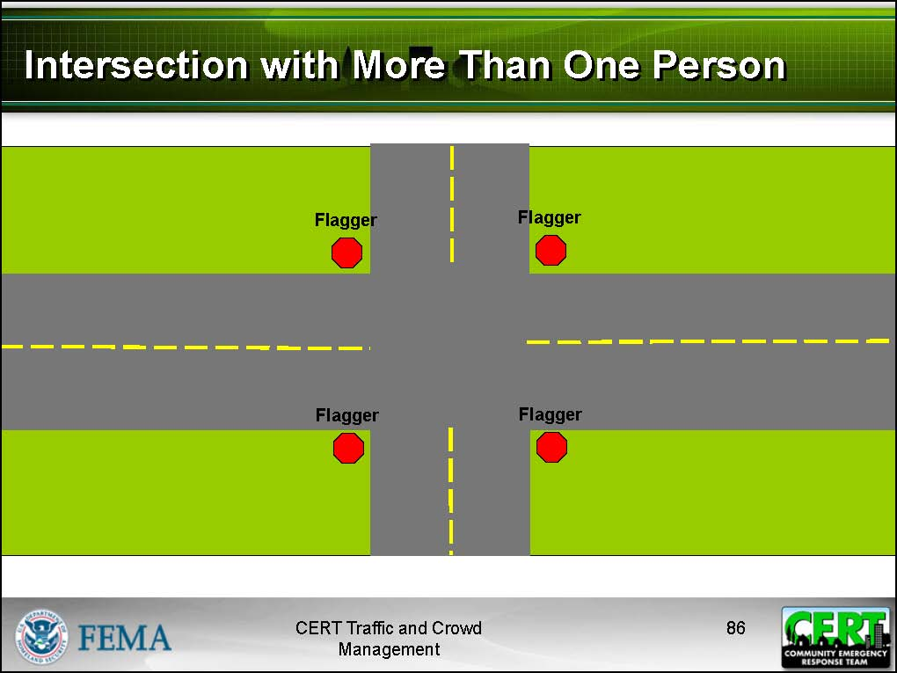

Exercise: Directing Traffic
Purpose: This exercise allows participants to practice setting up a traffic pattern and use traffic flags to direct traffic.
Instructions: Follow the directions of the instructor.

Traffic Management (Continued)

Developing a Traffic Management Plan for an Unplanned Incident

- Establish a team Incident Command System and Incident Commander/Team Leader.
- Assess the situation.
  - Assess location and extent of incident.
  - Determine number and position of lanes to be closed.
  - Determine expected duration of incident.
  - Assess sight distance to incident on each side of incident.
  - Determine if road must be closed or if traffic can be routed around incident.
  - Identify potential safety hazards.
  - Assess available resources (personnel and traffic control devices).
  - Call Incident Command with a sizeup/status report.
- Develop a plan of action.
  - Determine where to place staging area and command post.
  - Determine need for alternate routes.
  - Evaluate need for an emergency access lane.
  - Determine most efficient route for the flow of traffic.
  - Identify crossing and routing for pedestrians.
  - Determine placement of barricades for directing traffic and pedestrians.
  - Determine where to place flag persons.
  - Establish communications plan for the team.
  - Draw and write out your plan on an Incident Action Plan (IAP) form or any other piece of paper.
- Implement the plan of action.
  - Establish staging area and command post.
  - Brief team members on duties and safety concerns.
  - Set up a traffic pattern with flares, cones, or other barricades.
  - Assign flag persons to appropriate locations.
  - Rotate fresh members into the traffic management mission in order to rest and rehab those on the road.
- Evaluate the plan of action.
  - Observe traffic flow and flagger locations to see if adjustments are needed.
  - Assess input from team members.
  - Maintain a “large picture” of the scene.
  - Modify plan as needed based on changes in conditions.
  - Continue to update Incident Command on the status of the incident.
  - Remove all traffic control devices when no longer needed.

Important Tips to Remember
- Where conditions need no control, let traffic regulate itself.
- Normal traffic flow should be inhibited or altered as little as possible.
- Keep the interruptions in traffic flow simple. Stop traffic where a natural break in traffic occurs.
- Try to distribute traffic evenly and in the most efficient way possible.
- Anticipate congestion. Do not let any vehicle enter the intersection unless it can completely clear the intersection on the other side.
- Allow traffic to flow for an equal length of time on each street. Do not allow vehicles to wait longer than 1 minute.
- Do not let traffic back up and block adjacent intersections.
- Provide safe passage for pedestrians through the scene at all times.

Traffic Management (Continued)

Exercise: Develop a Traffic Management Plan
Purpose: This exercise allows participants to practice developing a traffic management plan based on a given disaster scenario.
Instructions: Follow the steps below to conduct this exercise.
- Review the scenario assigned to your small group.
- Use the Developing a Traffic Management Plan for an Unplanned Incident guide to write out a basic traffic management plan for the scenario using the Incident Action Plan form.
- Present your traffic management plan to the rest of the class.

Scenario 1
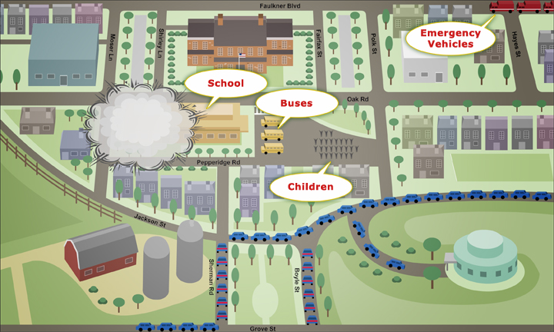

A large-scale earthquake hit your community 30 minutes ago, collapsing several buildings and a major bridge. The local school building has suffered some damage, although no one has been injured. Debris and wreckage have made many streets around the school impassable, but local responders have been dispersed elsewhere and are not on scene. Parents are waiting in lines of traffic, desperate to get into the school to see their children. Design a traffic plan to manage traffic into and out of the incident scene. You need to design a route for:
- School buses to exit the incident scene
- Parents’ automobiles to enter and exit the incident scene
Don’t forget to place flaggers where they will be needed to direct traffic.

Scenario 2

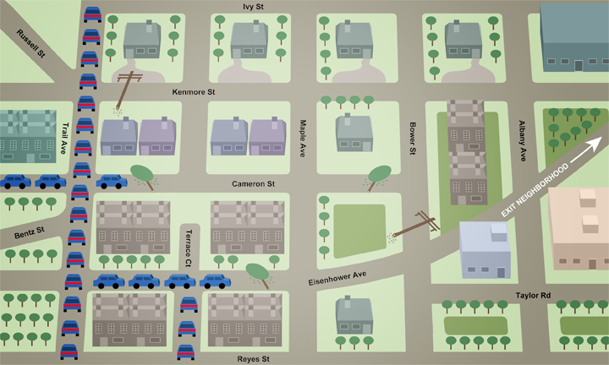

Following a very severe thunderstorm, your CERT self-activated per local program protocol. Fallen trees and power lines are blocking several roads in the neighborhood, and traffic is backed up in a few areas. Professional responders are busy handling other damage throughout the area. After assessing the situation, your team learns that most of the traffic consists of citizens trying to evacuate because they lost power in their homes. All of them are heading towards Eisenhower Avenue in an attempt to exit the neighborhood and get on the highway out of town. You need to design a route for:
- Traffic to exit the neighborhood
- Department of Transportation and power company vehicles to enter the neighborhood
Don’t forget to place flaggers where they will be needed to direct traffic.

Module Summary
Review of CERT Basic Training Concepts
You can use the information and skills learned in CERT Basic Training to conduct safe and effective traffic and crowd management operations:
- Setting up an Incident Command structure
- Performing CERT sizeup
- Maintaining scene safety
- Communicating with team members
Communicating Effectively
Providing clear, decisive hand signals and courteous interactions with the public are critical to maintaining a safe crowd or traffic scene. Radio communication becomes vital when team members are spread throughout a large incident or event or when backup assistance may be necessary.
Crowd Management
Understanding crowd behavior will help CERT members recognize the signs of an unruly or threatening crowd. Crowd situations can become extremely dangerous and CERT members must be prepared to call for assistance and back away from threatening situations.
Traffic Management
Traffic direction requires the same hand signals used to direct crowds, but with the addition of stop paddles or traffic flags.
Traffic management also requires specific safety attire and traffic control devices. CERT members must be able to:
- Provide clear signals to drivers
- Set up traffic control devices for various situations
- Remain calm and alert at all times to protect personal safety and safety of the scene

[This page intentionally left blank]

