Flood Response for CERTs

In this module, you will learn about:

- CERT Basic Training Concepts That Apply to Flood Response: How onscene management and the Incident Command System (ICS), personal safety, and medical skills apply to flood response.
- Identifying a Flood: How to know when a flood response will be needed and how the emergency management system responds to floods.
- The Dangers of Floodwaters: Recognizing the dangers of floodwaters and how to work safely around them.
- Working with Sandbags: How to fill and move sandbags during a flood response.
- Constructing a Sandbag Barrier: How to build a sandbag barrier safely and efficiently.

[This page intentionally left blank]

Introduction and Overview

Module Purpose
The purpose of this module is to ensure that CERT members can respond to a flood safely and efficiently.
The CERT supplemental training on floods is meant to support the disaster response training you have already received in the CERT Basic Training course. The focus of this module will be flood response, rather than flood preparedness.

What You Will Learn
This module will cover the following topics:
- CERT Basic Training Concepts That Apply to Flood Response
- Overview of Flood Response
- Personal Safety Around Floodwaters
- Working with Sandbags
- Building a Sandbag Barrier

Module Objectives
At the end of this module, you will be able to:
- Identify the CERT role in responding to floods.
- Explain CERT Basic Training concepts that apply to flood response.
- Describe how to know when a flood response will be needed and how the emergency management system responds to floods.
- Explain the dangers of floodwaters and how to work safely around them.
- State how to work safely with sandbags, including:
- How to fill them safely
- How to move them safely
- How to construct a sandbag barrier safely
- Demonstrate how to fill and move a sandbag correctly and how to construct a sandbag barrier correctly.

Review of CERT Basic Training Concepts
In this topic, you will review some of the skills and information from the CERT Basic Training course that are pertinent for a flood response, including:
- Onscene Management and the Incident Command System (ICS)
- Maintaining Personal Safety
- Typical Flood Response Injuries
Onscene Management
As with any CERT emergency response, onscene management is important during a flood response. Onscene management helps to:
- Maintain the safety of responders
- Provide clear leadership and organizational structure
- Improve the effectiveness of rescue efforts
ICS is the system used by emergency response agencies to manage emergency operations and establish onscene management. When CERTs activate for their neighborhood or workplace, they become part of that system.
All CERTs must report to the first fire or law enforcement official at their location and take directions from that person until told that the command system has changed or until they are relieved. If no professional responders are on the scene, a CERT Incident Commander/Team Leader (IC/TL) should guide the response effort. Initially, the IC/TL may handle all the command positions, but, as the incident evolves, he or she may assign personnel to fill these roles.

ICS Command Function Organization Chart
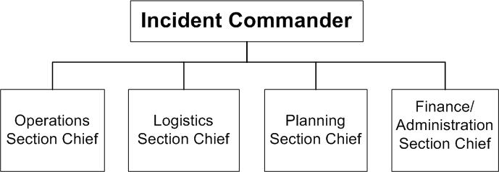
Operations  - Directs and coordinates all incident tactical operations  - Is typically one of the first functions to be assigned | Logistics  - Provides communications  - Provides food and medical support to Team members  - Manages supplies and facilities
Planning  - Tracks resource status (e. g., number of CERT members who have “reported for duty”)  - Tracks situation status  - Prepares the Team’s action plan  - Develops alternative strategies  - Provides documentation services | Finance and Administration  - Provides contract negotiation and monitoring  - Provides timekeeping  - Manages cost analysis  - Provides compensation for injury or damage to property

Review of CERT Basic Training Concepts (Continued)
Team Organization
A CERT may operate as a single team that performs all tasks or may be divided into smaller teams to achieve specific goals established by the team leader under the Operations function.
In all situations, each unit assigned must have an identified leader to:
- Supervise tasks being performed
- Account for team members
- Report information to his or her designated leader
Maintaining Personal Safety
Rescuer safety is paramount during a flood response. Ultimately, CERT members are responsible for ensuring their own safety because people know their own bodies and limitations better than anyone.
You will learn more about ensuring personal safety during a flood response activity later in the module. However, you should always:
- Know your personal limitations and never engage in any response activity that feels uncomfortable
- Use the buddy system

Review of CERT Basic Training Concepts (Continued)
Typical Flood Response Injuries
While taking certain safety precautions will limit the chance of injury, working in and around floodwaters is dangerous. It is important to know how to assess and treat typical flood response injuries using the skills learned in the CERT Basic Training course.
Typical flood response injuries include:
- Heat- and cold-related injuries
- Sprains
- Strains
- Lacerations
- Blisters
Cold-Related Injuries
Hypothermia may be caused by exposure to cold air or water, or by inadequate food combined with inadequate clothing and/or heat. Older people are particularly at risk.
Primary signs and symptoms of hypothermia are:
- A body temperature of 95° F (37° C) or lower
- Redness or blueness of the skin
- Numbness accompanied by shivering

Review of CERT Basic Training Concepts (Continued)
Because hypothermia can set in within only a few minutes, CERT members should immediately treat victims who have been rescued from cold air or water environments.
- Remove wet clothing.
- Wrap the victim in a blanket or sleeping bag and cover the head and neck.
- Protect the victim against the weather.
- Provide warm, sweet drinks and food to conscious victims. Do not offer alcohol.
- If possible, place the victim in a warm bath if the victim is conscious.
- Place an unconscious victim in the recovery position.
- Do not attempt to use massage to warm affected body parts.
Do not allow the victim to walk around even when he or she appears to be fully recovered. If the victim must be moved outdoors, cover the victim’s head and face.
Heat-Related Injuries
There are several types of heat-related injuries, or hyperthermia, that may be encountered during a flood response:
- Heat cramps are muscle spasms brought on by over-exertion in extreme heat.
- Heat exhaustion occurs when an individual works in extreme heat resulting in loss of body fluids through heavy sweating. Blood flow to the skin increases, causing blood flow to decrease to the vital organs. This results in a mild form of shock.
- Heat stroke is life-threatening. The temperature control system shuts down. Body temperature can rise so high that brain damage and death may result.

Review of CERT Basic Training Concepts (Continued)
Treatment is similar for both heat exhaustion and heat stroke. To treat heat-related injuries:
- Take the victim out of the heat and place in a cool environment.
- Cool the body slowly with cool, wet towels or sheets. If possible, put the victim in a cool bath.
- Have the victim drink water, SLOWLY, at the rate of approximately half a glass of water every 15 minutes. Consuming too much water too quickly will cause nausea and vomiting in a victim of heat sickness.
- If the victim is experiencing vomiting or cramping or is losing consciousness, DO NOT administer food or drink. Alert a medical professional as soon as possible, and keep a close watch on the individual until professional help is available.
Treating Sprains and Strains
The most common signs of a sprain are:
- Tenderness at the site of the injury
- Swelling and/or bruising
- Restricted use, or loss of use
The signs of a sprain are similar to those of a non-displaced fracture. Therefore, injuries should not be treated other than by immobilization and elevation.
Immobilization must cover the joints above and below the site of the injury.
A strain involves a stretching and/or tearing of muscles or tendons. Strains during a flood response most often involve the muscles in the shoulder, knee, ankle, and back.
In some cases, strains may be difficult to distinguish from sprains or fractures. It is better to err on the side of caution and treat these injuries as if they were fractures.

Review of CERT Basic Training Concepts (Continued)
Guidelines for splinting a sprain or strain are:
- Support the injured area above and below the site of the injury, including the joints.
- Assess PMS (Pulse, Movement, Sensation) in the extremity before initiating the splint.
- If possible, splint the injury in the position that you find it.
- Don’t try to realign bones or joints.
- Fill the voids to further stabilize and immobilize the injury.
- Immobilize above and below the injury.
- After splinting, reassess PMS and evaluate against initial PMS assessment.
Treating Lacerations and Blisters
Debris in floodwaters may cause lacerations, while handling sandbags and equipment in a wet environment increases the likelihood of blisters. Blisters can be a common injury at sandbagging sites.
- To prevent a blister, use gloves, socks, a bandage, or similar protective covering over the area being rubbed.
- If a blister happens, try to keep it intact if it’s not too painful. Unbroken skin over a blister provides a natural barrier to bacteria and decreases the risk of infection.
- Do not break blisters. Cover them loosely with dry, sterile dressings to keep air out, reduce pain, and prevent infection.
- For lacerations, control bleeding and dress and bandage the wound.
There are three main methods for controlling bleeding:
- Direct pressure
- Elevation
- Pressure points

Review of CERT Basic Training Concepts (Continued)
Direct pressure and elevation will control bleeding in 95 percent of cases.
Wounds should be cleaned by irrigating with clean, room temperature water. Once the wound is clean, apply a dressing and bandage to help keep it clean and control bleeding.

Overview of Flood Response
In this topic, you will be introduced to the basics of a flood response, including what constitutes a flood in your local community:
- What Is a Flood?
- The Emergency Management Response
- Flood Response Supplies, Operations, and Tools
What Is a Flood?
Floods are one of the most common hazards in the United States. Flood effects may be confined to a community or neighborhood, or may be widespread.
All floods are not alike. Some floods develop slowly, sometimes over a period of days, while flash floods can develop quickly, sometimes in just a few minutes and without any visible signs of rain. Flash floods often have a dangerous wall of roaring water that carries rocks, mud, and other debris. Flash floods can sweep away most things in their path.
Overland flooding occurs outside a defined river or stream – for instance, when a levee is breached – and can be very destructive.
Flooding can also occur when a dam breaks, producing effects similar to flash floods.

Overview of Flood Response (Continued)
Types of Floods
The different types of floods include:
- Coastal floods
- May occur due to tidal surges and flash flooding
- Often produced by hurricanes and other large storms
- Overland floods
- Occur when significant rainfall, sometimes combined with snow melt, causes a river to overflow waterway banks and levees
- Flash floods
- Usually result from intense storms dropping large amounts of rain in a brief period
- Occur with little or no warning
- May occur even without rain in the immediate area, if rain causes flooding upstream
- Effects are worsened by terrain
- Ice jams
- Occur when ice sheets break apart, pile up, and form obstructions along rivers in colder climates
- Dam failures
- Potentially the worst flood events
- Usually the result of neglect, poor design, or structural damage
- Giant quantity of water is suddenly let loose downstream

Overview of Flood Response (Continued)
How to Know if A Flood Is Coming
You can learn that a flood is coming from:
- News reports
- TV crawl
- National Weather Service alerts (Web site, weather radio, e-mail, text message)
- Rising water levels
National Weather Service
The National Weather Service’s Storm Prediction Center issues watches and warnings that can help communities prepare for floods, as well as tornadoes, severe thunderstorms, and hurricanes. It is important to monitor these watches and warnings during inclement weather.
The National Weather Service issues their watches and warnings using e-mail, text messages, and broadcasts on weather radios. It also posts this information on its Storm Prediction Center Web site at www.spc.noaa.gov.
Flood Watch
A flood watch is issued for situations related to widespread general flooding and indicates that flooding is possible and the situation could worsen. During a flood watch, you should:
- Watch water levels
- Stay tuned for further advisories
- Alert neighbors

Overview of Flood Response (Continued)
Flood Warning
A flood warning is issued when flooding is expected.
A flash flood warning will be issued in response to a few hours of locally heavy rainfall, a dam or levee failure, or water released from an ice jam.
Personal safety is the number one priority. In some instances, CERT members may have to evacuate instead of assisting professional responders.
During a flood warning, you should take the following actions:
- Alert neighbors.
- Listen to radio or television for further instruction.
- If there is any possibility of flash flooding, move to higher ground immediately.
- Prepare to evacuate.
- Move important items to an upper floor of your home.
- Turn off utilities at main switches or valves if instructed to do so.
- Disconnect electrical appliances.
- Make sure your car is filled with gas.
- Map a route to higher ground inland.
- Evacuate
- Do not walk through moving water.
- Do not drive into flooded areas.

Overview of Flood Response (Continued)
The Emergency Management Response
Response protocols vary by community. You need to know the protocol in your community and how CERT fits into the protocol.
The public and private partners involved in a community flood response will have different roles and responsibilities. Roles may vary based on the type of flood, timing, and other variables. It is important for CERT members to adhere to the protocols for the incident to which they are responding.
If your community needs your CERT for a flood response, CERT members will be contacted. CERT members should not self-activate.
There are many jobs in a flood fight. CERTs will primarily be used to help fill sandbags and build a sandbag barrier(s).
If a CERT member is unable to handle heavy sandbags, there are other less demanding but equally important jobs to fill. For instance, a designated “stomper” may be appointed to flatten sandbags after they have been placed, which will be discussed later in this module.
The CERT Incident Commander/Team Leader (IC/TL) and Safety Officer are responsible for monitoring individual and team safety and well-being:
- There will need to be a process for rotating crews to keep responders fresh.
- CERT members will need to sign in and out so the IC/TL knows their whereabouts at all times.
- The CERT Safety Officer will oversee the operations scene to minimize or eliminate any hazards for CERT members.
- The IC/TL and Safety Officer will direct CERT members to take breaks, eat, and drink enough fluids.

Overview of Flood Response (Continued)
Flood Response Supplies, Operations, and Equipment
Flood Response Supplies
In addition to people, the basic supplies needed for building a sandbag barrier include:
- Sandbags: Either cloth or plastic (both work well), and sand. Sandbags provide the mass to counter the force of the floodwaters.
- Polyethylene: Commonly called “Poly.” Poly provides a water barrier for sandbag barriers. The heaviest polyethylene sheeting available is used. Poly is generally available in 20- by 100-foot rolls from construction supply firms, lumberyards, and farm stores.
- Lumber and planking: Lumber may be needed for field construction projects, and planking is valuable to make paths over muddy ground.
- Shovels, wheelbarrows, etc.: These items are the mainstay of any flood fight.
- Other basic supplies: Drinking water, sanitation supplies, first aid kit, and work gloves.
Flood Response Operations
There are six basic operations that compose a flood response:
- Supply and transportation
- Filling sandbags
- Moving sandbags
- Building a sandbag barrier
- Flood patrols
- Support services
This module focuses on Operations 2, 3, and 4 – working with sandbags.
Operations 1, 5, and 6, will be covered briefly in this topic. Operations 2, 3, and 4 will be covered in detail in the Working with Sandbags topic.

Overview of Flood Response (Continued)
Operation 1, Supply and transportation
Those who work in this operation include: heavy equipment operators, truck drivers, people familiar with warehouse operations (including forklift drivers), school bus drivers to transport volunteers, and others. Without supplies and materials in the right place at the right time, the flood fight will grind to a halt.
Operation 5, Flood patrols
These teams, usually groups of three, patrol the flood works and keep an eye out for developing problems. They look for and report leaks, sand boils, and manholes or utility conduits that may have been missed and require sandbagging. Three-person teams are used for safety. If a problem develops or a person is hurt, one member can go for help while the other remains with the sick or injured worker.
Operation 6, Support services
Food service workers provide food and hot and cold beverages. Volunteers with medical experience deal with the minor cuts, scrapes, and blisters that can be expected.
Flood Response Equipment
Equipment during a flood response may include:
- Pumps (to remove water that infiltrates past the barrier)
- Trucks
- Forklifts
- Front-end loaders
- Sandbag-filling machines

Overview of Flood Response (Continued)
In addition to sandbags, a variety of barriers may be used during a flood response:
- Bags filled with dirt or gravel instead of sand
- Tubes and bladders filled with water
- Steel structures with a waterproof membrane
- Hay bales, plywood, or lumber covered with poly
- Concrete traffic dividers (Jersey walls)

Personal Safety Around Floodwaters
In this topic, you will learn more about the dangers of floodwaters and how to work safely around them.
Realities of Flood Response for CERTs
Be aware that flood response is a mentally and physically demanding process. Personal safety is always the top priority.
- Speak up if you are uncomfortable working in any situation.
- You know your limitations better than anyone.
Fatigue
Participating in a flood response is physically demanding. It is important to listen to your body and take breaks as needed, especially when working extended hours under stressful circumstances.
Weather
Weather conditions, such as rain and wind, can affect the flood response by making the tasks associated with constructing a sandbag barrier more difficult and increasing the likelihood of injury.
It is important to dress appropriately for the weather and to wear layers.
Mental Preparation
Responding to a flood is a long, arduous process. The work involved, including filling sandbags, is often repetitive, and there are few immediate signs that progress is being made. This can result in a frustrating experience for responders who aren’t mentally prepared.
The mental stress, as well as the physical stress, is another reason that taking breaks is important during flood response to stay alert.

Personal Safety Around Floodwaters (Continued)
Dangers of Flood Response
Some of the dangers of working in and around floodwaters include:
- Icy/muddy conditions
- Working around electrical equipment and machinery
- Swift water movement
- Contaminants
- Temperature (hot and cold)
- Debris
- Sand boils
Sand boils occur when the pressure of floodwater causes water to bubble up on the dry side of a sandbag barrier or levee. Although sand boils containing clean, clear water are generally harmless, sand boils containing sand (called “dirty”) are extremely dangerous and may lead to eventual levee failure.
Since it is very difficult to tell if water in a sand boil is dirty or clean, sand boils should never be ignored. The best way to deal with a sand boil is to fight it by building a ring of sandbags around it.

Personal Safety Around Floodwaters (Continued)
Common Ailments and Injuries
Some of the common ailments and injuries that may occur during a flood response include:
- Hyperthermia
- Hypothermia
- Sprains and strains (ankle, knee, back, and shoulder are the most common)
- Raw hands
- Blisters
- Lacerations
Work Smart: Flood Response Safety Tips
Take Care of Yourself
- Drink plenty of fluids and eat regularly.
- Pace yourself.
- Dress appropriately.
Stay Healthy
- Wash your hands before eating, and follow basic sanitary procedures.
- Always lift with your legs, not your back.
- Properly care for all wounds and injuries, no matter how minor.
- Stop immediately if you feel dizzy, have chest pain, shortness of breath, or pain down your left arm. Women are somewhat more likely than men to experience symptoms such as shortness of breath, nausea/vomiting, and back or jaw pain. Seek immediate medical attention if you experience any of these symptoms!
Practice Safety
- Use gloves, goggles, and a personal flotation device.
- Use the buddy system.
- Travel only when necessary and in groups of three.
- Plan an emergency escape route.
Watch Out!
- Use extreme caution around electrical equipment and machinery.
- Don’t walk behind construction equipment.
- Use extreme care when walking in flooded areas.
- Be particularly cautious when working around levees or barriers that may fail.
- Be careful around foundations and watch out for cave-ins.
- Report broken gas lines immediately!
- Treat all sand boils as if the water is “dirty.” Ring all of them with sandbags.

Working with Sandbags
Operations 1, 5, and 6 in flood response were summarized earlier. Now you will learn about Operations 2, 3 and 4 which focus on sandbagging. Sandbags are the primary tool for fighting floods:
- Operation 2: Filling sandbags
- Operation 3: Moving sandbags
- Operation 4: Building a sandbag barrier
How to Fill a Sandbag
Hundreds or thousands of sandbags may be needed for a flood response, so it is important to follow the best practices outlined in this module to conserve energy.
Several essential items are used to make sandbags.
- Sand (or dirt)
- Bags (cloth or plastic)
- Shovel
You may use bulk food bags from restaurants if traditional sandbags are not available.
The following is the correct way to fill a sandbag with a shovel:
- Filling a sandbag is a two- or three-person operation.
- One volunteer holds the empty sandbag on the ground, slightly in front of his or her spread feet, folding out the throat.
- Second volunteer empties a shovelful of material into the open end until the bag is 1/2 to 2/3 full.
- Third volunteer, if available, stacks and stockpiles the filled sandbags.
For larger operations, bag-holding racks, funnels on the backs of trucks, and other power-loading equipment, if available, may be used to expedite the process.

Working with Sandbags (Continued)
General Sandbagging Tips
- Keep your elbows close to your sides when filling sandbags.
- Rotate the various duties involved in filling sandbags so that you aren’t working the same muscle group for extended periods of time.
- Gloves are extremely important so your hands don’t become raw.
Sandbags do not need to be tied, although they may be tied loosely at the top. Untied bags form a tighter seal when stacked than tied sandbags.

How to Move a Sandbag
Move a Sandbag Correctly
Using the improper technique to lift and move a sandbag increases the likelihood of injury and the rate at which you become fatigued.
- When lifting sandbags, it is important to use your knees, not your back.
Sandbags are typically moved via a passing line.
- Standing in a staggered line with volunteers facing each other reduces the physical exertion required to move sandbags down the line.
- The following technique can be used to set up the diagonal-pass formation:
- Volunteers who are part of the pass line stand side by side and count off “1, 2, 1, 2” etc.
- All the ‘1s’ take a baby step back.
- All the ‘2s’ turn around.
As a general rule, when constructing a barrier on an incline, the taller volunteers should be at the end of the line farthest from the barrier.

Working with Sandbags (Continued)
Diagonal-Pass Demonstration
Purpose: To demonstrate the recommended method for moving sandbags down a line.
Instructions:
- The class will be divided into two groups.
- One group will line up side by side.
- The other group will form a staggered line facing each other (as you would to use the diagonal-pass method).
- Pass the sandbag down the line.
- After you have passed the sandbag up and down the line at least two times, switch formations.
- Repeat Step 4.
Conclusion: Instead of requiring that you turn your body 180 degrees after receiving a sandbag, the diagonal-pass formation creates a virtual conveyor belt that reduces stress on your body and increases efficiency.
Safety Concerns When Filling and Moving a Sandbag
- Be aware of what is happening around you at all times to ensure your safety.
- If large vehicles are in the area, listen for the sound of them backing up.
- Be careful when working around power-loading equipment.
How to Build a Sandbag Barrier
There is a specific way to construct a sandbag barrier. Barriers that are not constructed properly are much more susceptible to failing. The steps for building a sandbag barrier are reviewed on the next pages.

How to Build a Sandbag Barrier
- Remove any debris from the areas where bags are to be placed.
- Dig a trench 4-6 inches deep and two sandbags wide.
- Place poly flat on the ground, extending across the trench and away from the bottom row of sandbags and toward the water.
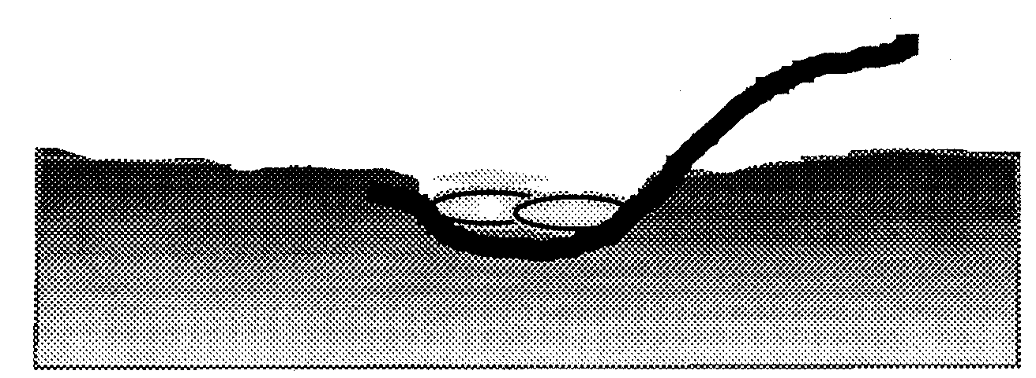
Water is on this side

- Place a row of sandbags over the poly edge to anchor it.
  - Place the bags lengthwise and parallel to the direction of flow.
  - Overlap the sandbags parallel to the direction of the water flow.
  - The filled portion of one bag should lie on the unfilled portion of the previous bag.

- Stagger the second layer of bags perpendicular to the first layer.
  - Place sandbags over the seams of the previous layer.

- Roll the poly over the anchoring row of sandbags and anchor again.
- Flip the poly over the second row of sandbags to move it out of the way while you are building the barrier. The end result will look like this:
Water is on this side
- Place additional layers of sandbags in alternating directions.
  - Offset adjacent rows of sandbags by one-half bag length.
- Stack sandbags in a pyramidal structure using a 3-to-1 ratio. That is, for every foot in height, there should be 3 feet in width. This ratio provides the best structural integrity.
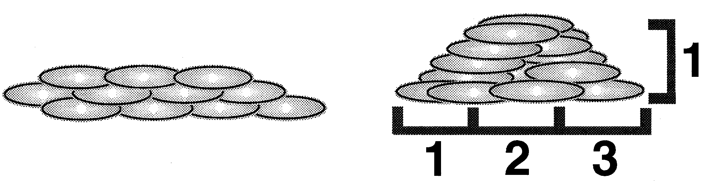
- After placement, tamp each sandbag in place to eliminate gaps and form a tight seal.
  - Walk on the sandbag and butt the ends of the sacks together, maintaining a staggered joint placement and folding under all loose ends.
- Once the barrier is at the appropriate level, fold the poly over the top of the barrier and anchor it with additional sandbags.

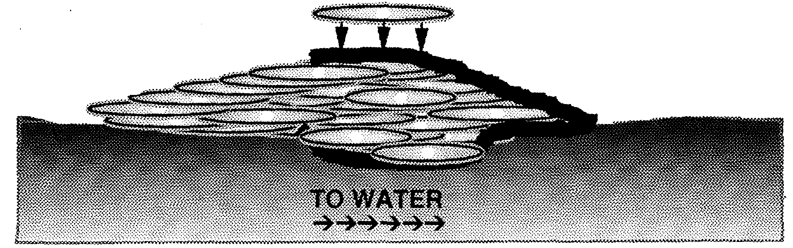

Sandbagging Manholes and Sand Boils

Do not place sandbags on manhole covers! Ring manholes with sandbags and allow the water to seek its own level.
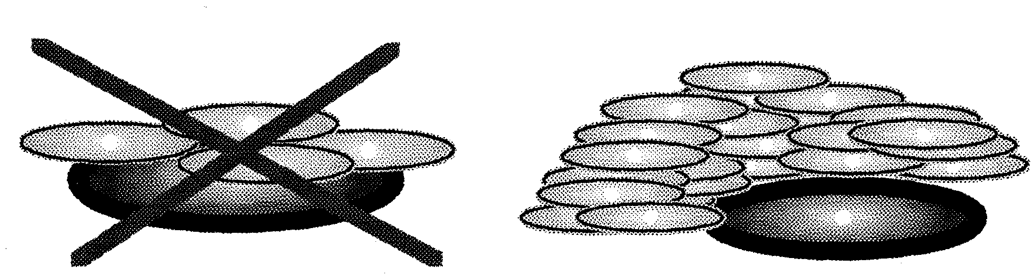

Ring sand boils with sandbags to reduce water flow and stop sand and soil movement. Do not attempt to completely stop the water flow.

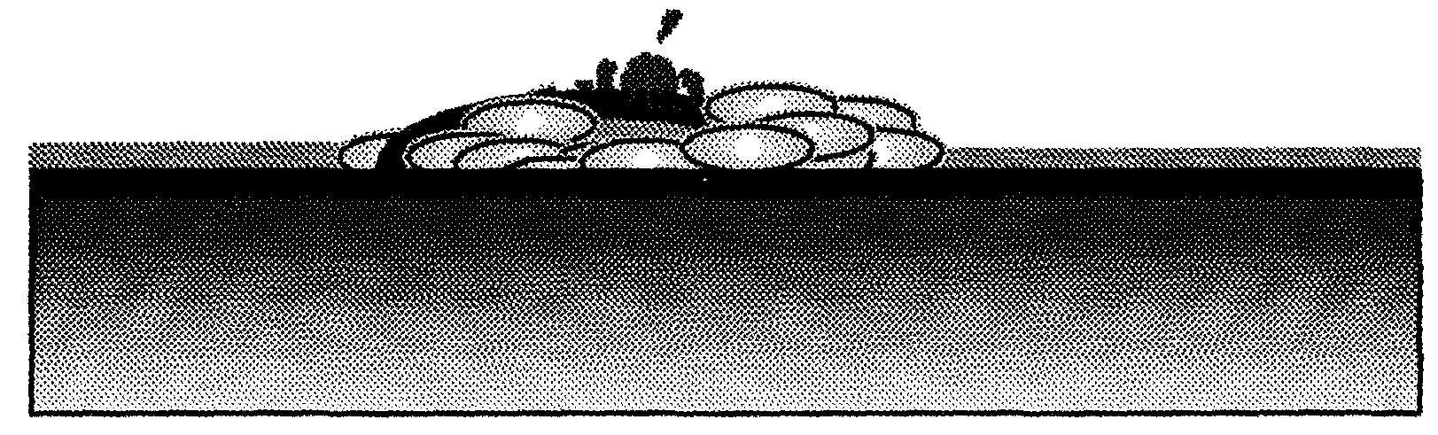

Illustrations from Federal Emergency Management Agency’s Expedient Flood Training and U.S. Army Corps of Engineers Flood-Fight Handbook: Preparing for a Flood (St. Paul)

Working with Sandbags (Continued)
Pyramid or Vertical?
Sandbags should generally not be stacked vertically. However, they may be placed one on top of another if the floodwater is not fast moving and is up to a foot high with no debris.
Related Safety Concerns
- It is impossible to tell if water in a sand boil is dirty or clean, so boils should always be treated as dirty.
- Be cautious when working on levees; barriers may break.

Sandbagging Activity
Purpose: This exercise allows you to practice filling and moving sandbags and constructing a sandbag barrier. Everyone will have an opportunity to practice each skill involved in the sandbagging process.
Instructions:
- The class will be divided into teams of two.
- Each team must fill 10 sandbags – five per team member – with one team member holding the empty sandbag on the ground and the other team member using a shovel to fill the sandbag.
- After each team has filled 10 bags, bring your filled sandbags to a communal stockpile. Be sure to lift sandbags with your knees, not with your back.
- You will then form a diagonal-pass line to practice moving sandbags.
- At the end of the line, place the sandbags to form a barrier, as specified by your instructor.
- You should periodically rotate your positions along the line, so that everyone has an opportunity to practice placing the sandbags.

Module Summary
Key points discussed in this module include:
- Types of floods common in the local area
- Relevant concepts from CERT Basic Training
- Remember onscene management and the ICS structure.
- Personal safety is paramount.
- Conduct medical assessment and treatment.
- Types of floods and flood watches and warnings
- Emergency management system response to floods
- Flood response supplies, operations, equipment
- Flood realities and dangers
- How to fill and move sandbags safely and correctly
- How to build a sandbag barrier safely and correctly

Sources for Additional Training and Information
You can access the following Web sites for additional information on flood response procedures:
- www.ag.ndsu.edu/disaster/flood.html
- www.ready.gov/floodawareness
- www.redcross.org/en/prepare/events
On the next few pages, you will find a glossary of flood response terms and two OSHA fact sheets: Cleanup Hazards and Flood Cleanup.

Glossary of Terms
Flood categories:
Coastal: Occur from tidal surges and flash flooding; are often produced by hurricanes and other large storms.
Overland floods: Occur when significant rainfall, sometimes combined with snow melt, causes a river to overflow waterway banks and levees.
Flash floods: Usually result from intense storms dropping large amounts of rain in a brief period; may occur even without rain in the immediate area, if rain causes flooding upstream.
Ice jams: Occur when ice sheets break apart, pile up, and form obstructions along rivers in colder climates.
Flood crest: Maximum height of floodwaters.
Flood patrols: Teams, usually groups of three, that patrol the flood works and keep an eye out for developing problems.
Floodplain: Any land area susceptible to being inundated by floodwaters from any source.
Floodwaters: The waters of a flood.
Jersey barrier: A concrete barrier originally developed as a highway median. Also called Jersey wall, Pennsylvania separator, traffic divider, and K-rail.
Levee: A natural or artificial slope or wall to regulate water levels. It is usually earthen and often parallel to the course of a river or the coast.
National Weather Service watches and warnings:
Flood Watch: National Weather Service notice that flooding is possible. Tune in to NOAA Weather Radio, commercial radio, or television for information.
Flash Flood Watch: National Weather Services notice that flash flooding is possible. Be prepared to move to higher ground; listen to NOAA Weather Radio, commercial radio, or television for information.
(continued)

Flood Warning: National Weather Service notice that flooding is occurring or will occur soon; if advised to evacuate, do so immediately.
Flash Flood Warning: National Weather Service that a flash flood is occurring; seek higher ground on foot immediately.
Poly: Polyethylene that provides a water barrier for sandbag levees.
PPE: Personal Protective Equipment. For flood response it includes appropriate dress for the weather, gloves, goggles, and personal flotation devices if working near water.
Sand boil: Along a river levee, a "sand boil" can be formed by a difference in hydraulic pressure between the water the levee is holding back and saturated ground on the other side of the levee.
Sandbag: A sack made of burlap, polypropylene, or other materials that is filled with sand or dirt and used for flood control.
Sandbag barrier: An artificial levee made of sandbags.

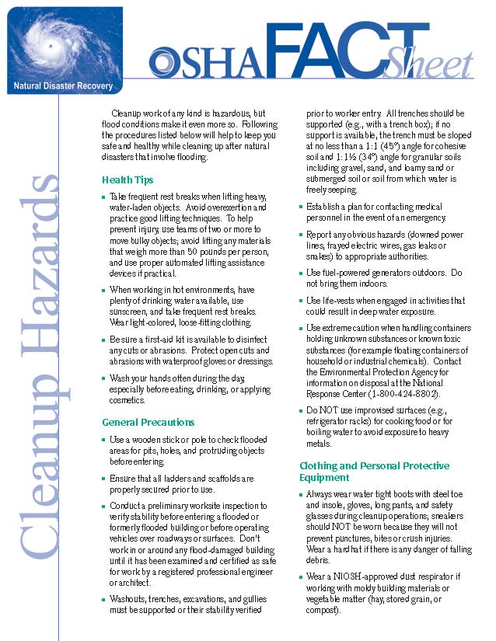
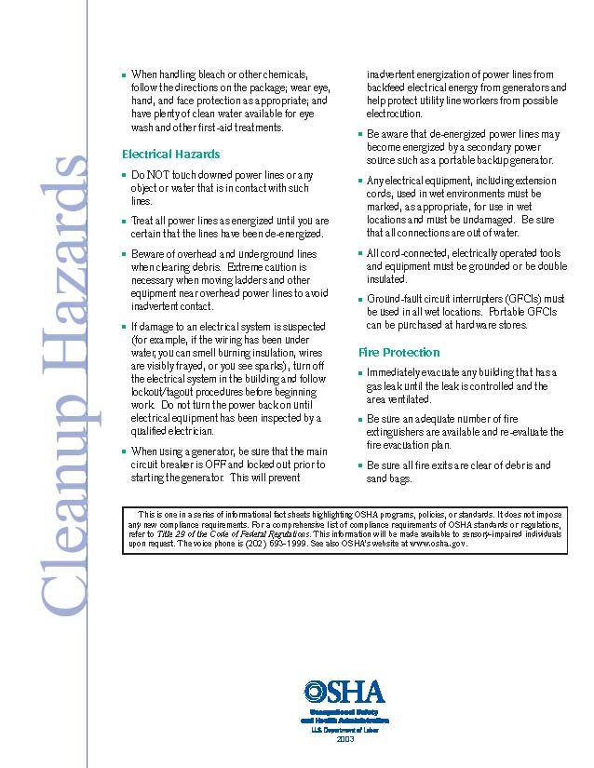
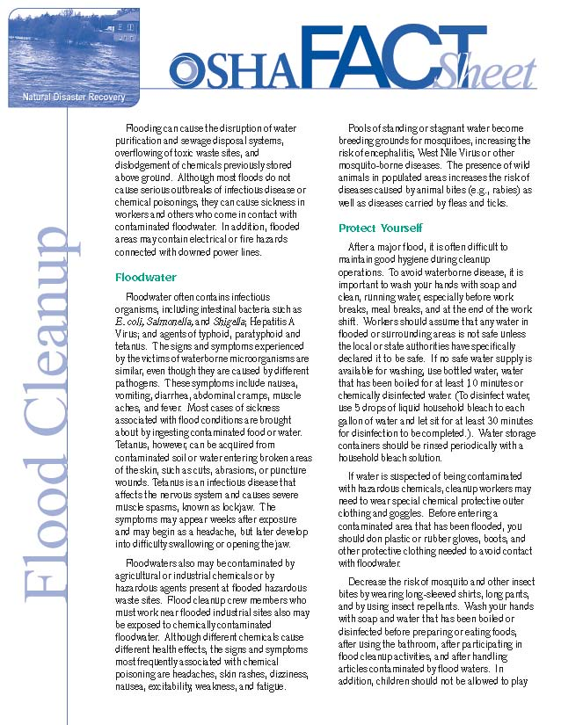
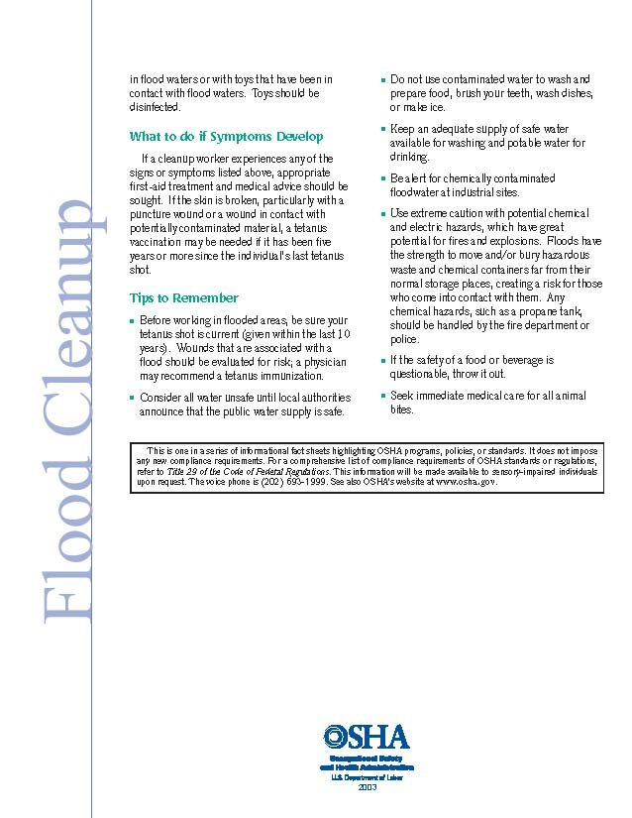

Sources
- Arizona Flood Response document
- Federal Emergency Management Agency’s Expedient Flood Training Instructor Guide and Participant Materials
- Occupational Safety and Health Administration Flood Cleanup and Cleanup Hazards fact sheets
- U.S. Army Corps of Engineers Flood Fight Design and Planning Workshop Agenda and Overview
- U.S. Army Corps of Engineers Flood Fight Design Guidelines
- U.S. Army Corps of Engineers Flood-Fight Handbook: Preparing for a Flood (St. Paul)
- U.S. Army Corps of Engineers PowerPoint presentation (Seattle)
- U.S. Army Corps of Engineers sandbagging brochure (Seattle)
- University of Missouri Extension sandbagging demonstration video

[This page intentionally left blank]

