CERT Emergency Communications

In this module you will learn about:

- The role of CERT in emergency communications
- How to use a communications plan
- Communications modes and technologies, including different phone and radio types
- An overview of basic two-way radios and how to use them
- How a CERT member participates in Net Operations
- Radio discipline techniques to encourage effective communication
- How to use tactical call signs
- How to make a call on a radio
- Proper radio use techniques

[This page intentionally left blank]
Objectives | At the conclusion of this module, the participants will be able to:  - Describe the importance of communications in emergency response.  - Describe the role of CERT in communications during an activation.  - Describe how to use an emergency communications plan.  - Describe the local jurisdiction communications plan.  - Describe the local CERT Communications Plan.  - Identify communications modes used in emergency response.  - Identify the advantages and limitations of different communications modes.  - Identify general regulations regarding various radio services.  - Describe how to properly communicate using communications devices.  - Describe the function of Net Operations in communications.  - Identify techniques for effective radio discipline.  - Describe tactical call signs and their purpose.  - Use tactical call signs and pro-words to make and acknowledge a call.
Scope | The topics that will be discussed in this unit are:  - Introduction  - The role of CERT communications during an activation  - Communications plans  - Communications modes  - Basic radio anatomy  - Communications operations
Estimated Completion Time | 4 hours
Training Methods | The instructor should begin by explaining to participants the essential role of communications during an emergency. The instructor should include examples of how communications played a part during an emergency that the participants may have firsthand experience with. Take an opportunity to ask the participants about how they may have seen communications play a role in emergency response. The instructor should keep this discussion brief and follow it with an overview of the module.  The instructor should next discuss the role of CERT emergency communications during an activation. This is a broad topic and should be customized to reflect the sorts of activities the CERTs are likely to be involved in. The instructor should highlight the fact that communication is a safety issue.  Next, the instructor should discuss the communications plan. The instructor should begin by describing the local jurisdiction’s communications plan, and then go on to describe the communications plan for CERTs. This information should be kept to a level of “what a volunteer needs to know to do his/her job.” Participants will then do group activities to reconstruct how a communications plan works.  The instructor will then move into a discussion of communications modes. The instructor should cover each mode briefly and then focus on those methods likely to be used by the CERTs. It is critical that this lecture remain non-technical to help assure that the information will be conveyed effectively to all participants.  The instructor should hand out radios to the class (if available) so that the participants can learn basic radio anatomy. The instructor should review the basic components on the radio (those components that will appear on any radio) and discuss battery use. The participants should take some time to familiarize themselves with the radios.  The next topic is communications operations. The instructor should begin by describing Net Operations and the role of the Net Control Operator. Next, the participants will break into groups and complete a Net Operations scenario. The instructor should then discuss good radio discipline and explain how to use tactical call signs. The instructor should cover how to make and acknowledge a call. Participants can practice making and acknowledging calls using tactical call signs.
Training Methods (continued) | The instructor should then cover basic tips for effective radio use, including pro-words and the phonetic alphabet. The instructor should customize this section based upon common pro-words used and the type of phonetic alphabet used (this may vary if the CERT’s sponsor is a law enforcement organization).  Finally, the participants will engage in practical exercises where they take on different roles in a communications operation and must communicate messages using protocols, tactical call signs, phonetic alphabet, pro-words, and Net Operations.  The instructor will close with a Q&A review session, along with a discussion of where participants can go to learn more.
Instructor Guidance | - CERT Program Managers may add material to this course, but should not remove any of the topics.  - Instructors must spend time customizing this course for use with their local CERTs. In particular, they must customize the sections on:  - Jurisdiction Communications Plan (Note: Slide 11 must be completed with details from the local jurisdiction’s plan.)  - CERT Communications Plan  - Recommended Communications Modes  - Be familiar with the ARRL Amateur Radio Emergency Communications Course Level 1 or the ARRL Public Safety Communications Manual.  - Keep the material non-technical.  - Be cautious not to let licensed ham operators divert discussions or run the practical exercises.  - Most participants will be familiar with one another; extensive introductions are probably unnecessary.  - Be fully aware of and prepared to describe the jurisdictional and CERT Communications Plans.  - Provide a completed ICS 205 form in the Participant Manual.  - Instructors may want to mention that none of the communications modes are particularly secure.  - Avoid recommending CBs for CERT use.  - Module invitations
Instructor Guidance (continued) | - Request that participants:  - Bring their radios and manuals (if they already own them)  - Bring their communications plan (if they have one)  Notify participants that if they do not have a radio, the class will help them determine which one is appropriate.
Resources Required | - CERT Emergency Communications PowerPoint slides  - CERT Emergency Communications Instructor Guide  - CERT Emergency Communications Participant Manuals  - Copies of local CERT Communications Plan (if one has been adopted) to hand out
Notes | A suggested time plan for this module is as follows:  Introduction 10 minutes  Role of CERT in Emergency Communications 15 minutes  Communications Plans 45 minutes  Communications Modes 30 minutes  Basic Radio Anatomy 15 minutes  Communications Operations 125 minutes  Total Time: 4 hours
Participant Prerequisites | Participants must have completed the CERT Basic Training course.
Instructor Qualifications | Instructors for Emergency Communications should have the following qualifications:  - Completion of CERT Basic Training Course  - Licensed amateur or professional radio operator  - Some instructional experience know how to not get buried in technicalities  - Familiarity with ARRL Amateur Radio Emergency Communications Course Level 1 (or book) or familiarity with ARRL Public Safety Communications Manual (free download)
Acknowledgements | The national CERT Program would like to thank the following people who participated in a focus group to develop this training module:  Robert Beckmann, Jr.  CERT Program Director  Nassau County, NY  Ken Greenhouse  CERT Liaison  Prince George’s County (MD) ARES  Sharon Kennedy  Emergency Manager  City of Hillsboro, OR  Paul Lufkin  CERT Coordinator  Office of Emergency Services  Palo Alto (CA) Fire Department  Bill Morris  Captain, Portland Fire & Rescue (ret.)  Section Emergency Coordinator, Oregon Section ARRL  State RACES Officer, Oregon  Phil Yocum  CERT Program Director  Wentzville (MO) Police Department

[This page intentionally left blank]

Instructor guidance | Content

Welcome and Introduction
Welcome the participants and introduce yourself. Briefly explain classroom logistics (breaks, class rules, etc.).
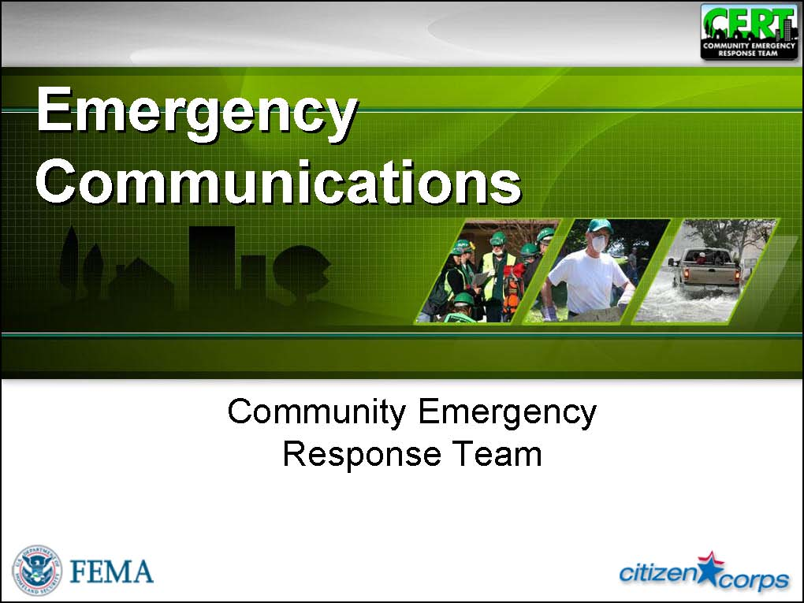  Display Slide 0 | Emergency Communications  Tell participants that emergency communications is a system of coordinating people and transmitting information to first responders during an emergency. When we talk about emergency communications, we reference several topics:  - The communication method or mode  - How the communicators organize themselves  - Techniques for effective communication in an emergency
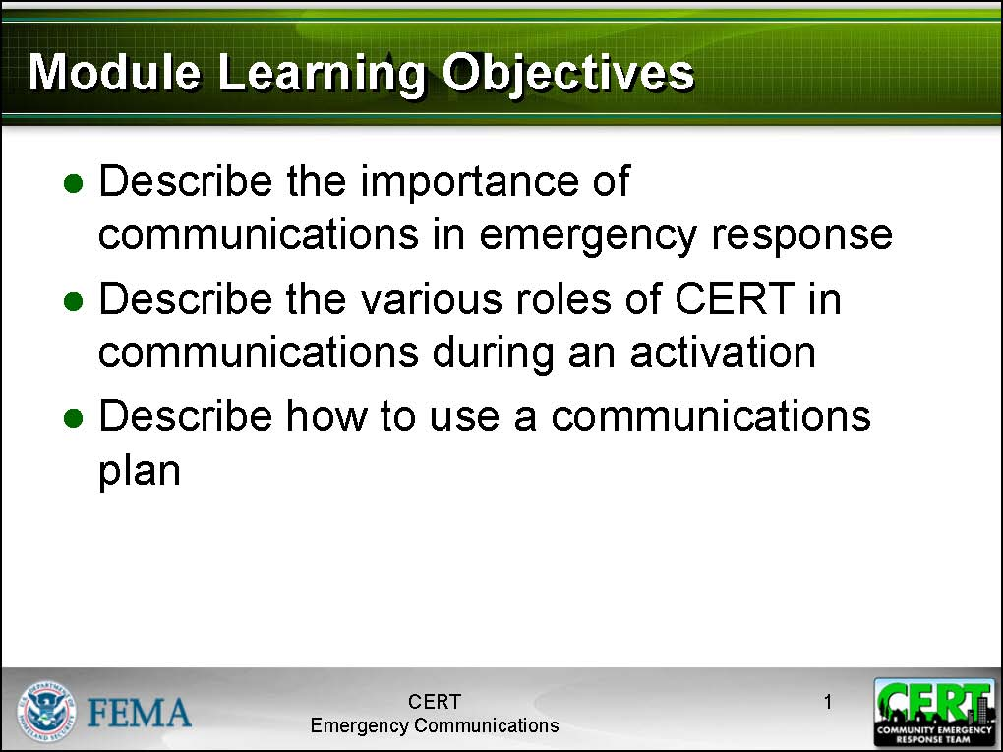  Display Slide 1  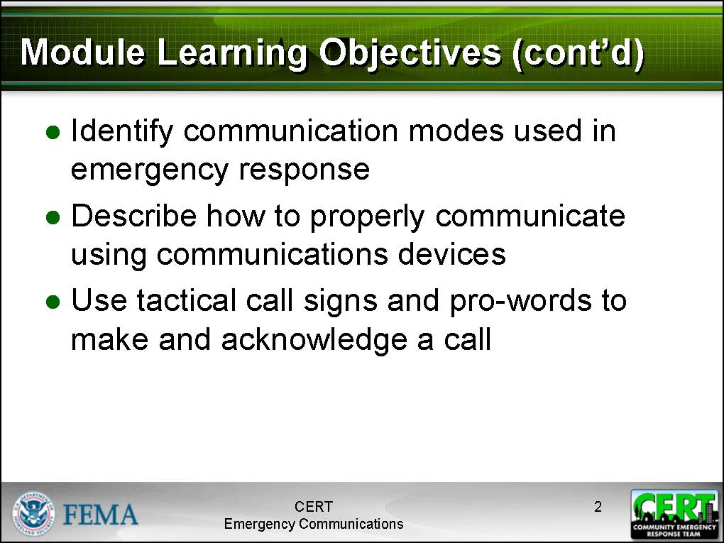  Display Slide 2 | Learning Objectives  Review the learning objectives with the participants.  - Describe the importance of communications in emergency response.  - Describe the role of CERT in communications during an activation.  - Describe how to use a communications plan.  - Describe the jurisdiction’s Communications Plan.  - Describe the CERT Communications Plan.  - Identify communications modes used in emergency response.  - Identify the advantages and limitations of different communications modes.  - Identify general regulations regarding various radio services.  - Describe how to properly communicate using communications devices.  - Describe the function of Net Operations in communications.  - Identify techniques for effective radio discipline.  - Describe tactical call signs and their purpose.  - Use tactical call signs and pro-words to make and acknowledge a call.
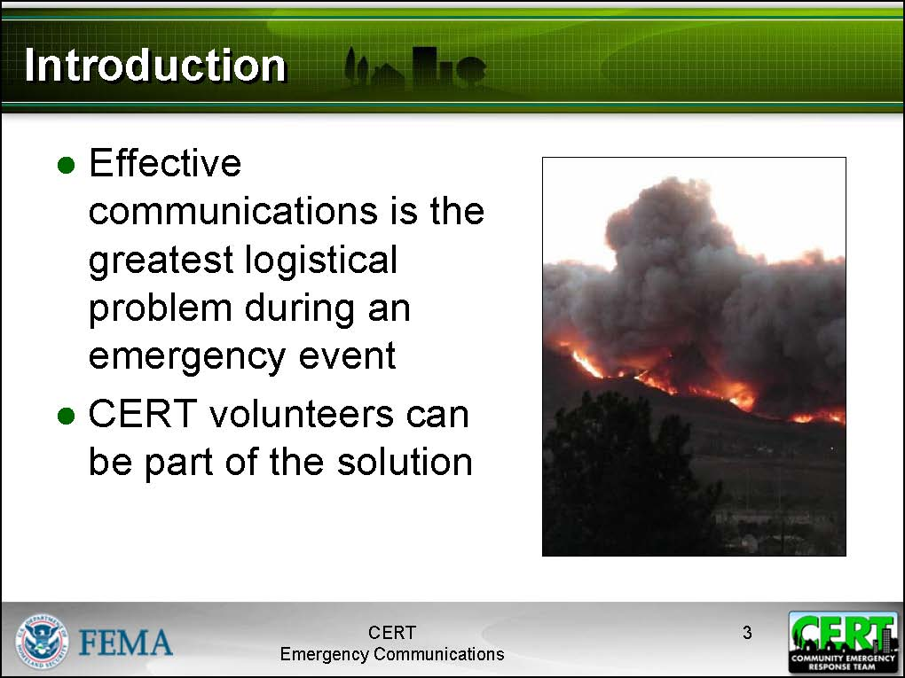  Display Slide 3 | Introduction  Tell participants that during an emergency, effective communications is one of the greatest logistical problems. Without effective communications, first responders, including CERTs, will not know where to respond or what to expect. Without well-coordinated communications, an emergency response organization will be unable to effectively coordinate its resources. Without clear communications, responders may misunderstand a situation, responding to the wrong location or responding unprepared for the actual situation. Worse, if communications fails, first responders may find themselves in danger for which they are unprepared.  Tell participants that successful communications is essential to successful emergency response, while problematic communications may actually make the situation worse.  Effective, clear, organized communications is essential in an emergency response.
 | CERT volunteers will be part of a communications network when participating in an emergency response, whether they are serving as a runner or coordinating multiple teams as a Net Control Operator. Having some basic familiarity with communications modes and techniques and an overview of how CERTs fit into the communications plan will go a long way towards ensuring that CERTs remain a part of the solution, rather than complicating the problem.
Before class, prepare a few discussion points about a local emergency response and how communications successes and failures played a role. | Communications in Disasters  Tell the participants that next you will look at the role communications played in real emergency response situations.
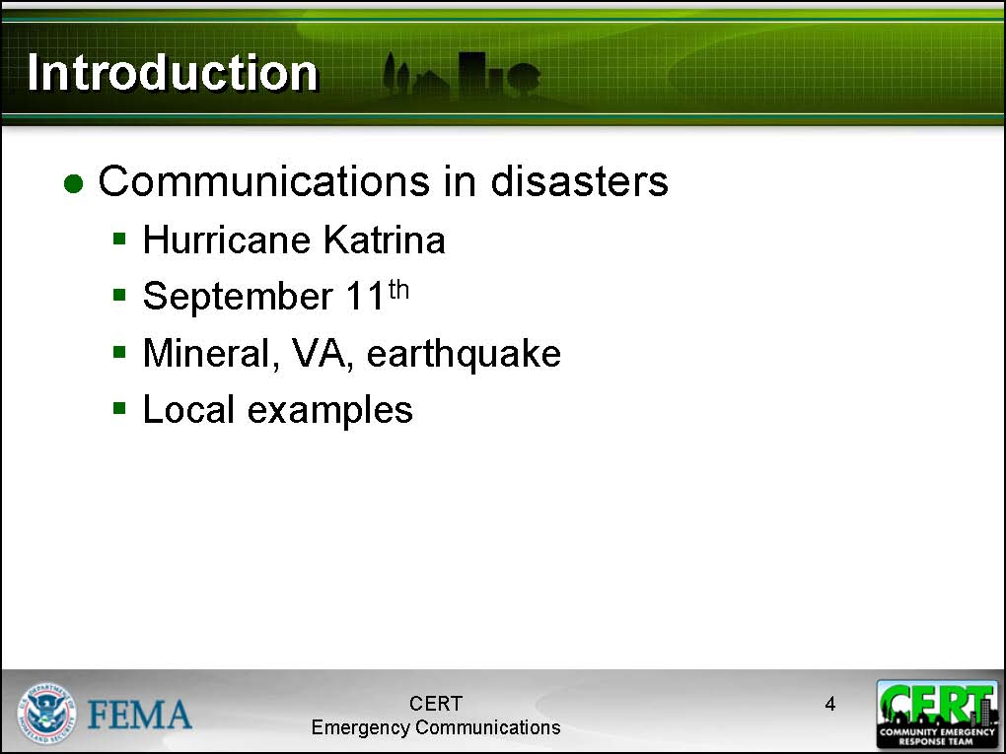  Display Slide 4 | Hurricane Katrina  Coordination of the rescue efforts on August 28-29, 2005 were hindered by failures in the local communications system. Most cell phones, landline telephones, and Internet connections were inoperable due to line breaks, destruction of base stations, or power failures.
9/11
During the terrorist attacks of September 11th, problems with emergency communications caused significant hindrances for first responders. Here are just a few of the problems:
- Firefighters in the first building were unaware the second building had collapsed.
- Volunteer first responders entered the scene without radios and thus were unable to receive updated information about the status of the buildings.
- Cell phone and landline systems were quickly overloaded, making it difficult or impossible for citizens to contact their family members.
- Conflicting instructions from 9-1-1 and public safety workers in the buildings resulted in confusion among evacuees.
- Major communications hubs were located in the towers
Mineral, VA
On August 23, 2011, a magnitude 5.8-6 earthquake 84 miles southwest of Washington, D.C. resulted in an overload of cell phone networks from North Carolina to New York. Although the quake caused no major damage, there were simply too many callers on at the same time.
Local Examples
- Provide local examples of communications in emergency response.
Ask participants about what examples they can think of. Keep this discussion brief (no more than 5 minutes).
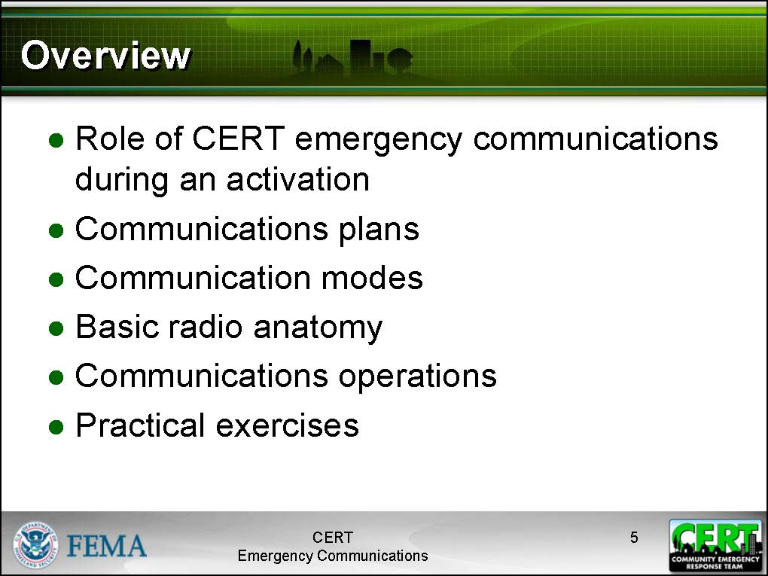  Display Slide 5 | Module Overview  Briefly discuss each topic that will be covered in the CERT Emergency Communications module:  - Role of CERT emergency communications during an activation: Participants will learn about what sorts of communications activities they may be involved with during an activation.  - Communications plans: Participants will learn what a communications plan is and how to use it. They will also learn details about local jurisdictional and CERT Communications Plans.  - Communications modes: Participants will learn about various communications modes, especially those likely to be used by their CERT.  - Basic radio anatomy: Participants will become familiar with basic handheld radios.  - Communications operations: Participants will learn effective communications techniques and how to participate in Net Control Operations.  - Practical exercises: Participants will practice radio communications using the protocols and techniques they have learned.
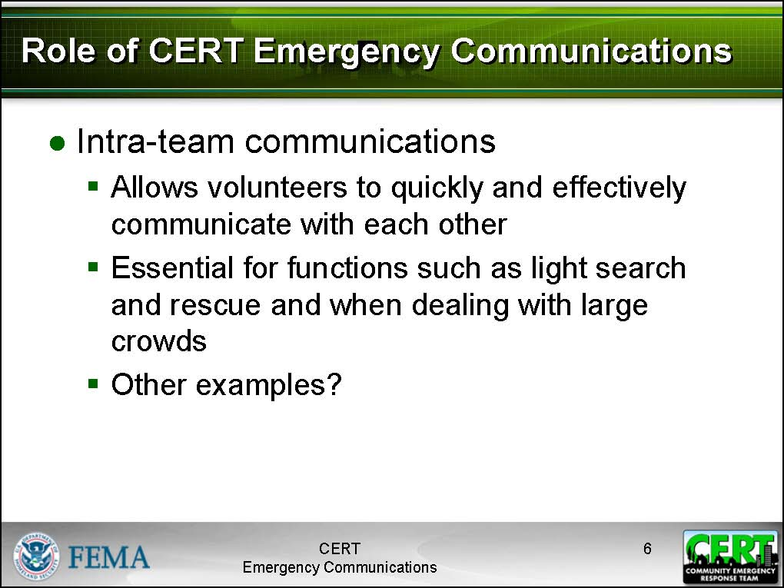  Display Slide 6 | Role of CERT in Emergency Communications  Intra-Team Communications  Tell participants that one communications function that they will participate in during an activation is intra-team communications.  Effective intra-team communications allows volunteers to quickly and effectively communicate to one another. It is a critical component of tasks such as light search and rescue.  Intra-team communications may be as simple as sending runners from one group to another or may involve the use of handheld radios and transmitting using Net Control protocols.
Record responses on an easel pad or whiteboard. Suggested responses:  - Providing an update to the CERT’s command post from an incident site  - Alerting residents by going door-to-door  - Assisting first responders directly  - Coordinating CERT groups working at different sites in the neighborhood or building | What other tasks might involve intra-team communications?
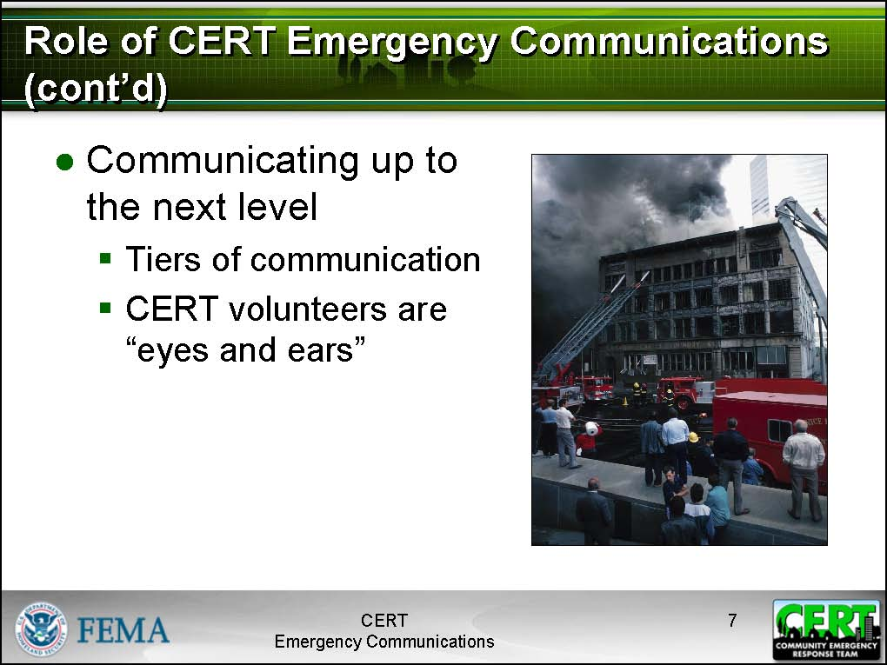  Display Slide 7 | Communicating Up to the Next Level  Explain to participants that one of the most important roles that CERT volunteers fulfill is acting as “eyes and ears.” CERT volunteers, working alongside professional emergency responders during an emergency, are expected to be able to communicate back to the professionals. In this way, the professionals can be dispatched to where they are most needed, and the CERT volunteers act as “force multipliers” for the professional responders.  However, each volunteer cannot simply radio all emergency personnel at the moment he or she needs them. This would rapidly devolve into chaos. Instead, each CERT and jurisdictional office of emergency management has its own protocols for how emergency response groups coordinate communication. This is called a communications plan, and it defines who talks to whom.
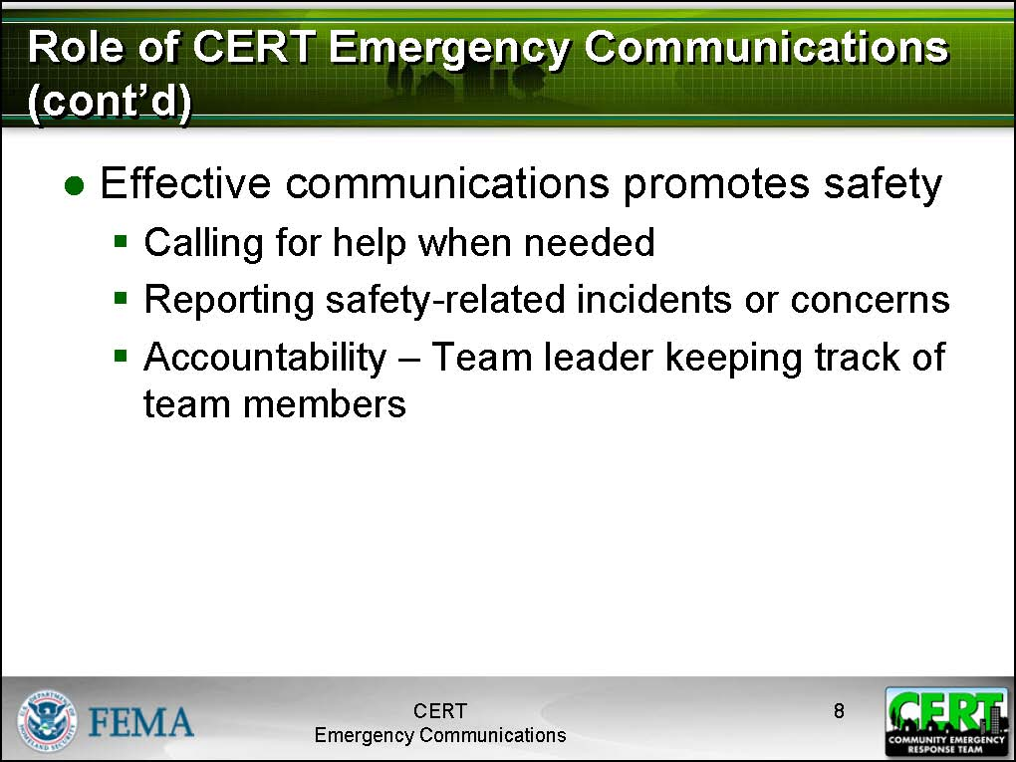  Display Slide 8 | Communications Promotes Safety  Tell participants that one of the most important functions of communications is to promote safety—both the safety of the responder as well as the safety of the individual affected in an emergency. An effective communications network allows:  - A responder to quickly call for help when it is needed.  - A responder to notify others of potential safety concerns in the area.  - A team leader to keep track of volunteers; this is called accountability.
Answers: call for help, notify others of safety concerns, accountability | What are three safety functions of communications that affect CERT volunteers?
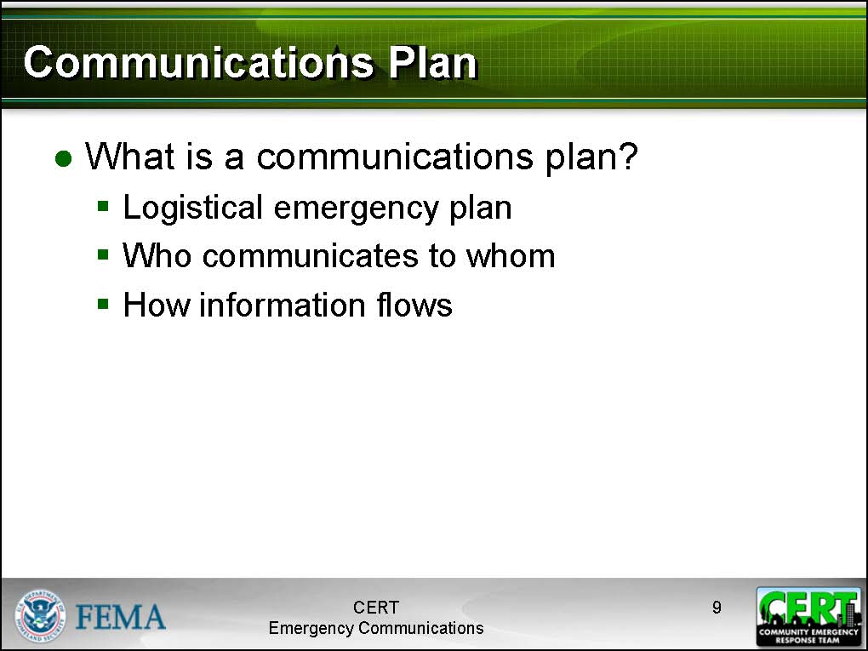  Display Slide 9 | Communications Plan  What is a Communications Plan?  Tell participants that when communicating in small groups of four or fewer, a structure is not particularly needed. However, when multiple teams work together on a larger incident, and those teams must coordinate with other emergency response organizations, we need a plan.  Explain to participants that a communications plan is a document that defines communications roles and establishes protocols for different groups during an emergency. Each community or jurisdiction will have its own communications plan.  Explain that CERTs also have a communications plan. The CERT Communications Plan is a function of the jurisdictional communications plan, and includes details such as how CERT volunteers are contacted during an activation and what radio channels they have available for communication.
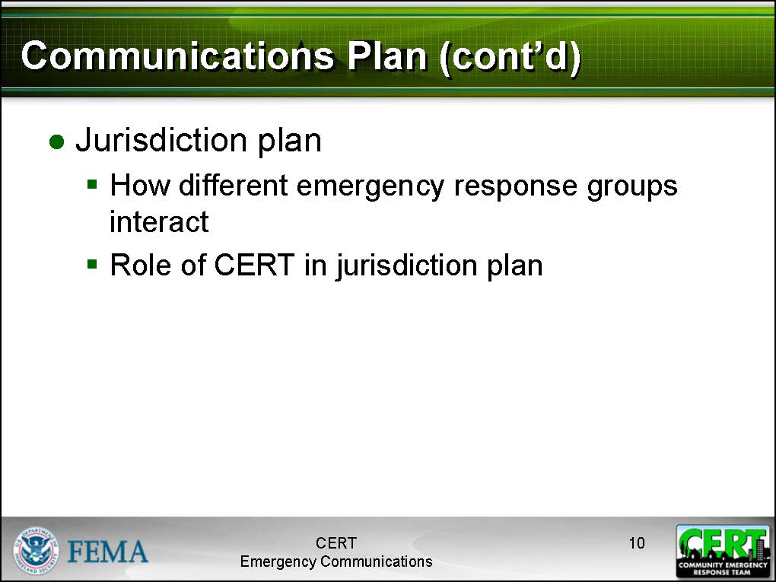  Display Slide 10 | Jurisdiction Communications Plan  A community or jurisdictional communication plan is defined by the local or regional office of emergency management. It defines what organizations use what radio channels in the event of an emergency. It also establishes clear rules for who can communicate with whom. These are necessary logistical rules in order to ensure that communications channels are not flooded and responders are not drowned in irrelevant chatter, and that communications lines are open and available when they are needed.
Prepare ahead of time by researching the jurisdiction’s communications plan. Modify the PowerPoint Slide 11 to include highlights of the jurisdiction plan.
When presenting the jurisdiction communications plan, keep it simple. Only present the information that participants need to know in order to be effective volunteers.
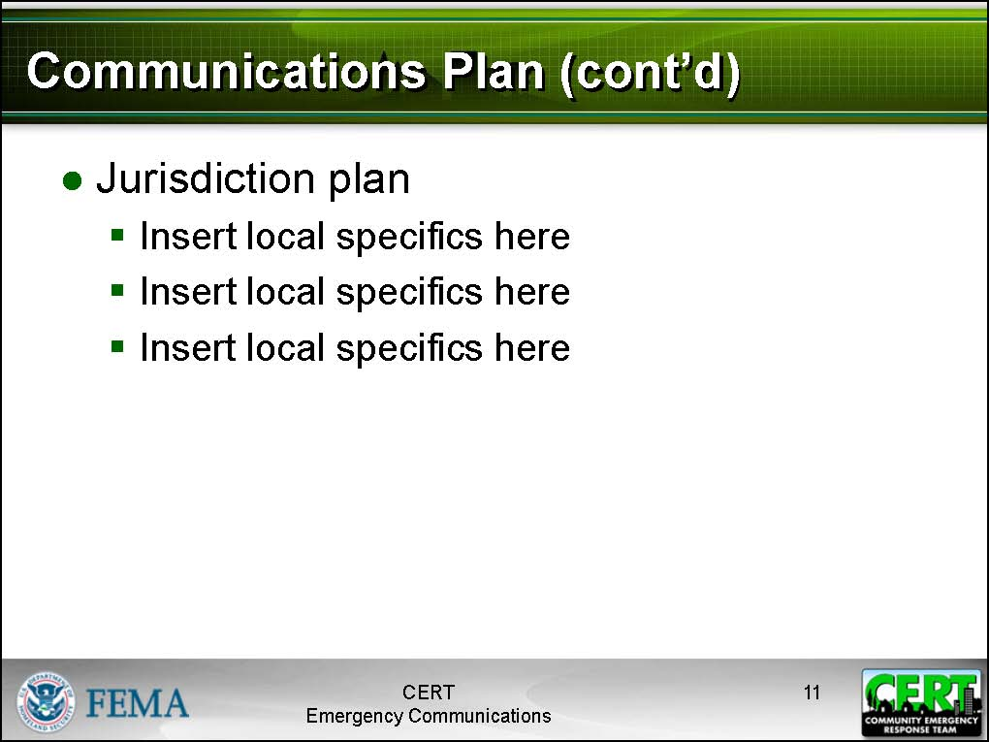  Display Slide 11 | Briefly describe the jurisdiction’s communications plan, highlighting:  - The CERT’s place in the plan  - Other important emergency responders  - How the CERT communicates with emergency responders  - The CERT’s sponsoring agency
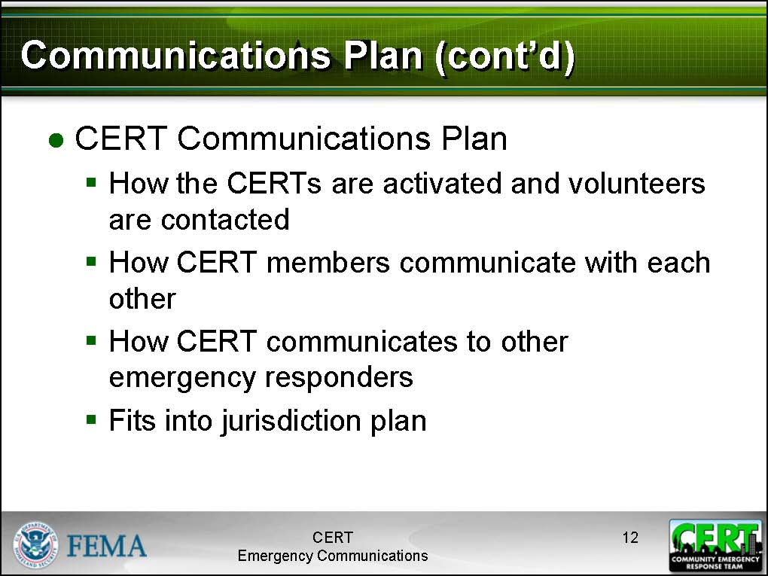  Display Slide 12 | CERT Communications Plan  Explain to participants that the CERT also has a communications plan. This plan is based on the Incident Command Structure (ICS) that they learned about in CERT Basic Training.
A brief description of a Controlled Net may be necessary at this point; this topic is detailed later in the module.  Expect to spend up to 20 minutes explaining the CERT Communications Plan to the class. | A CERT Communications Plan explains:  - How the CERT is activated and volunteers are contacted.  - How volunteers in the same CERT communicate.  - How volunteers in different CERTs communicate.  - How the CERTs communicate to other emergency responders.  - How the CERT fits into the jurisdiction plan.
Hand out copies of the local CERT Communications Plan. | Explain the local CERT Communications Plan to participants, highlighting:  - Roles they might play in communications  - How their CERT communicates with other emergency responders  - What they need to know about the local CERT Communications Plan  Ask participants if they have questions about the CERT Communications Plan.
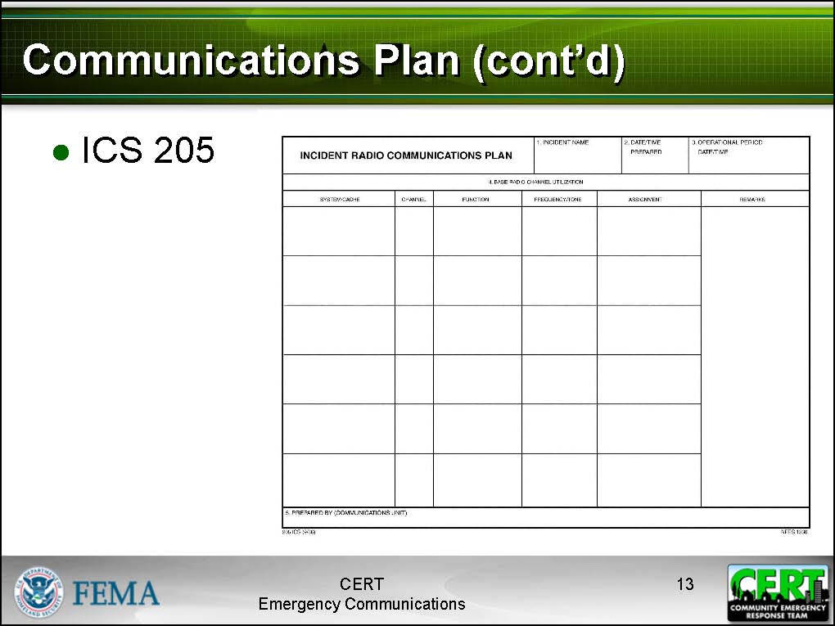  Display Slide 13 | Tell participants that an ICS 205 form is from the National Incident Management System (NIMS) and is used in an emergency to detail roles and tasks as a part of the CERT Communications Plan. Tell participants that they can see a blank ICS 205 form on page 8 of their Participant Manuals.

PM, P. 8 | ICS 205
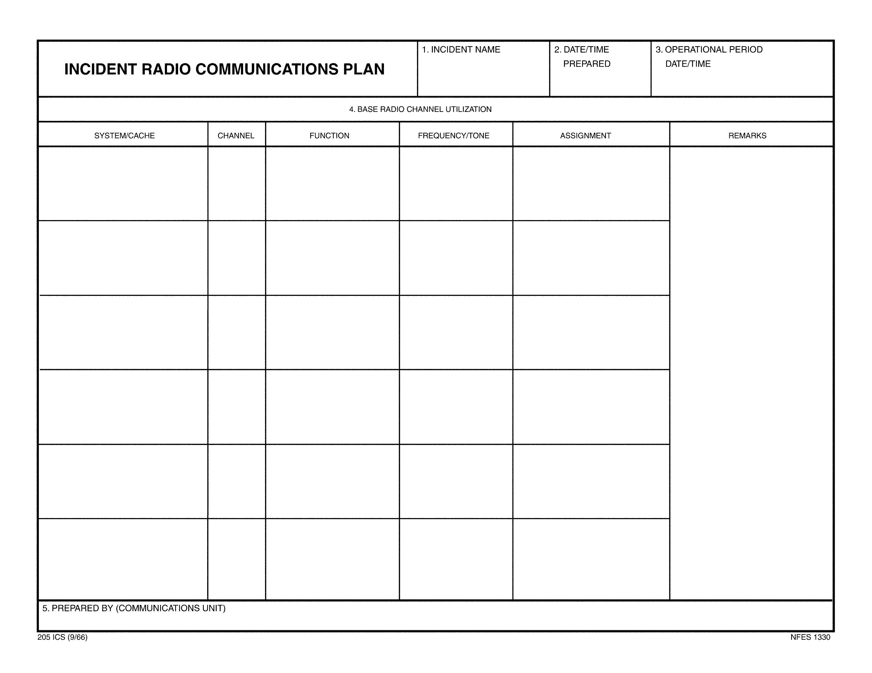

 | Instructor guidance |  | Content
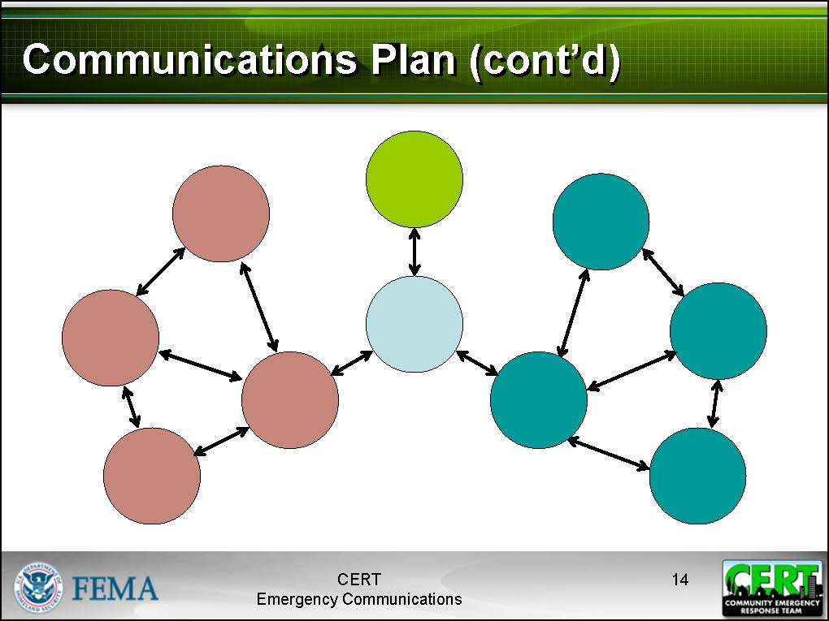  Display Slide 14  Slides 14 and 15 include a basic communications plan diagram. You may alter it to reflect your communications plan if necessary. |  | Communications Plan Diagram Activity  Explain to participants that the blank diagram that they are looking at is a scheme of the basic relationships a communications plan is meant to define. In this particular example (a very simple one), we have two response teams, A and B.  Tell participants that in this basic diagram, the light blue circle in the center represents the Command Unit.  Instruct participants to fill in the blanks on the diagram included in their Participant Manuals as the class answers the questions.
Answer: Team A Leader or Team B Leader |  | What does the red circle connected to the Command Unit represent?
Answer: Team Members for Team A or B |  | What do the other red circles represent?
Answer: Team B Leader |  | What does the teal circle connected to the light blue circle represent?
Answer: Team Members for Team B |  |  | What do the other teal circles represent?
Answer: Other emergency response agencies |  |  | What does the green circle represent?
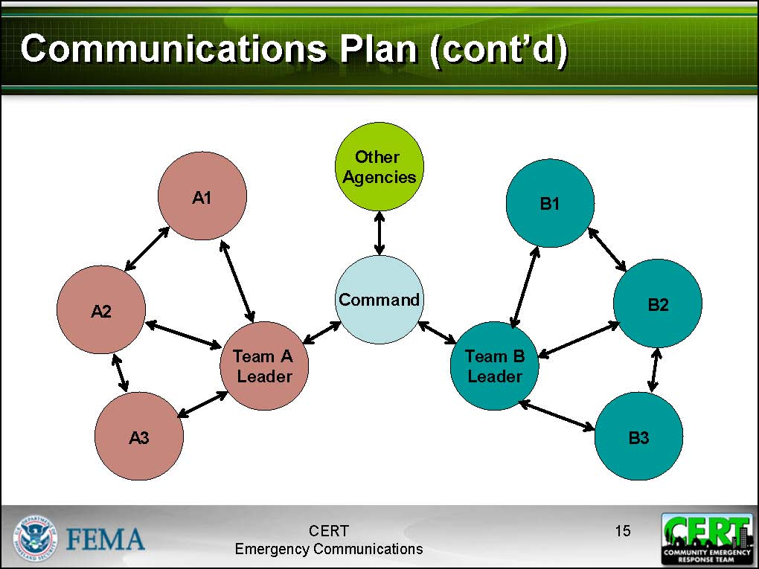  Display Slide 15 |  |  | Tell participants to look at the completed diagram. Note that while the members of each team can communicate directly with one another, only the team leader can communicate with Command, and only Command can communicate with other agencies.  Mention to participants that the Command may instruct individual team members or team leaders to contact another team or an emergency response agency directly. How this happens will be discussed later under Net Control Operations.  Ask if anyone has any questions about the CERT Communications Plan.  Explain that the next topic will cover methods and devices for communicating.
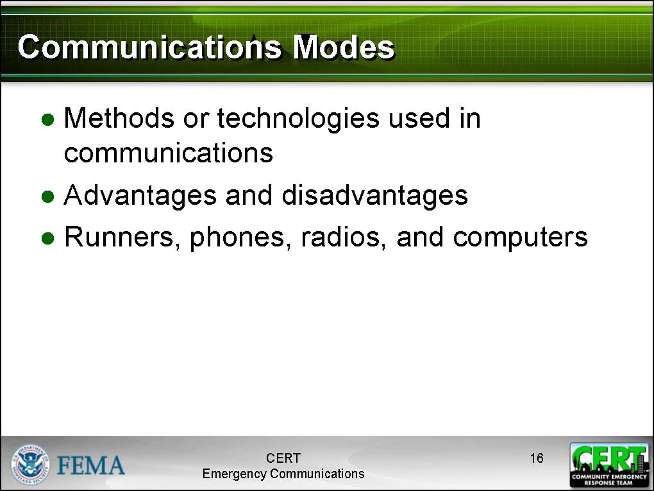  Display Slide 16 |  |  | Communications Modes  Tell participants that a communications mode is a technology or method for communicating.  Each communications mode has its own particular advantages and limitations.  A CERT will focus on the use of a few different communications modes, but it will be helpful to be familiar with all of them in the event that CERT members encounter them during an activation.  They can broadly be categorized as runners, phones, radios, and computers.  Let participants know that they can use the Communication Modes Table in the Appendix at the back of their Participant Manuals for a quick reference to the different modes of communication.
Focus extra time on the communications modes that are applicable to the local CERTs. In particular, if there is a specific type of equipment used by local CERTs, be sure to spend extra time talking about it. Be prepared to answer questions.
The other communications modes should be covered only briefly.
Impress upon participants that they do not need to go out and buy special equipment in order to be an effective CERT volunteer.
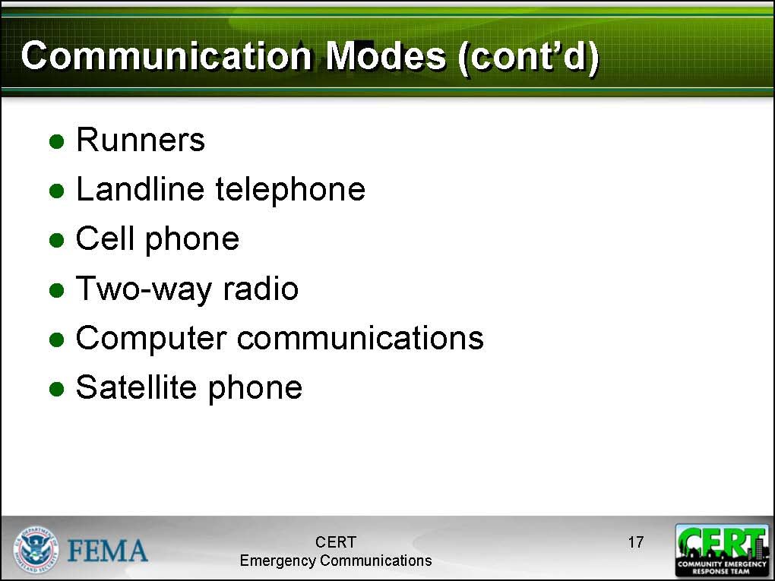  Display Slide 17  Remind participants about the “Communications Modes” table in the Appendix of the Participant Manual during this next section.  If it is relevant to the local CERTs, advise participants that none of these methods is secure. The most secure communication methods are runners and e-mail, and these are not particularly secure. |  |  | Overview  List and briefly describe the main communications modes that will be covered in this section:  - Runners: Individuals carrying written messages from one location to another  - Landline telephones: Analog and digital phones connected by physical lines  - Cellular phones: Mobile digital phones connected by signals transmitted by cellular phone towers; many are capable of transmitting lower bandwidth text messages  - Two-way radios: Handheld, mobile, or base-station radios used for communicating on radio frequencies; many require licensure by the FCC  - Electronic: Computer-based communications that may be transmitted over the Internet or with runners via USB drives, floppy disks, or CD-ROMs  - Satellite phones: Mobile phones that use signals transmitted by satellites

[This page intentionally left blank]
Communications Modes Table

Mode of Communication |  | How it works | Reliability | Availability | Advantages | Limitations
Runners |  | Volunteers carry messages from one location to another | Extremely reliable | Any reliable person can be used as a runner | - Reliability  - Flexibility  - Familiar with environment  - Availability  - No special training | - Distance and time  - Requires written information for accuracy  - Availability  - Requires familiarity with the area
Landline Telephones |  | Phones that are powered by themselves and rely on local telephone lines | - May operate during power failures, but handheld batteries can die and digital phones may or may not work  - Local telephone system generally fails when a large number of people in an area attempt to use phone at the same time | Very common | - Familiarity  - Commonplace  - Enhanced 9-1-1  - Data transfer | - Not mobile  - System overloads easily  - Network susceptible to physical damage  - May be affected by power failure
Cellular Phones |  | Phones that transmit signals relayed by cell phone towers | - Vulnerable to the same weaknesses as telephones  - Cell phone towers require electricity to operate | Very common | - Familiarity  - Mobility  - Commonplace  - Text messaging | - Towers may fail due to power outage or damage  - System overloads easily
 |  |  | - Local service (voice) generally fails when a large number of people in an area attempt to use service at the same time |  | - Requires less bandwidth – may get through when voice will not  - Camera phones | - Requires knowledge of phone numbers  - May be dependent on landlines
Satellite Phones |  | Relays transmissions via satellite. | If other phone systems are down, can only communicate locally with other satellite phones | Rare | - Always on  - Global operation | - Expensive  - Rare  - Requires visibility to sky or building with compatible antenna
Computer Communications |  | Transmits data via the Internet or by runners using USB drives or other media such as CDs | - May work when other systems are down | Very common | - May work when other systems down  - Provides electronic record  - Versatile network connections  - Relatively secure  - Large amounts of information  - Formatted/pre-formatted info  - Thumb drives and discs do not require Internet  - Information redistribution | - Equipment may not be mobile  - May require internet connectivity  - Requires specific hardware  - Expensive  - Requires power source
Two-way Radios | Family Radio Service (FRS) | Radios that transmit and receive on certain frequencies | Have a very limited range; useful only for intra-team communications | FRS only radios are common, but becoming increasingly difficult to purchase new | - Inexpensive  - Widely used  - No license required  - Range up to 1 mile  - 14 channels  - Shared communication with GMRS radios  - Best used for intra-team communications | - Hard to find  - Handheld only  - Cannot alter radio (no antennas) = limited range
Two-way Radios | General Mobile Radio Service (GMRS) | Radios that transmit and receive on certain frequencies | - Have a greater range than FRS radios  - Signals can be improved with antennas and repeaters | New GMRS only radios are not widely available for purchase | - Inexpensive  - Range of 2-5 miles  - Best for intra-team communications  - Base station or mobile  - Boost signal with external antennas or repeaters | - Requires a license (one per family)  - Intended for family use  - Some business licenses are grandfathered  - Limited availability
Two-way Radios | FRS/GMRS Hybrid | Radios designed to be operated on FRS or GMRS frequencies | - Have a greater range than FRS or GMRS radios with 22 channels available  - Have all of the advantages/disadvantages of FRS and GMRS radios because both FRS and GMRS have been combined into one radio | Commonly available; users must have a license to operate on the GMRS channels | Same advantages as FRS and GMRS, depending on which mode is used | Same limitations as FRS and GMRS, depending on which mode is used
Two-way Radios | Multiple-Use Radio Service (MURS) | Radios that can be used with repeaters and external antennas | Only 5 channels available for use | Hard to find at general commercial retail stores; more available at hobbyist stores specializing in communications. | - Handhelds or base units available  - 3-4 mile range for handhelds  - Increase range with repeaters and external antennas  - Transmit voice or data  - No license required | - Limited to 5 channels  - Limited availability  - More expensive than FRS/GMRS radios
Two-way Radios | Citizen Band (CB) | Radios that transmit and receive on public frequencies | Have 40 channels, but due to frequency they are practically useless for short range transmissions | Common | - No license required  - 40 channels | - Casual conversation  - Not reliable  - Not recommended for CERT use
Two-way Radios | Public Safety Bands | A special high-powered communication mode used by emergency dispatchers, fire fighters, EMS, police, and other government emergency responders | Extremely reliable | Limited; must be used with jurisdictional protocol | - Direct communication to emergency first responders  - Extremely reliable  - Range to 20 miles with simplex, 50 miles with repeaters  - Handheld, mobile, or base units | - Requires authorization of jurisdiction  - Expensive  - Must be used with jurisdictional protocol  - Licensed to municipality or government entity
Two-way Radios | Amateur Radio | Available in a variety of configurations; transmit using repeaters and antennas | Very reliable | Widely available | - Various data types (voice, text, data, photos, documents, e-mail, television)  - Range in excess of 100 miles with repeaters  - Operates using simplex or repeaters  - Good availability  - Moderately priced  - Handheld, mobile, and base stations available  - Reliability  - Interoperability  - More simultaneous conversations possible  - Connect to computer  - Connect to global positioning system (GPS) and automated position reporting system (APRS) | - Requires license  - No business use  - Operators cannot be paid  - Complex radios  - Complex protocols  - Must work with existing area Emergency Communications Plans

Instructor guidance | Content
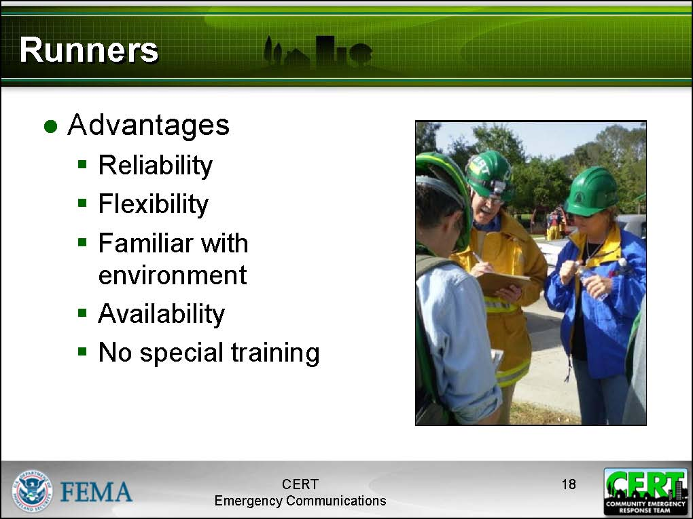  Display Slide 18  It is recommended that runners be covered in detail, as they are commonly used by CERTs. | Runners  Describe the advantages and limitations of runners to participants as highlighted on the slides.  Runners are volunteers who carry messages from one location to another. Runners are extremely reliable, since they can operate in situations that would otherwise disable other communications systems.
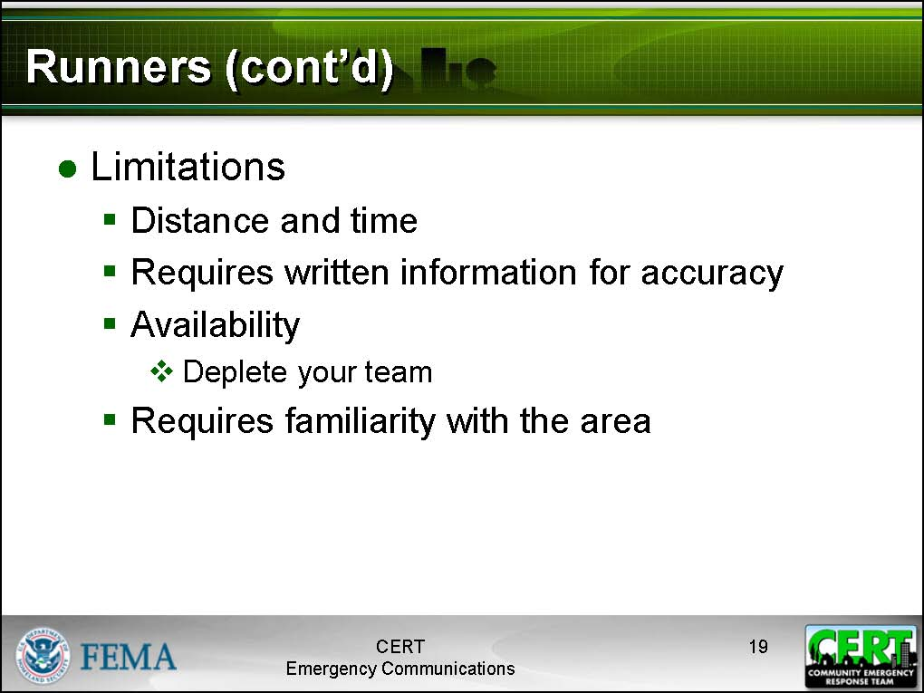  Display Slide 19 | Where possible, use emergent volunteers or people who are not doing anything else to help out as runners; otherwise you will deplete your pool of trained volunteers.  Always have runners carry written messages in order to avoid miscommunication.
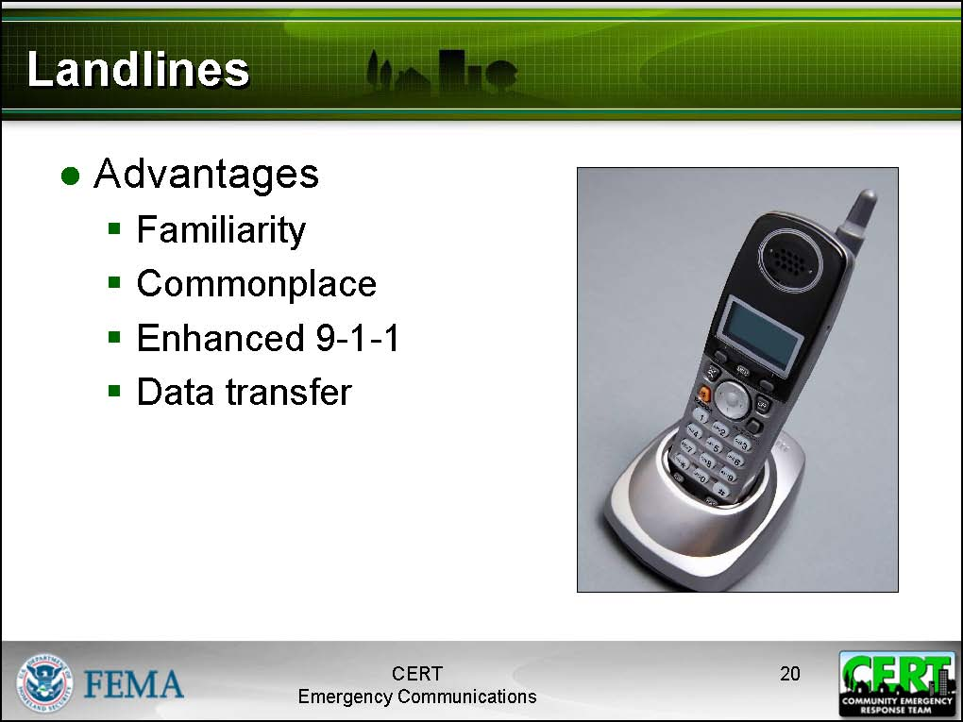  Display Slide 20 | Landlines  Describe the advantages and limitations of landline telephones to participants as highlighted on the slides.  Tell participants that land line telephones, especially analog phones, may operate during power failures, as they are powered by the phone line itself. Note, however, that handheld portable phones may only last as long as their batteries or will not work without normal power and digital phones may or may not work, depending on the model.  Many communities now have Enhanced 9-1-1, enabling 9-1-1 operators to lock onto your location by providing them your address and phone number.
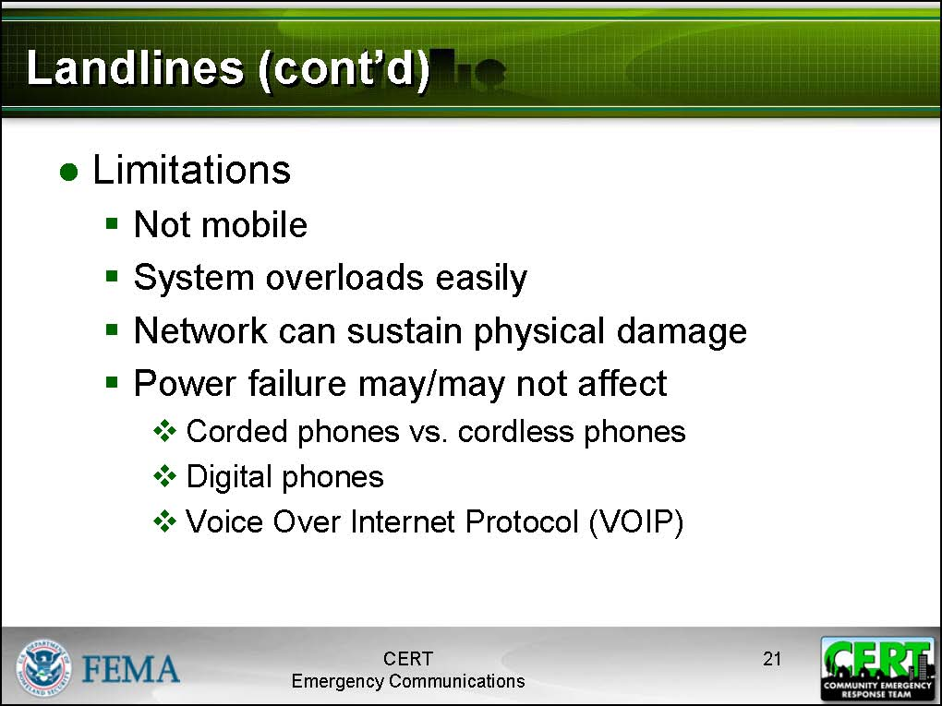  Display Slide 21 | Be aware that local telephone systems typically cannot handle a load of more than 10% at any one time. That means that if more than 10% of the people in an area attempt to use the phone at the same time, the system will overload and fail.
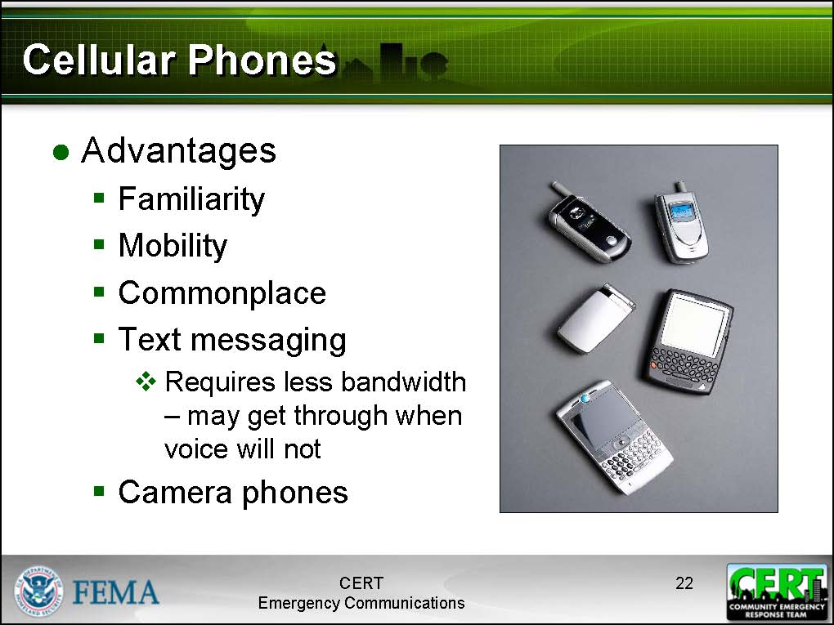  Display Slide 22 | Cell Phones  Describe the advantages and limitations of cell phones to participants as highlighted on the slides.  The greatest advantages of cell phones as communications devices are that they are commonplace and that they are mobile.  Most cell phones are also able to transmit text messages. In the event of a system overload or a weak signal, a text message may get through when a voice message will not. This is because a text message requires far less bandwidth than voice.
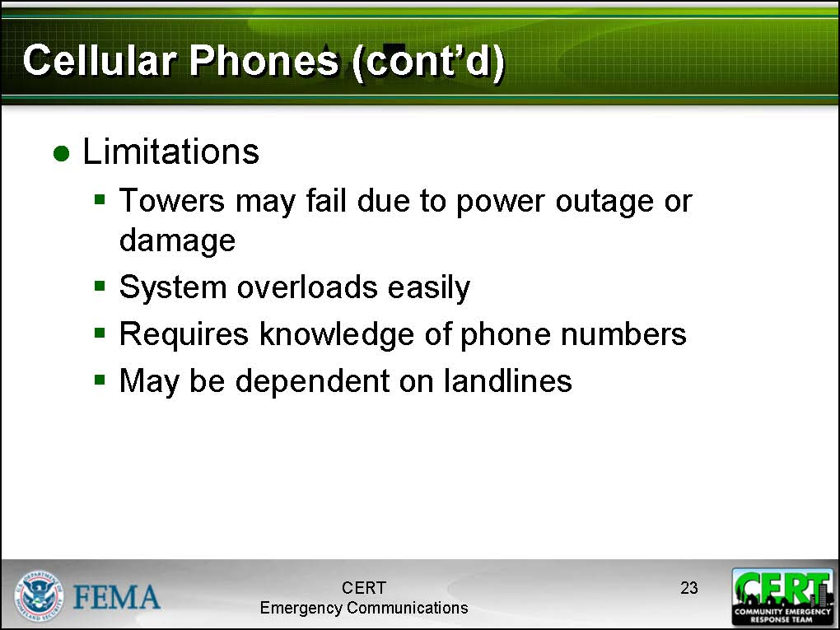  Display Slide 23 | Explain that, in contrast to common belief, cell phones do not communicate via satellites. Instead, they transmit signals as a radio does that are relayed by cell phone towers. Sometimes this involves retransmitting the signal; sometimes it involves rerouting the signal into a landline. Therefore, cell phones are vulnerable to the same sorts of weaknesses as telephones. Additionally, cell phone networks require electricity, since the towers themselves require electricity to operate.  Cell phone networks are also easily overloaded during times of high demand.  Another problem with using cell phones in emergency communications is that first responders must have each other’s cell phone numbers.  For those volunteers using cell phones during an emergency response, it is recommended that hands-free headsets and microphones be used.
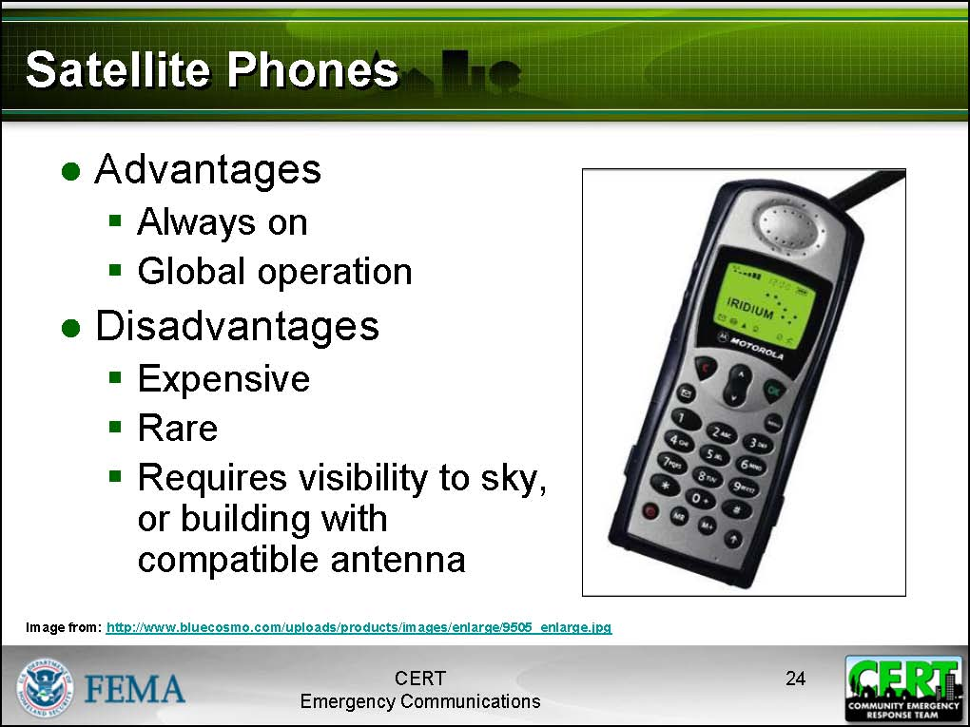  Display Slide 24 | Satellite Phones  Describe the advantages and limitations of satellite phones to participants as highlighted on the slides.  Point out that when other phone systems are down, satellite phones will only be able to communicate locally with other satellite phones.  Satellite phones are typically available to and used by large emergency responders, such as FEMA.  Satellite phones range in price from $750 to upwards of several thousand dollars and have a high per minute rate ($1.85 or more).
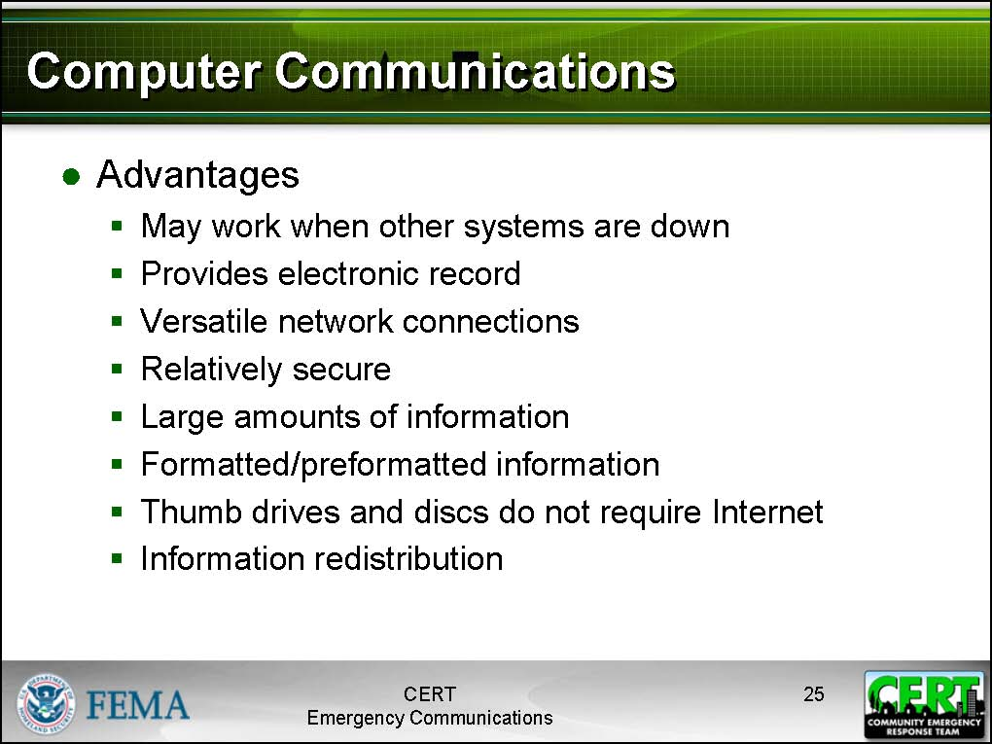  Display Slide 25 | Computer Communications  Describe the advantages and limitations of computer communications to participants as highlighted on the slides.  Computer communications includes e-mail, photos, video, audio, formatted documents, or other data transmitted via the Internet or by runners using USB drives (commonly known as “thumb drives”) or other media such as CDs.  One of the overlooked advantages to using computers for communication is the ease of mass distribution. Using e-mail, alerts, notices, preformatted documents, and other information can be sent out to any number of participants with a single click.
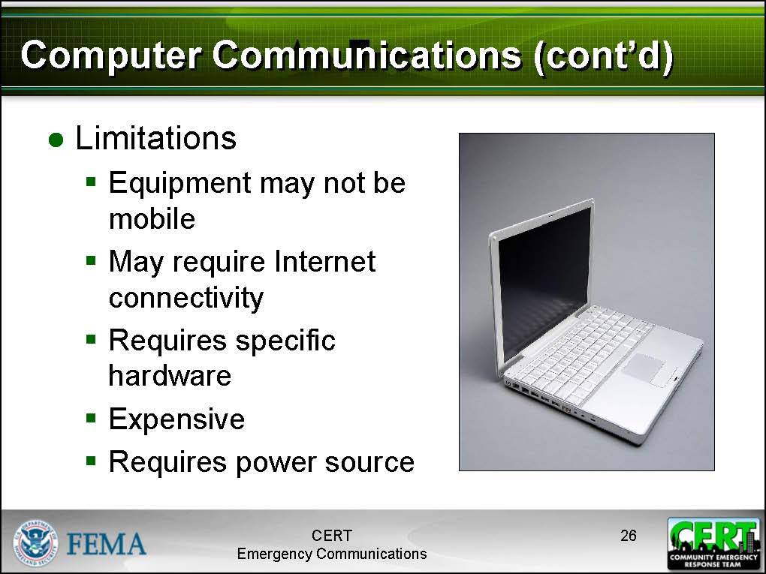  Display Slide 26 | While laptops are portable, they may not be ideal for use in emergency response situations due to their size. Also, it is worth noting that both senders and receivers have to have functioning, specialized equipment in order to communicate using computers. Receivers must also be monitoring such equipment. It doesn’t help to e-mail a team leader a photo of a dangerous situation if that team leader doesn’t have immediate access to e-mail.
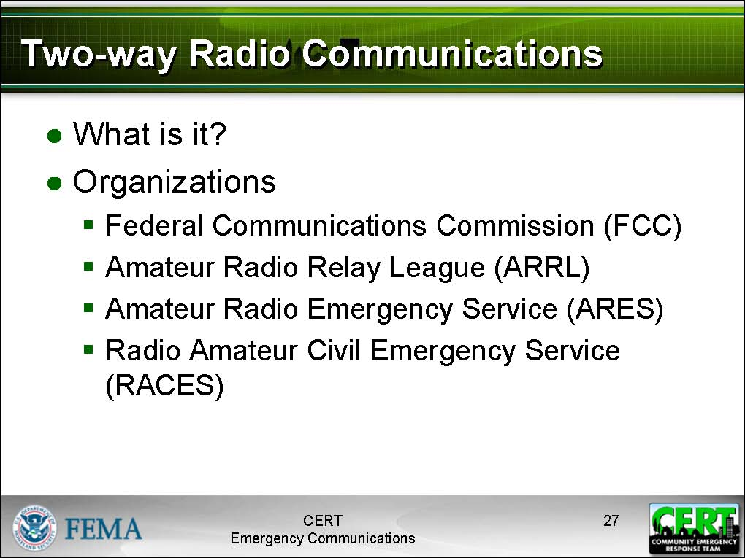  Display Slide 27 | Two-way Radio Communications  Tell participants that two-way radios include a variety of devices and are often defined by the frequencies (or channels) they are designed to operate on. Radios capable of more powerful transmissions typically require a license from the FCC.  There are several organizations involved with two-way radios that are important to know about.  - The FCC regulates licensure and allocation of frequency spectrum and bandwidths. Many two-way radios require an FCC license to use.  - The ARRL provides training and testing for amateur radio licenses and other radio emergency service functions.  - ARES operators volunteer to provide communications services via amateur radio during emergences. These operators are organized by regional coordinators to serve that function, and thus may be involved in the CERT Communications Plan.  - RACES operators perform a similar function to ARES operators, only they are specifically sponsored by the government.
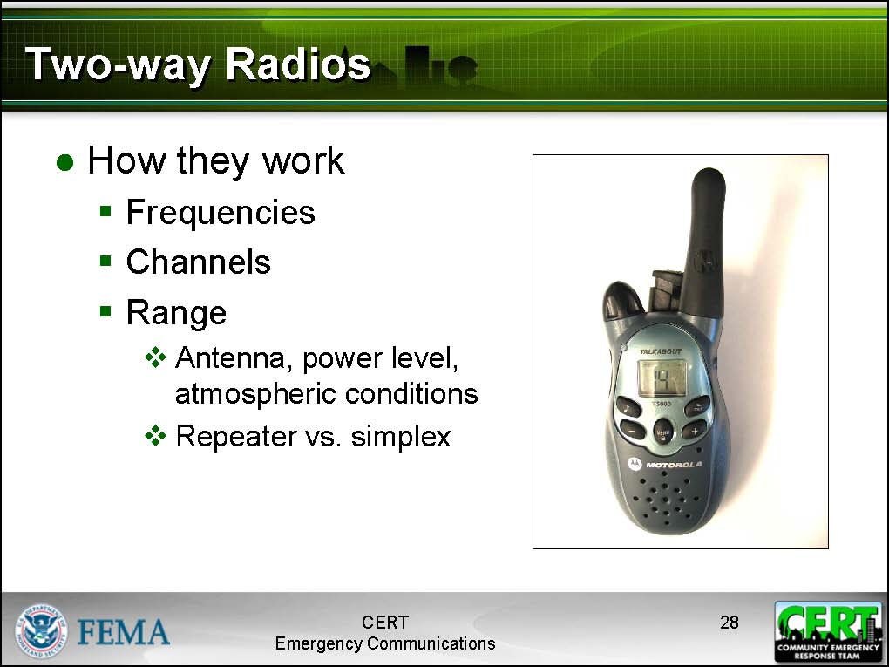  Display Slide 28 | How Do They Work?  Tell participants that two-way radios operate by transmitting and receiving on certain frequencies. No one owns or has exclusive rights to a frequency, but the FCC determines who can use them and when.  On radios, frequencies are typically divided into a number of discrete channels. Since only one person can speak on a channel at a time, more channel availability means that more conversations can happen in the area. Each team is typically assigned a channel to use as part of the communications plan.
The ranges of the radios discussed here depend on a wide variety of factors. Actual performance will depend on the area terrain and atmospheric conditions. Keep in mind that the printed claims on the box are advertising and not a guarantee of regular performance.
The range of a radio can be increased by using a better antenna or a repeater. A repeater is a regional transmitter that picks up radio signals and retransmits them, essentially extending their range.
If a radio is not using a repeater to transmit, the radio is said to be in “simplex” mode. Radios operating in simplex mode are usually limited to line-of-sight distances.
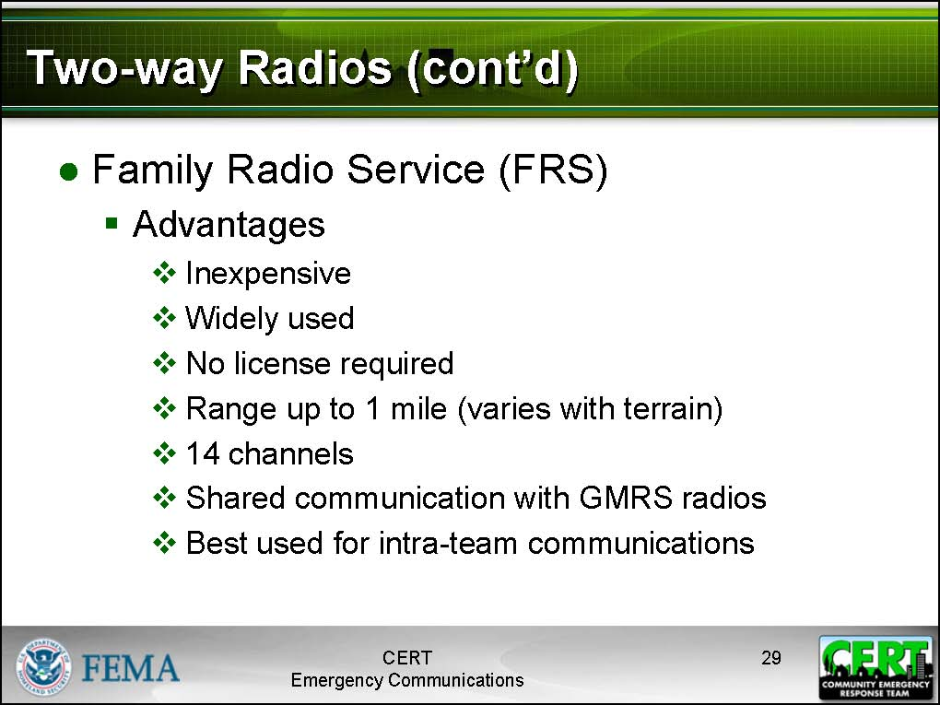  Display Slide 29 | Family Radio Service (FRS)  Describe the advantages and limitations of FRS radios to participants as highlighted on the slides.  Tell participants that FRS radios are simple, basic, two-way radios that are good for intra-team communication between CERT members. FRS radios do not require a special license by the FCC. Many people have FRS radios; however, FRS only radios are becoming increasingly difficult to purchase new. Most radios now available are FRS/GMRS hybrids (which will be covered later).
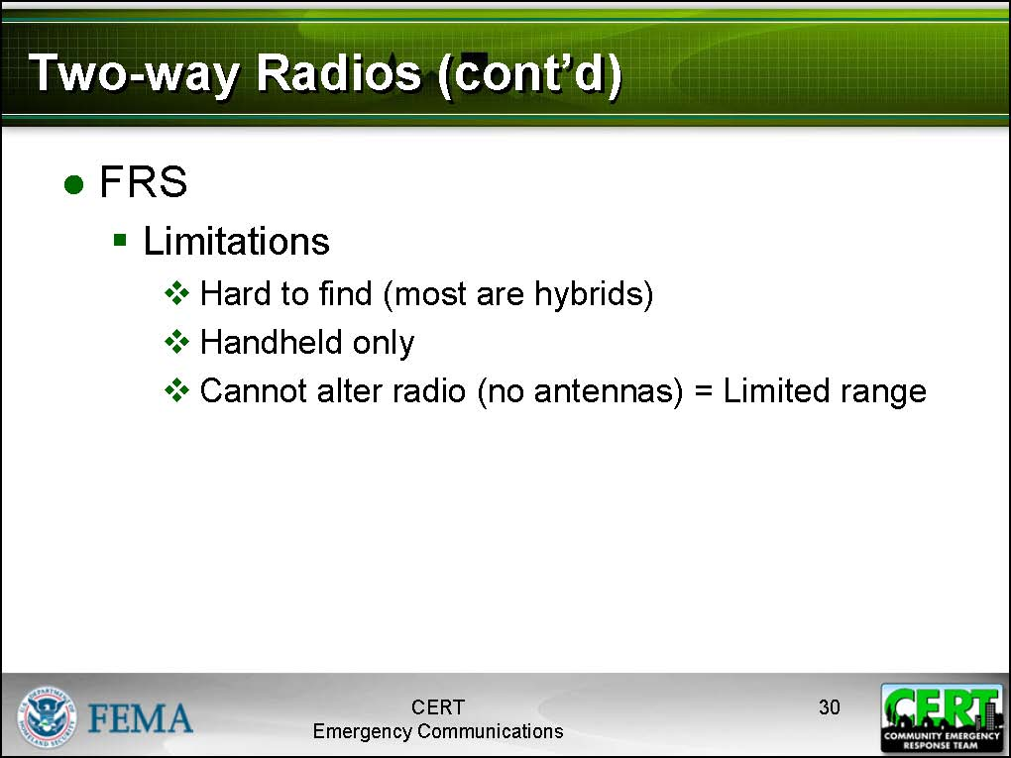  Display Slide 30 | FRS radios have a very limited range, which makes them useful only for intra-team communications. It is against FCC regulations to boost the signal of an FRS radio with a signal or repeater.
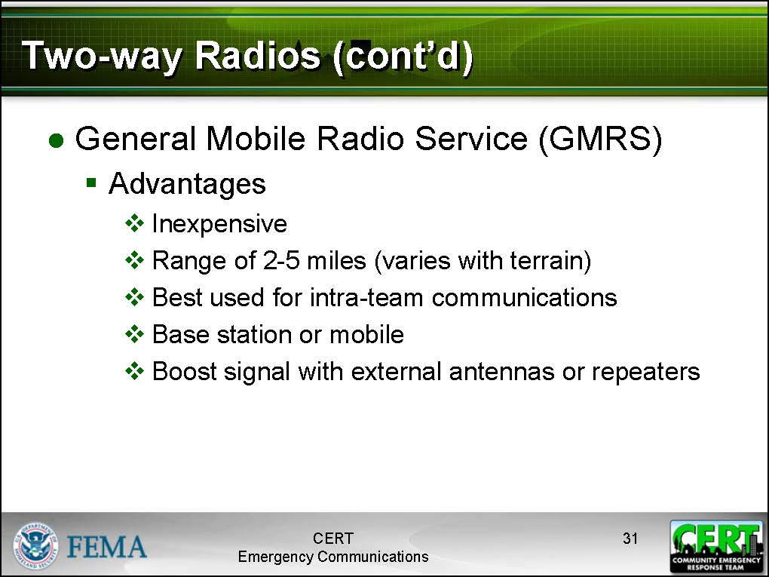  Display Slide 31 | General Mobile Radio Service (GMRS)  Describe the advantages and limitations of GMRS radios to participants as highlighted on the slides.  GMRS radios have a greater range than FRS radios, and their signals can be improved with antennas and repeaters. They are very useful for intra-team communications.
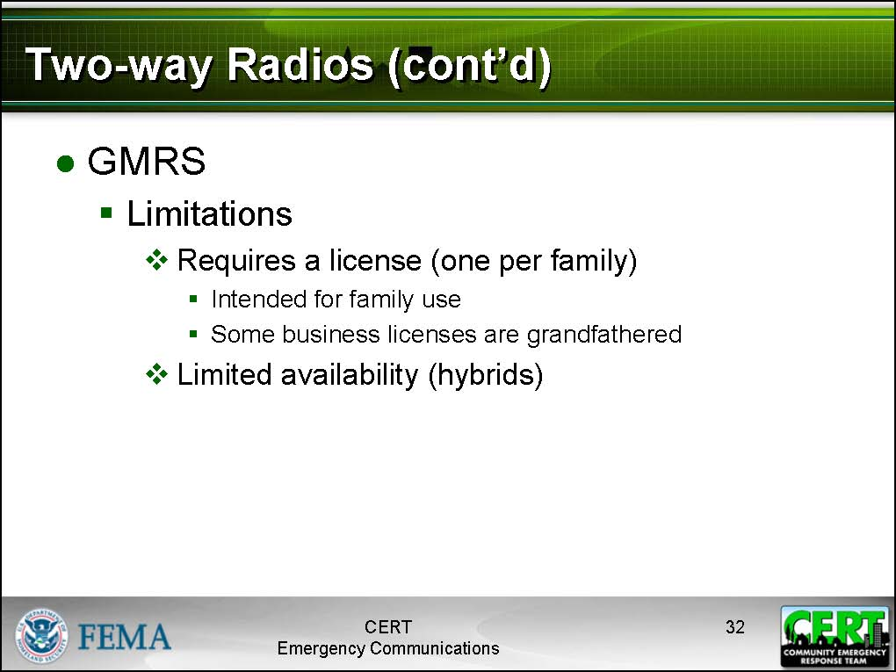  Display Slide 32 | Using a GMRS radio does require an FCC license. In addition, due to the predominance of hybrid radios in the marketplace, GMRS only radios are no longer widely available for purchase.
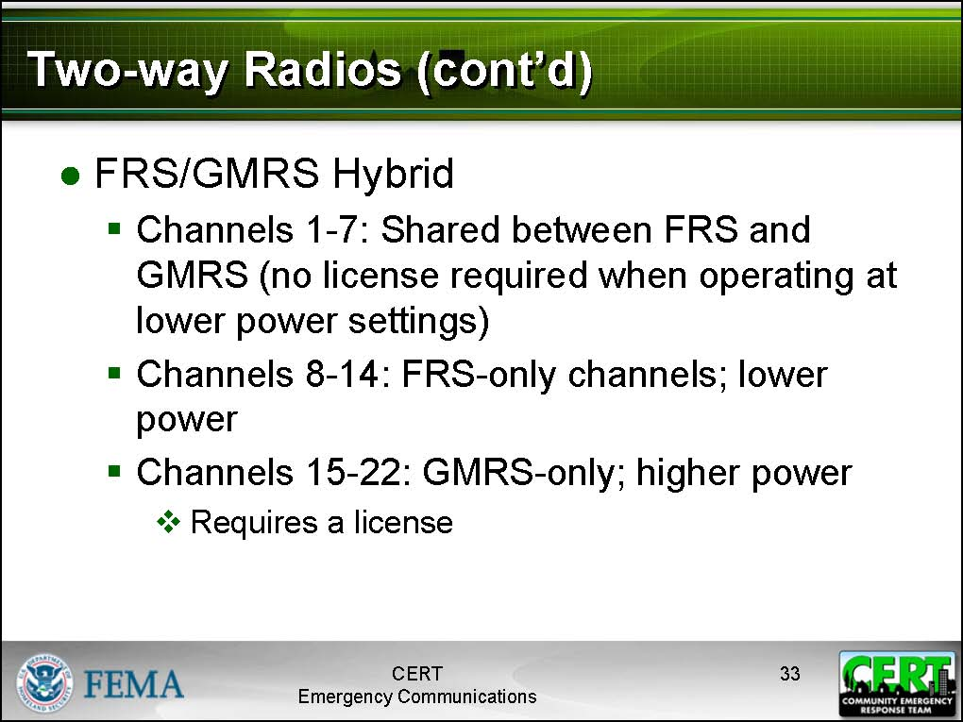  Display Slide 33 | FRS/GMRS Hybrid  Describe the advantages and limitations of FRS/GMRS hybrids to participants as highlighted on the slides.
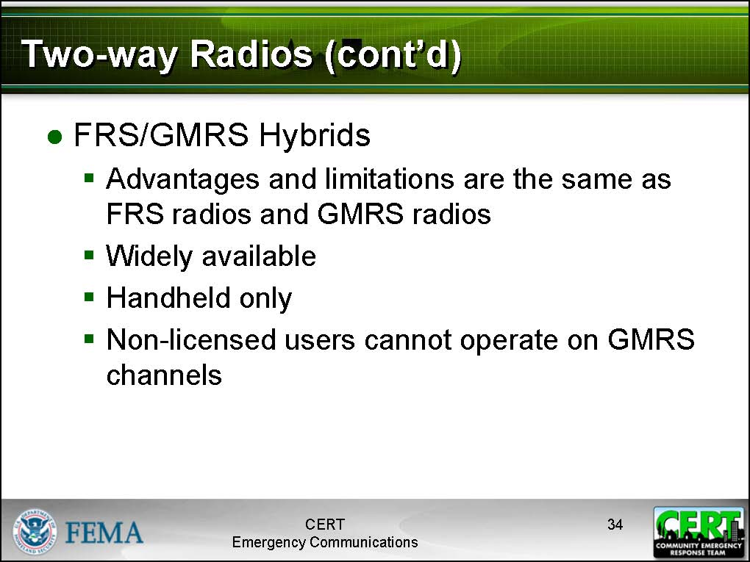  Display Slide 34 | FRS/GMRS hybrid radios are inexpensive and commonly available two-way radios. They are designed so that they can be operated on FRS or GMRS frequencies and include seven shared channels. They have all the advantages and limitations of an FRS and a GMRS radio, depending on which mode is being used.  Users must have a license to operate using the higher-powered GMRS frequencies.
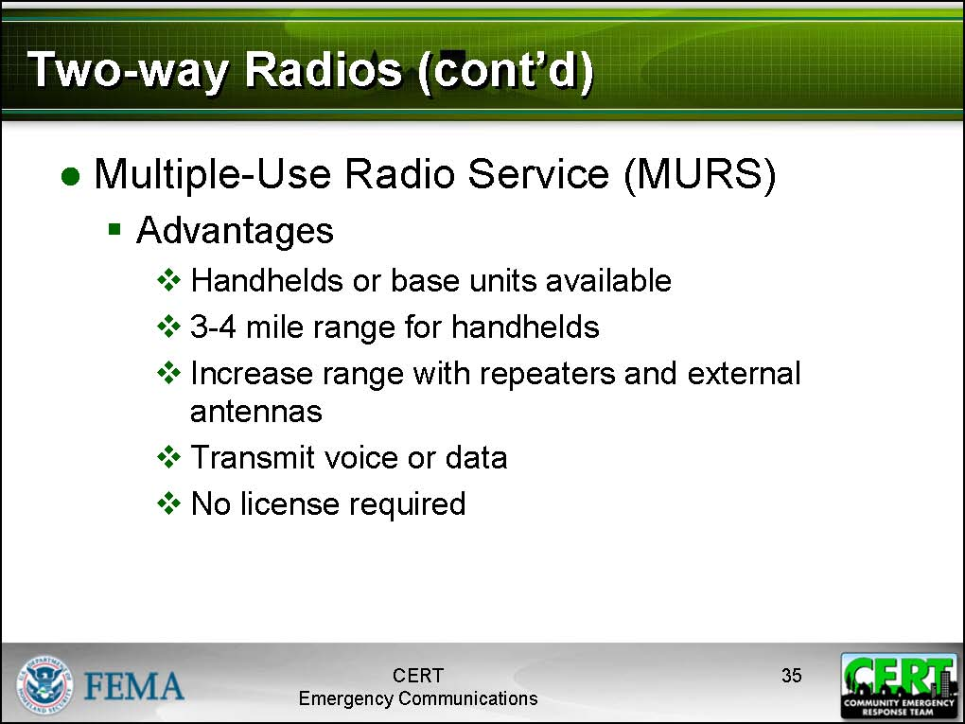  Display Slide 35 | Multiple-Use Radio Service (MURS)  Describe the advantages and limitations of MURS to participants as highlighted on the slides.  MURS radios are a newer type of two-way radio. They are more powerful than GMRS radios, they can be used with repeaters and external antennas, and no license is required for their use.
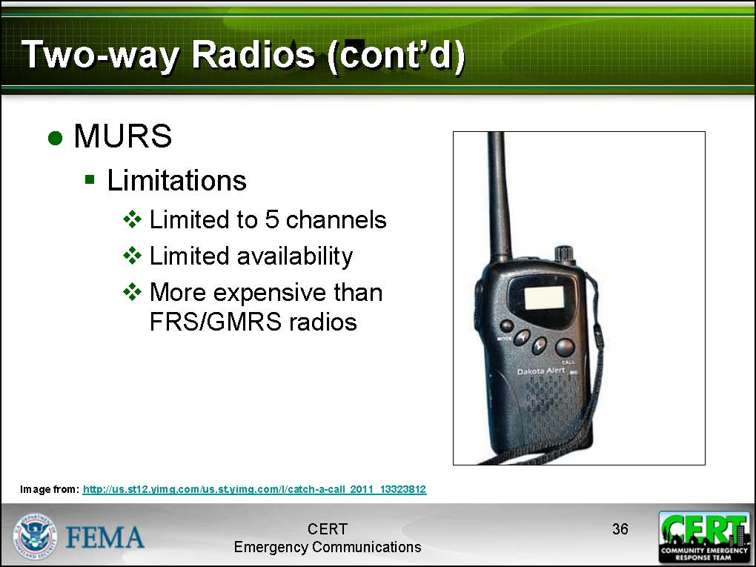  Display Slide 36 | Unfortunately, MURS radios are more expensive than FRS/GMRS radios, only five channels are available for use (as opposed to 22 on a hybrid), and not many people have them, making it difficult to communicate with other users.
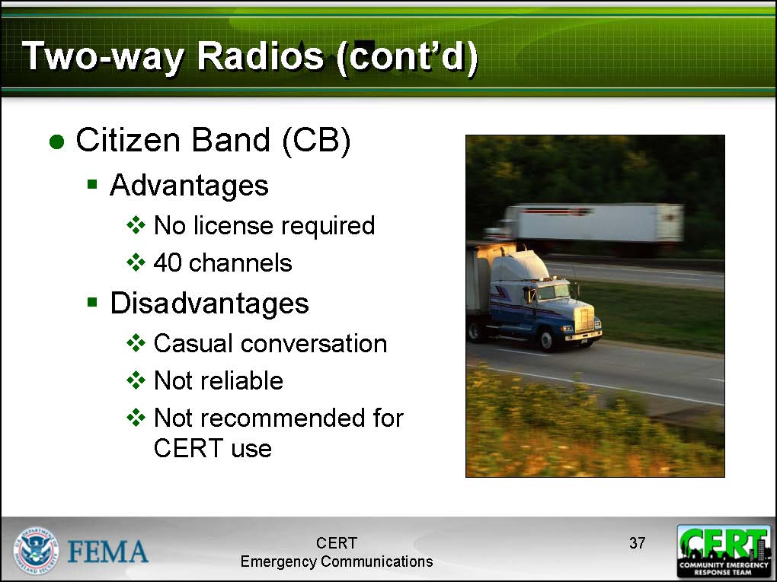  Display Slide 37 | Citizen Band (CB)  Describe the advantages and limitations of CBs to participants as highlighted on the slides.  CB radios have no license requirement and have a large number of channels; however, due to the frequency that they operate on they are practically useless for short-range transmissions.  CB radios are not recommended for CERT use.
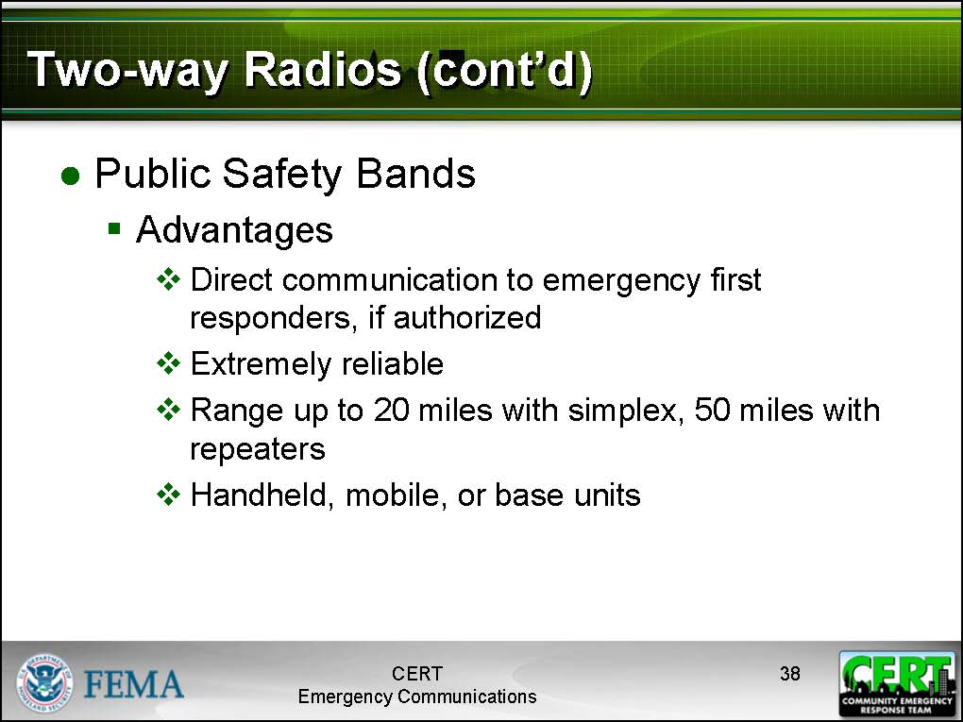  Display Slide 38 | Public Safety Bands  Describe the advantages and limitations of public safety bands to participants as highlighted on the slides.  Emergency dispatchers, fire fighters, EMS, police, and other government emergency responders use a special high-powered mode called public safety bands.
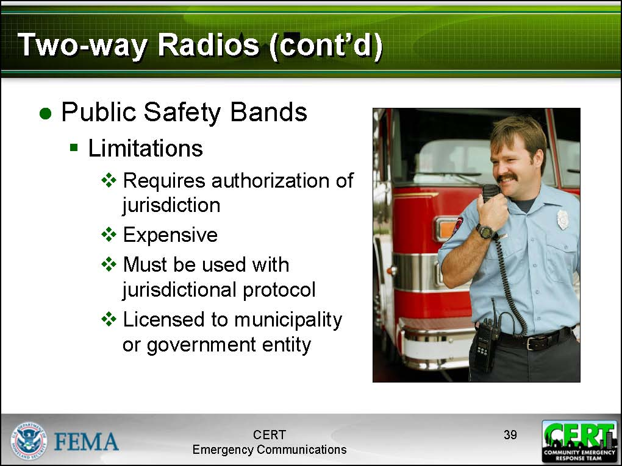  Display Slide 39 | Public safety bands are licensed to municipal governments and require the authorization of the municipality in order to use.
Correct Answer: Simplex | Tell participants to close their Participant Manuals for a moment (so that the Communication Mode table is unavailable to them).  If a two-way radio is transmitting directly to another two-way radio, what mode is it operating in?
Correct Answers: Repeater towers, antennas  Other possible answers: Elevation, moving around, operating with higher power | What devices can be used to increase the distance that the signal of a two-way radio can travel?
Correct Answers: FRS, FRS/GMRS hybrids (partial), and MURS radios | What two-way radios do not require special licenses by the FCC?
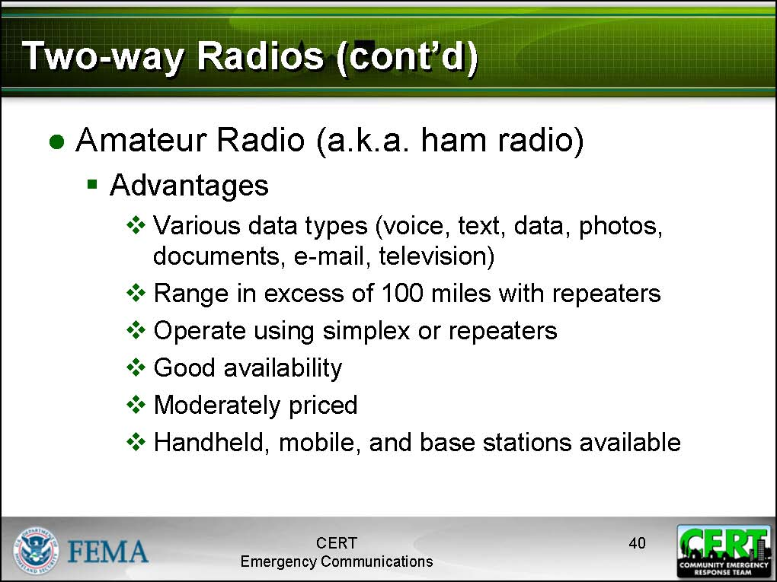  Display Slide 40 | Amateur Radio  Describe the advantages and limitations of amateur radios to participants as highlighted on the slides.
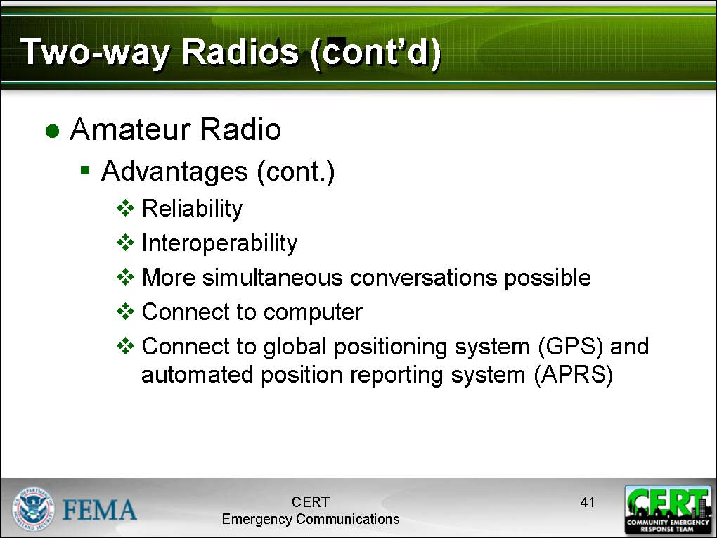  Display Slide 41 | Also known as “ham” radio, amateur radio is a very reliable communications method employed during emergency response situations. Amateur radios are widely available in a variety of configurations and can be used to transmit in excess of 100 miles using repeaters and antennas.
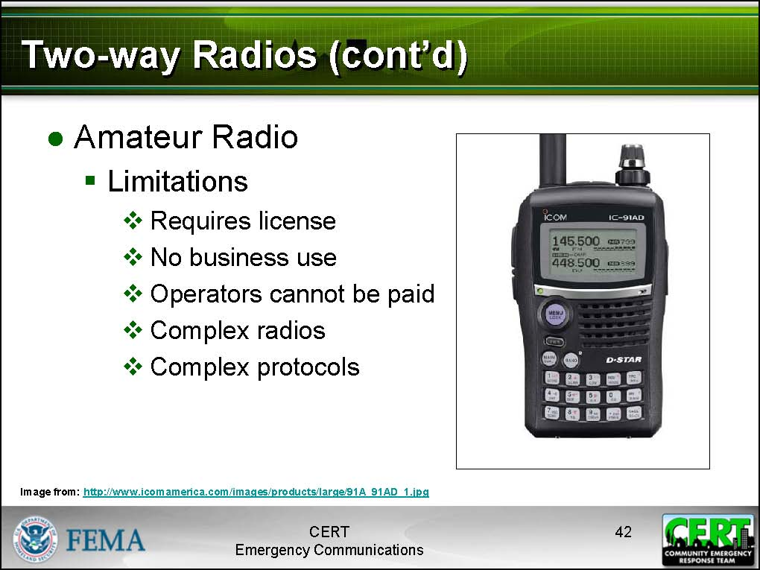  Display Slide 42 | Amateur radios require a license from the FCC. This requires studying for and passing a relatively inexpensive exam. Amateur radios are complex devices with elaborate protocols; users must study and practice to learn how to use them properly.
The instructor should be familiar with the radio before attempting to give instruction on its use.  For this part of the training, participants should have radios in-hand if possible. If participants brought radios, ask them to take them out now. If radios are available for training, pass them out to participants. If there are not enough radios for each participant, ask participants without a radio to sit with a partner. | Basic Radio Anatomy  Tell participants to avoid turning the radios on, as the amount of noise is liable make the class very chaotic.  Tell participants what type of communications device is recommended for purchase by CERT volunteers interested in radio communications.  Make clear to participants that this recommendation is not a requirement. The recommendation should be in accordance with the CERT Communications Plan.  Advise participants that the first thing they should do with a radio before using it is READ THE MANUAL!  Owners should practice using the radios regularly to be familiar with the two-way radio when it is needed.
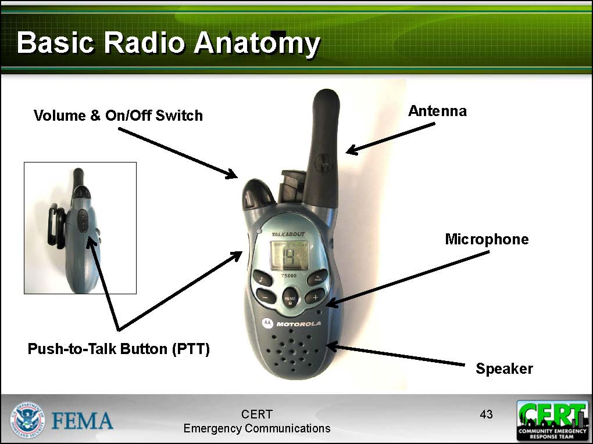  Display Slide 43 | Point out the basic controls on the radio, including:  - On/off switch  - Volume control  - PTT button (Push to talk)  - You must press down the PTT button while you are speaking.  - Remind participants that they must release the button to listen!  - Antenna: Hold it vertical for best reception  - Speaker  - Microphone
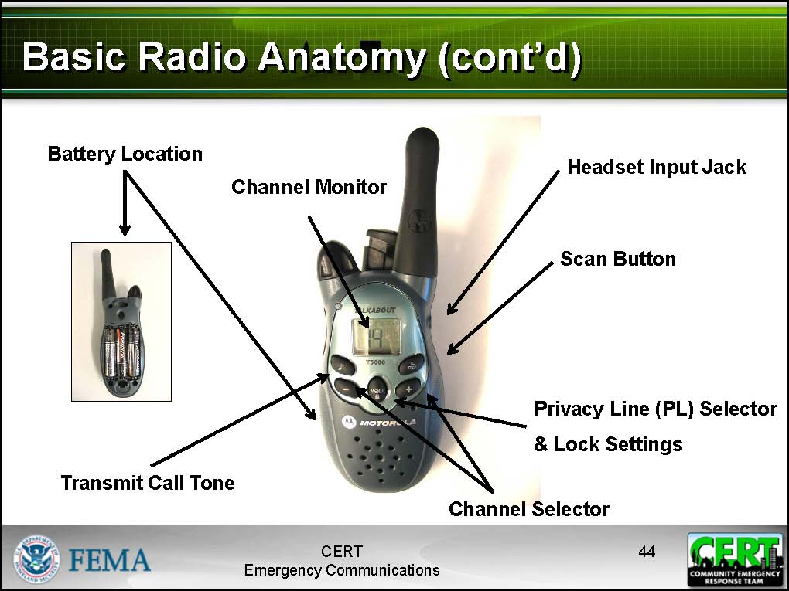  Display Slide 44 | Point out advanced features of the radio, including:  - Battery location  - Channel selector  - Channel monitor  - Headset input jack  - Privacy line selection  - Lock button  - Transmit call tone selection  Point out any additional features on the radio that you are demonstrating in class that may differ from the slides, including:  - Monitor button  - Ring tone selector  - Power settings selector
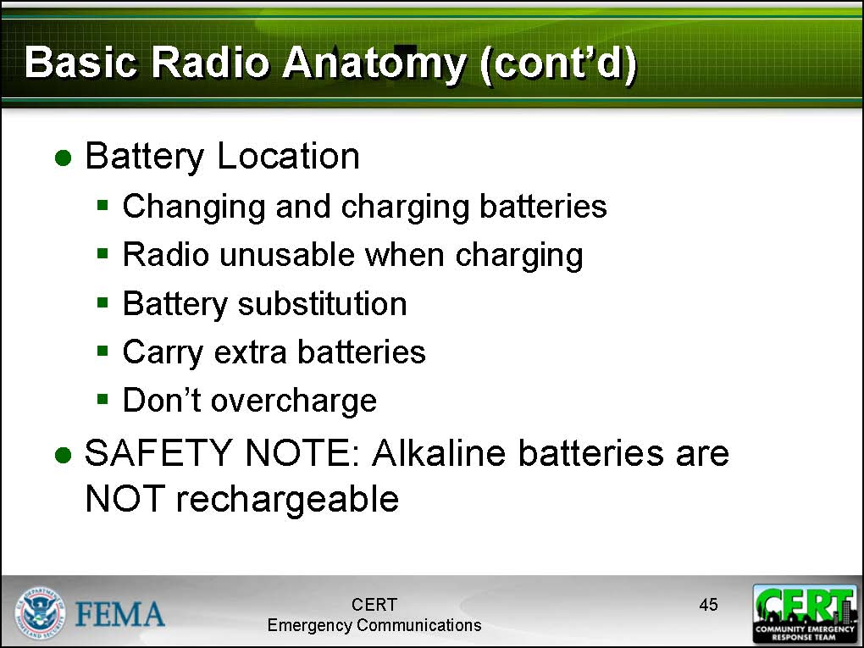  Display Slide 45 | Battery Location  Point out the location of the battery on the radio. Explain to participants how to change the battery, and how to recharge the battery.  If applicable to their radios, explain to participants where battery substitution is possible. Using AA batteries eliminates the need for carrying a battery charger and AA batteries are readily available.  Remind participants that a radio is practically unusable while it is charging; therefore they should always carry extra batteries when working with the radio.  Avoid overcharging the radio, as this can damage the unit!
 | SAFETY NOTE: Never attempt to recharge alkaline batteries!
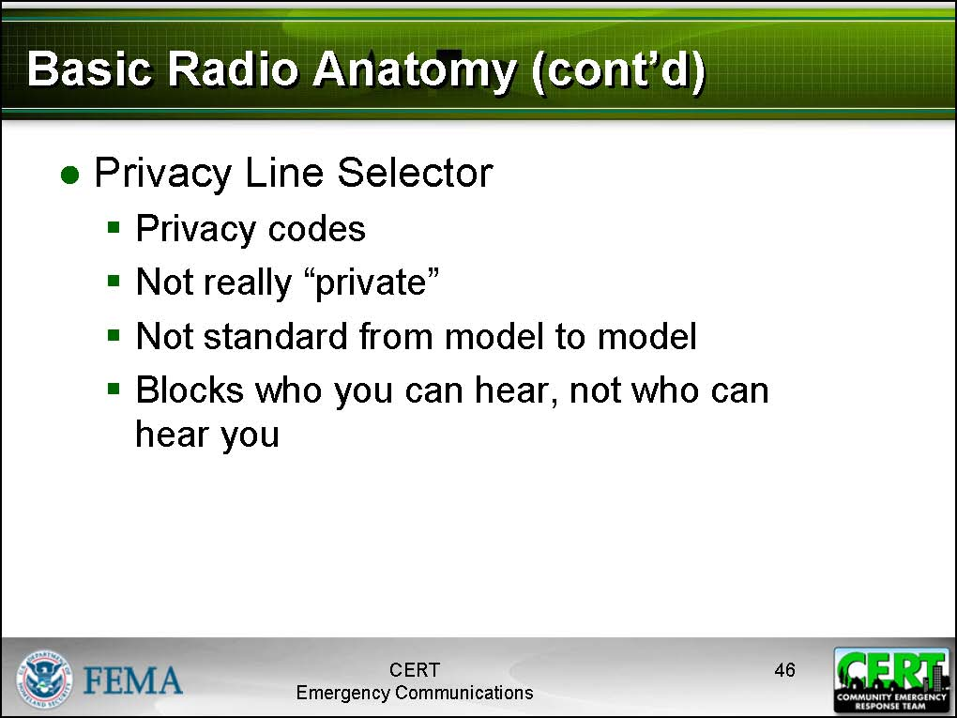  Display Slide 46 | Privacy Codes  Explain to participants that most radios are equipped with a privacy line selector. Despite what the name suggests, these “privacy codes” do not make your conversation private. All a privacy code does is block you from hearing other conversations on that channel.  Privacy codes are not standard between different brands of radio.  Privacy codes are not recommended for CERT use.
Give participants a moment after you list each item in order to give them time to locate the component.  Tell participants that if they are unable to locate a component on their radio, to raise their hand.  Go to the participant and help them locate the component on their radio. | Locate the following items on your radio:  - PTT button  - Battery  - Antenna  - Volume control  - Speaker  - Microphone
Answer participants’ questions, as needed. | Ask participants if they have any questions about where a component is located or how to physically operate the radios.
 | Practical Exercise: Using a Radio
Do not do this exercise if the radios require a license and participants are unlicensed. | Purpose: This short exercise allows participants to practice using their radios.
Be aware that this exercise will generate a great deal of noise; be sure your class will not disturb others in the area.  Also be aware of radio-to-radio feedback if participant radios are close to each other or a lot of the participants are on the same channel. | Instructions: Tell participants that they have 3 minutes to turn on the radios and experiment with their use.  If participants are using FRS/GMRS hybrid radios, instruct them to remain on FRS-only channels.
Debrief: After 3 minutes, instruct participants to turn the radios off.
Ask participants if anyone had difficulty turning the radios on or off or adjusting the volume.
Explain to them that in the next part of the lesson, they will learn how to use the radios in an activation.

Communications Operations
Net Operations
Explain to participants that Net Operations, or a Controlled Net, is a system for coordinating communication among groups of four or more people.
The details of how a Controlled Net functions is typically defined in a communications plan, but the way it works is like this:
As long as a small team is communicating among themselves, they use standard radio protocol. However, once a team needs to contact either another team, report into a command unit, or contact another emergency response agency, they need to contact a Net Control Operator.
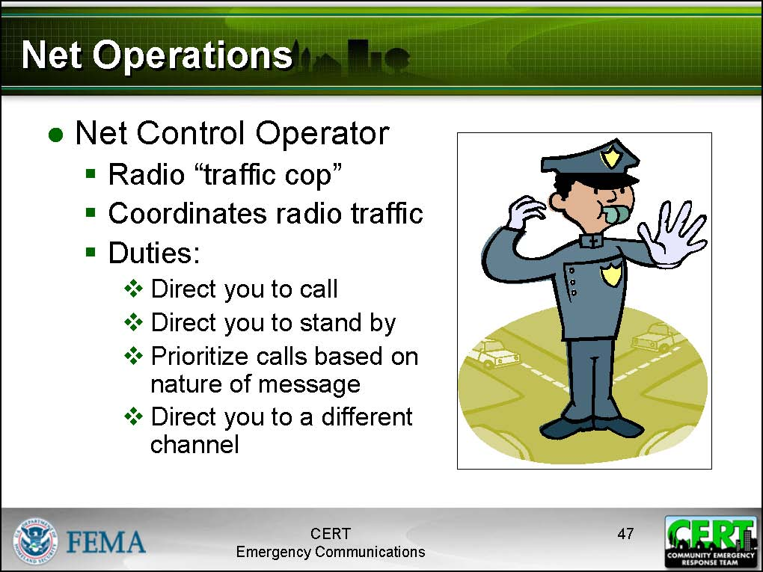  Display Slide 47 | A Controlled Net has one or more Net Control Operators. The Net Control Operator is essentially a radio “traffic cop.” When you call a Net Control Operator, the operator will:  - Direct you to call whomever you need to speak to.  - Direct you to stand by.  - Direct you to a different radio channel.  - Prioritize calls based on the nature of the message.  A Net Control Operator is functioning as the “brain” of a communications network. Large networks may require several networks of Net Control Operators.
 | Practical Exercise: Net Operations
Purpose: To consider different possibilities for setting up a radio communications net for a single neighborhood CERT during an incident. Each group will then chart the radio net that the group agrees would be most advantageous to the CERT in the scenario. Each group will have the same scenario and 10 minutes to review the scenario, answer the questions to create a net plan, and then chart their plan (or fill out the ICS 205 form). Tell the participants that after 10 minutes, each group will pick a spokesperson to describe that group’s net operations plan.
Stress that there are no wrong answers to the questions and that the different plans will have different strengths.
Instructions: Follow these instructions to set up the activity:
- Divide the class into five or six small groups. If possible, put all the licensed amateur radio operators into a single group.
- Refer participants to the communications net scenario in their Participant Manuals.
- Instruct the participants to elect one volunteer to read the scenario aloud for their group.
- Tell participants to answer the questions as a group. There is space in their Participant Manuals to write their solutions.
- Give each group 10 minutes to perform this exercise.
Scenario:
It is a Saturday afternoon in November. During the morning hours, a severe storm hit the community with unexpected force. Winds in excess of 50 mph have brought down trees and power lines all over the city. Many roadways are blocked by trees and other debris from the storm. It is 1:30 p.m. and the storm has ended.
Following the city’s protocol, your neighborhood CERT, “SW CERT,” has activated and nine Team members have been able to show up at the pre-designated meeting place. Six untrained neighbors have also arrived and are willing and able to help. A command post has been established at 7th St. & Oak. The Team Leader has been identified.
The Team Leader has identified Team members for the following positions: Operations Leader, Search and Rescue Group Leader, Medical Group Leader, and Command Post Radio Operator. Each person will communicate via radio.
Following the city’s protocol, the Team Leader has had the Command Post Radio Operator inform the city’s Emergency Operation Center that the SW CERT is in action and operating from 7th St. & Oak.
Based on initial damage assessment performed by Team members, the CERT’s first priority is the community center, which had been damaged during the storm. Eight people who had been at a class at the community center and decided to remain there to wait out the storm were injured when a tree came through the window. They are being moved by the Search and Rescue Group to a treatment area in an undamaged part of the building.
The Medical Group is taking care of the victims there.
At this point in the operation:
- In addition to the city’s Emergency Operation Center, with whom does the Team Leader of SW CERT need to communicate?
- With whom does the Operations Leader of SW CERT need to communicate?
- With whom does the Search and Rescue Group Leader of SW CERT need to communicate?
- With whom does the Medical Group Leader of SW CERT need to communicate?
- Given the current communications needs, should the SW CERT set up Net Operations?
The EOC radios the Team Leader with two messages:
- A sparking downed power line has been reported just two blocks from the SW CERT’s command post. Could the CERT check it out immediately?
- CERT members from an adjoining neighborhood are able to assist the SW CERT if help is needed.
The Team Leader acknowledges both messages and sends a CERT member with two of the untrained volunteers to check out the downed power line.
- In addition to the city’s Emergency Operation Center, with whom does the Team Leader of SW CERT now need to communicate?
- With whom does the Operations Leader of SW CERT now need to communicate?
- Given the current communications needs, should the SW CERT set up Net Operations now?
Debrief:
At the end of the small group discussion (10 minutes), ask each group to pick a spokesperson to report the group’s conclusion about a Net Operations Plan.
Ask if anyone has any questions on Net Operations.
Explain that the next topic will cover on-air techniques and discipline.
Radio Discipline
Tell participants that effective radio communication requires good discipline.
Write the participants’ answers on an easel pad. If participants do not get all of the suggested answers, add these to the easel pad as well.  Suggested Answers:  - One person talks at a time.  - Be clear and concise. It takes practice to be clear and concise to get the message across in shortest time possible. In normal conversation we use many words that are not needed.  - Use plain language.  - Think before you transmit.  - Stay on-topic.  - Listen before you transmit.  - Speak calmly (don’t yell).  - Leave a gap between transmissions.  - Prioritize messages. | What behaviors do you think would make for effective radio discipline?  When someone mentions “prioritizing messages,” point out any protocols in your local CERT Communications Plan involving transmission priority.
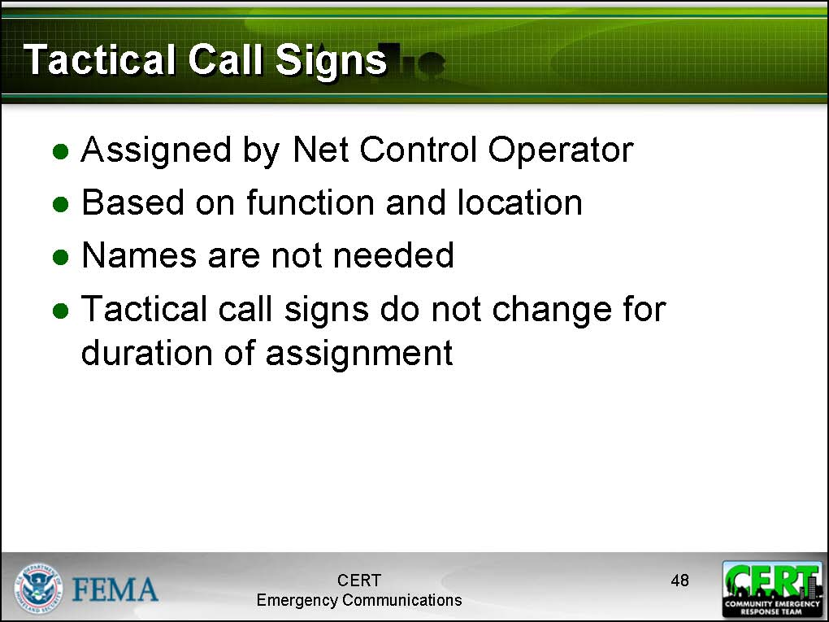  Display Slide 48 | Tactical Call Signs  Tell participants that instead of using names, part of Net Operations is to use tactical call signs.  A tactical call sign is a designation assigned to a team or an individual based on function or location. Tactical call signs are assigned by a Net Control Operator and are made for the duration of an assignment.  Provide a few examples that might relate to the previous class exercise, e.g., “SW CERT Command,” “SW CERT Medical One.”  Note that FCC licensed services such as ham operators will add their official call sign to this exchange when and where required by FCC rules.
Write three or four answers on the easel pad. If any of the examples given are not good examples of tactical call signs, explain why. | Can you think of some other sample tactical call signs?
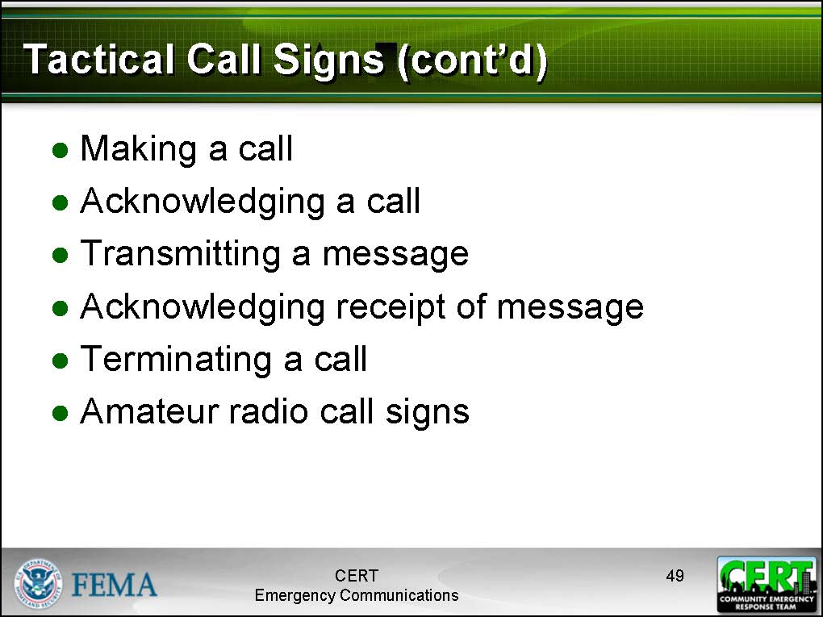  Display Slide 49 | Tactical Call Signs – Making a Call  Tell participants that to transmit and acknowledge calls using tactical call signs, follow these steps:  - To make a call, give the other person’s tactical call sign first, then your tactical call sign, then the word “over.”  - To acknowledge a call, give the call sign of the person calling you, then say, “This is” then give your call sign, then say “over.”  - Next, transmit the message. Always identify yourself when you are transmitting the message.  - The receiver should acknowledge receipt by identifying him- or herself, repeating the gist of the message, and then saying “over.”  - The transmitter then terminates the message by identifying him- or herself and then saying “out.”
 | Practical Exercise: Tactical Call Signs Demonstration
 | Purpose: This short exercise will demonstrate to participants how tactical call signs are used.
Tactical Call Sign Demonstration Script A and Script B are located on slides 60 and 61 of the PowerPoint Slides. | Instructions: Follow these steps:  - Ask for two volunteers to come to the front of the class.  - Hand one of the volunteers the Tactical Call Sign Demonstration Script A and the other one Script B.  - Instruct the volunteer with Script A to read the first bullet point on the script.  - The volunteer with Script B should respond by reading the first bullet point on his/her script.  - The two volunteers should continue alternating back and forth until the message is completed.
Thank the volunteers. | Debrief: Ask the participants if they have any questions about what a tactical call sign is or how it is used.  Tell the participants that they will have opportunities to practice an activity like this a little later.
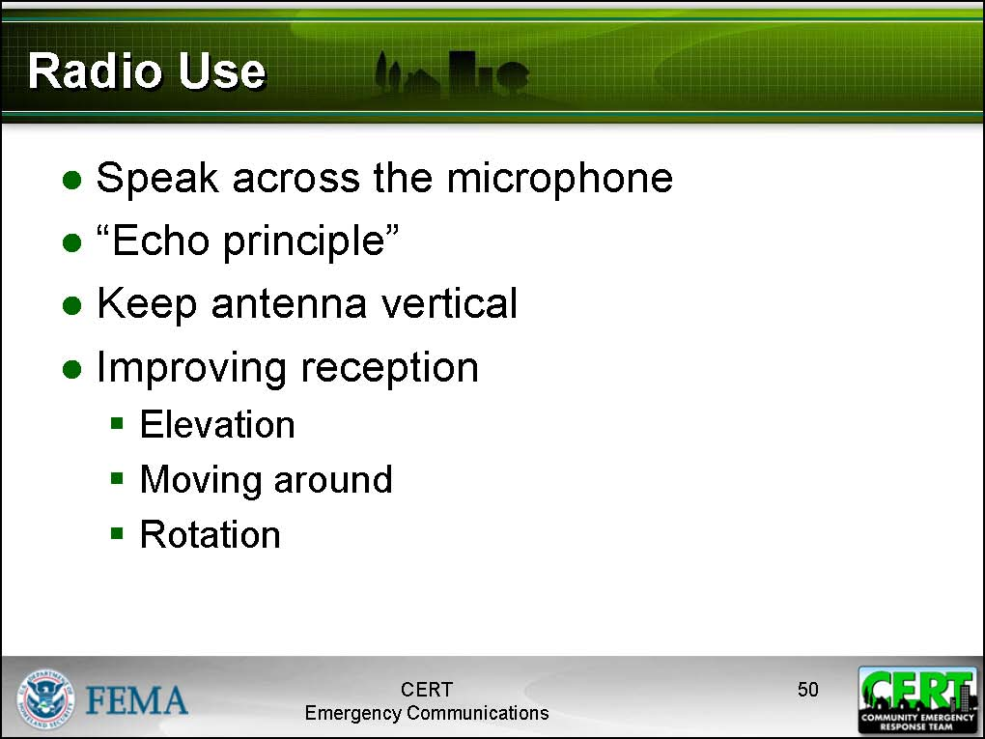  Display Slide 50 | Radio Use  Tell participants that this part of the training will teach them good techniques for improving reception and transmission quality.  - Speak across the radio microphone rather than directly into it in order to produce a clearer message.  - Use the “echo principle.” Repeat essential parts of the message to the sender.  - Keep the antenna in a vertical position.  If you have poor reception, try elevating your radio, or stand on a stable elevated surface.  If you are in a structure, try moving near an open window or moving to another area of the structure.  If your radio is in your pocket or on your belt, and you have poor reception, try to raise the radio above your body, as your body can interfere with signal reception. Also, try rotating slowly to see if the signal clears.  If you have poor reception in a vehicle, stop the vehicle, and then try raising the antenna above the vehicle or moving away from the vehicle.
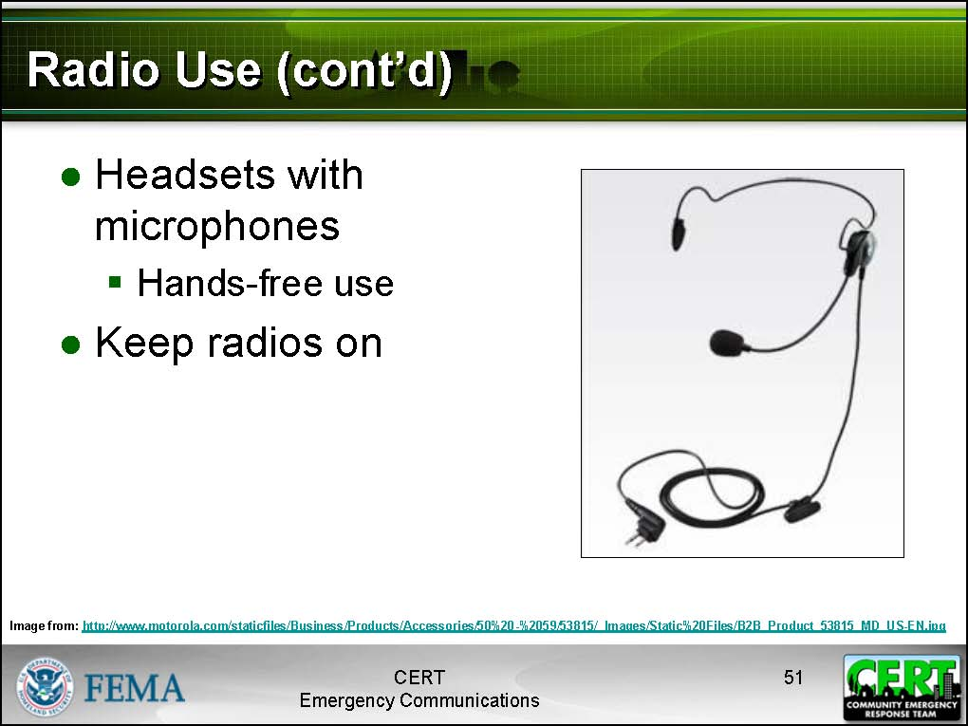  Display Slide 51 | - Team radios should be equipped with a headset with a microphone whenever possible. This will enable the CERT volunteer to keep both hands free while sending and receiving messages.  - Always keep radios turned on. Monitor your radio for safety, accountability, and intra-team communications.
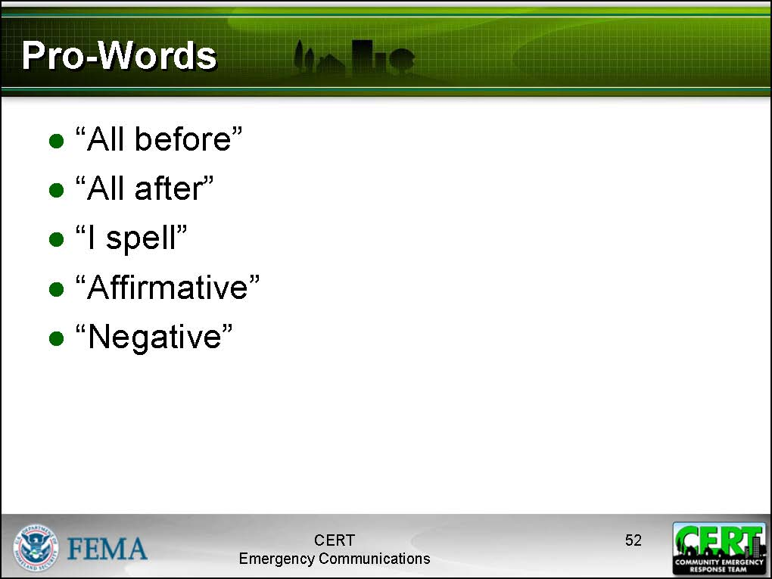  Display Slide 52 | Pro-Words  Tell participants to familiarize themselves with these words that are commonly used in radio transmissions.  - “All before X” – Repeat everything prior to X (a word in the message).  - “All after X” – Repeat everything after X (a word in the message).  - “I spell” – Say prior to spelling a difficult or ambiguous-sounding word.  - “Affirmative”  - “Negative”
If your CERT uses a phonetic alphabet other than the ITU Standard Phonetic Alphabet, hand copies of this out to the class and explain that this is used instead of the document in their Participant Manuals. Remove the image from PowerPoint slide 52 if you use a phonetic alphabet other than the ITU. | Phonetic Alphabet  Tell participants that radio operators use code words to spell out difficult or ambiguous-sounding words. This is called using a phonetic alphabet.
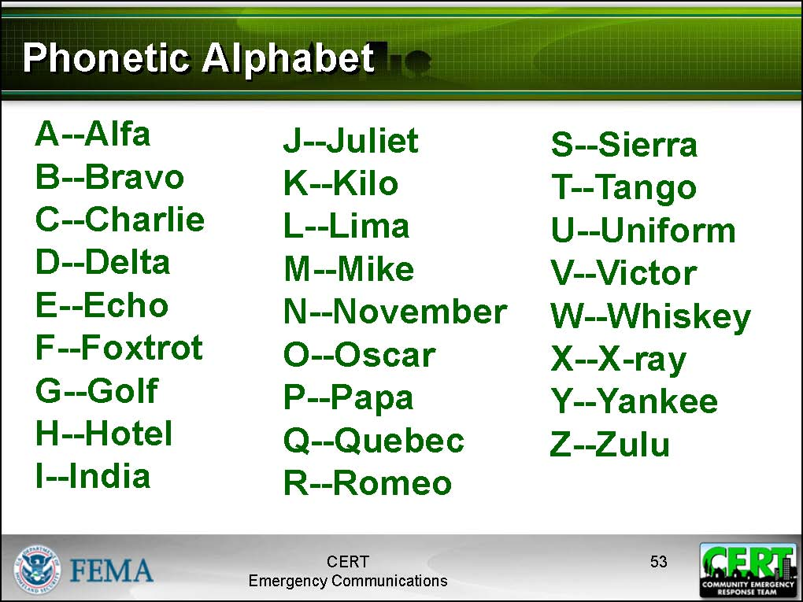  Display Slide 53 | Tell the participants that they are going to practice using the phonetic alphabet. Tell participants to turn to page 37 in their Participant Manuals titled “Phonetic Alphabet Exercise.”
 | Practical Exercise: Phonetic Alphabet
 | Purpose: To familiarize participants with using a phonetic alphabet
Instructions: Follow these instructions:
- Select a participant at one side of the class.
- Ask the participant to spell the first name of a family member phonetically.
- Instruct the rest of the class to translate the name from the phonetic alphabet back into a written alphabet. Tell them to use the blank space on page 31 in their Participant Manuals to write down the translation.
- Move to the next participant and repeat until all of the participants have had an opportunity to spell a name phonetically.
 | Debrief: Ask participants if they understand how to use the phonetic alphabet. Ask if any of the participants have any questions.
Example: If the participant decided to spell the name of his brother “Frank,” he would say aloud:
Foxtrot – Romeo – Alfa – November – Kilo
The other participants should write the name “Frank” on the blank page in their Participant Manuals.
 | Practical Exercises – Role-playing 1
 | Purpose: To allow participants to practice all of the techniques they have learned
Instructions: Follow these directions:
- Divide the class into pairs for this practical exercise, a role-playing activity. Encourage the participants to move around the room so that they are not standing next to one another.
- Hand out a “Small Scenario Role-playing Card” to each pair. Each card contains two tactical call signs, one for the caller and one for the receiver. Each card also contains a brief scenario.
- One participant chooses to be the caller; the other will be the receiver.
- The caller should examine his scenario, then make a call to the receiver and transmit the information, then terminate the transmission.
- The receiver should acknowledge the call and verify the message.
- Instruct the participants not to speak too loudly in order to avoid disrupting the other participants.
After the role-players complete this brief exercise, they should switch roles and repeat it. After they have completed the exercises, they should trade role-playing cards with their neighbors and repeat the exercise.
Debrief: The instructor should move around the class, listening to each pair. The instructor should listen to ensure that the participants are using:
- Tactical call signs
- Pro-words
- Phonetic alphabet
- Echo principle
- Good radio protocol
 | Practical Exercises – Role-playing 2
 | Purpose: In this next role-playing exercise, participants will practice operating in a group with a leader.
Instructions: Follow these directions:
- Bring a group of five volunteers to the front of the class.
- Assign a sixth volunteer the role of Net Control Operator. Request that this role be played by an experienced amateur radio operator (if you have one in the class).
- In the initial five volunteers, assign one the role of IC/CERT Leader.
- Describe the sample scenario to the participants (details are given below).
- Instruct the volunteers to play out a scenario. The Command unit should ask the Willow Park CERT Leader for a status check on his team. The Leader should call for a status check on each team member. As much as possible, volunteers should attempt to communicate using tactical call signs, net operations protocol, and other proper radio use techniques.
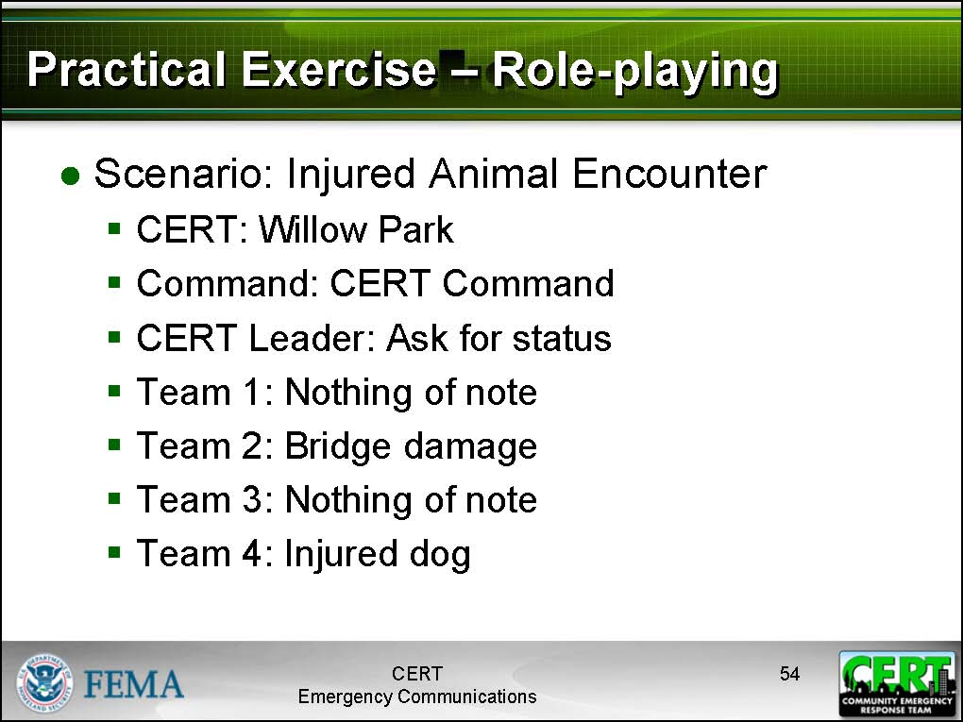  Display Slide 54 | Scenario – Injured Animal Encounter  The CERT is conducting damage assessment in the Willow Park area. Team 1 has not found anything worth noting. Nearby, team 2 was approaching a footbridge and discovered that high waters had damaged the structure of the bridge. Team 3 is checking for civilians in the picnic area and has found a leftover picnic basket but no people. Team 4 has just spotted an injured dog that is limping but does not appear to be acting threatening towards the volunteers.
 | Debrief: At the end of the scenario, ask the class to critique the scenario by identifying what worked and what could have been done better. Give the volunteers a round of applause before continuing the exercise.
Continuing the Exercise: Follow these instructions to continue the exercise.
- Bring up a new group of volunteers.
- Ask the other participants in the class to shout out ideas for a scenario that would involve some basic communication.
- Write the ideas on an easel pad.
- Once a single scenario has been fleshed out significantly to create a communications situation, instruct the role-players to act it out.
Repeat this exercise until all participants have had an opportunity to act as role-players.
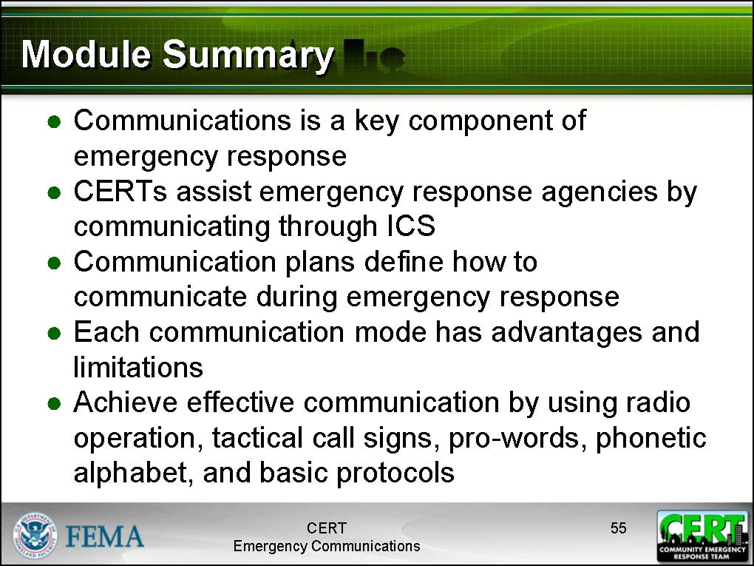  Display Slide 55 | Summary  Review the following points with the participants:  - Communications is a key component of emergency response. Effective communications allow for effective tactical emergency response. Ineffective communications will result in poorly managed emergency response and may result in increased dangers to the responders or civilians in the emergency.  - CERT volunteers act as the “eyes and ears” for other emergency response agencies by communicating through the ICS.  - A communications plan defines how different levels communicate during an emergency response situation.
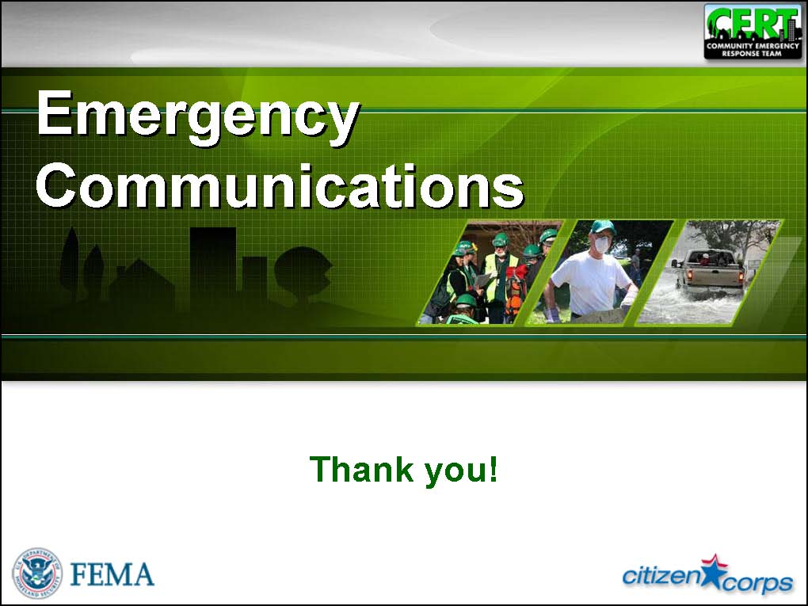  Display Slide 56 | - Instructor Note: Present one or two key points from the local CERT Communications Plan.  - Different communications modes have different advantages and limitations during an activation.  - Effective communication can be achieved by knowing how to operate a radio, using tactical call signs, using pro-words, using the phonetic alphabet, and using some basic protocols.  Ask if anyone has any questions.  For more information, refer participants to your local amateur radio club that conducts licensure training.  Closing  Provide information on any upcoming training or other CERT program activities.  Present certificates to participants and thank them for attending the session.

[This page intentionally left blank]

